2023 Guideline for Authors (Formatting and Template)
Updated on February 1, 2023: Created on March 15, 2021, by S. Ueno

Contents
Ⅰ. General Guidelines for Authors (Academic Paper Sessions)
Ⅱ. General Guidelines for Authors (Doctoral Colloquium)

Ⅰ. General Guidelines for Authors (Academic Paper Sessions)

Academic paper sessions at the main conference have always been the center of the APMAA annual conferences. As in every other year, the sessions provide subject areas that encompass various fields and accept manuscripts of almost any accounting subject (see the "Primary and secondary subject areas of the Academic Paper Sessions" below). Your manuscripts can be theoretical or practice-oriented.

Primary and secondary subject areas of the Academic Paper Sessions

01. Challenges and Opportunities to Management Accounting in the Digital Era
-Management Accounting in the Digital Era
-AI and robotic process automation in Accounting and Auditing
-Data Science and Analytics in Accounting, Auditing, and Taxation
-Cloud accounting and Cyber security
- Performance management through the cloud computing system
-Accounting education and curriculum in the Digital Era
-Accounting research in the Digital Era
- Digital Competency Readiness and Acceptance by management accountants

- Cost management and Manufacturing Industries
- Cost accounting
- Supply chain management
- Production management
- The changing roles of management accounting in Industry 4.0

- Performance Management
- Performance Management Systems and Budgeting in an uncertainty environment
- Data analytics, Enterprise Planning, and Performance Management
- Performance Appraisal and Incentives
- Multi-Criteria Decision-Making and Accounting
- Impacts of management accounting practices on forecast-based business valuation

04. Strategic Management Accounting
- Factors influencing the deployment of SMA techniques
- Strategic Planning and Performance Management
- Profit-sharing within a supply chain
- Accounting for servitization business models
- Accounting for start-up and unicorn companies
- Intellectual Capital, Intangibles, and Knowledge Management

05. Management Accounting for Multinational Enterprises
- Transfer pricing
- International Tax planning
- Performance management in MNEs
- Management accounting roles and Risk management in a borderless business environment

06. Management Accounting for State-owned Companies, Public Sector, and Non-profit Organizations (NPOs)
- Management accounting in state enterprises
- Open data management for the government
- Management accounting for the third sector (NPOs and civil societies)

07. Management Accounting for SMEs and Family Businesses
- Decision-Making in Publicly Traded vs. Private Companies
- Issues of Business continuity and succession
- Tax planning for the family business

08. Business Reporting and Communication
- Financial Reporting and Business Communication
- Impact of IFRS on corporate management
- Corporate Social Responsibility Accounting
- Social, Environmental and Sustainability Management (SDGs) Accounting

09. Business Ethics and Internal Control
- Internal Control and Accountability
- Business Ethics, and Fraud Prevention and Detection
- Corporate Governance

10. Mathematical Models in Accounting
- Contract Theory
- Capital Market
- Disclosure
- Product Market Competition

11. Comparative (Cross-cultural) Management Accounting
- Cross-cultural comparison
- Cross-national comparison

12. Management Accounting of Islamic Business
- Management Accounting of Islamic Finance and Banking
- Electronic Transactions in Islamic Banks and Markets
- Islamic Financial Industries and Sustainable Development
- Sukuk, Wakaf, and Zakat management

13. Management Accounting Education and History
- Accounting Education
- History of Accounting discipline
- History of Management Accounting practices

14. Other Management Accounting Issue

2023 Guideline for Authors (Formatting and Template)
1. All submitted manuscripts should report original, unpublished research results.

2. The official language of APMAA 2023 is English in both writing and presentation. If English is not your mother tongue (first language), check your draft using a professional editor and/or with a spelling- and grammar-matching application such as Grammarly before submitting your manuscript. You can download a free version of this application on a webpage and install it on your PC. If your document is hard to read, we will decline it before sending it to our reviewer (Desk Rejected).

3. Manuscripts should follow the structure of a traditional research paper, i.e., you will need to adjust your document to the academic format (If not, Desk Rejected). An empirical research paper's typical organization is Title, Abstract, Introduction, Literature Review, Methodology, Results, Discussion, Conclusion, and References.

4. Use Times New Roman font with font size 12, page size A4, and single-spaced.

5. Abstract should be 200-300 words on a separate page immediately preceding the text. Show five keywords below the abstract. The text should be over 5,000 but usually not exceed 10,000 words (If not, Desk Rejected).

6. The cover page should contain the title of the paper, the author's name (first name, initial(s), and family name), position, and affiliation (capitalize the first character of each word). Also, contain email addresses. Please indicate the corresponding author and add his/her phone number.

7. To promote anonymous review, authors should not identify themselves directly or indirectly in their writing.

8. A Single author should not use the pronoun "we." Referencing should follow the APA style (http://www.apastyle.org).

9. Each author registering for the conference is limited to two (2) full-length paper submissions (including co-author papers) for the Academic Paper Sessions.

10. Authors who received a "Minor Revision" or "Major Revision" notification are expected to resubmit their revised (final) manuscripts before a specified date (the temporal deadline is August 20) to get an "Accept" notification by September 1. Our review team engages in review on a first-come-first-served basis.

11. All authors of accepted manuscripts must complete and submit their camera-ready papers for inclusion in the "Proceedings" and abstracts for the "Book of Abstracts" before the due date (Sep.15, 2022). Authors can choose a "full-length paper" or "executive summary" submission for the conference proceedings, although we recommend submitting a full-length paper.
Executive summaries are more extended than abstracts, running 3–7 pages (around 1500-2,000 words). They summarize the research output's purpose, methods, results, and conclusions so that someone who reads only the summary can understand the research.

12. To attend and present their papers, the presenter (hopefully, the first author) must register (pay the participation fee) for the Conference before September 15, 2023.

Template for an Academic Paper

The Margin on an A4 page
APMAA adopts the margins predefined by Microsoft Word. Authors can choose either Normal margins or Moderate margins.
Word: Normal | Top 35.01 mm, Bottom 30 mm, Left 30 mm, Right 30mm
Word: Moderate | Top mm 25.4, Bottom 25.4 mm, Left 19.05 mm, Right 19.05 mm

Cover Page
Paper Title
……………………………………………………………………………
……………………………………………………………………………

The author's name (First name, initial(s), and family name)
Position and affiliation
Affiliated University
Email address

The corresponding author's name (First name, initial(s), and family name)
Position and affiliation
Affiliated University
Email address and telephone number

Text

Paper Title
(14-point fonts; capitalize the first character of each word)

ABSTRACT: The abstract needs to provide a brief but comprehensive summary of the contents of your paper. It provides an overview of the paper and helps readers decide whether to read the full text. Visit and read Abstract and Keywords Guide, APA Style 7th Edition.
(200-300 words)

ABSTRACT: ……………………………………………………………………………
……………………………………………………………………………………………
……………………………………………………………………………………………
……………………………………………………………………………………………
……………………………………………………………………………………………
……………………………………………………………………………………………
……………………………………………………………………………………………
……………………………………………………………………………………………

Keywords: aging, attention, information processing, emotion, Japan
(5 keywords, lowercased (but capitalize proper nouns), not italic or bold)

Keywords need to be descriptive and capture the most important aspects of your paper. They are used for indexing in databases and as search terms for readers. Visit and read Abstract and Keywords Guide, APA Style 7th Edition.

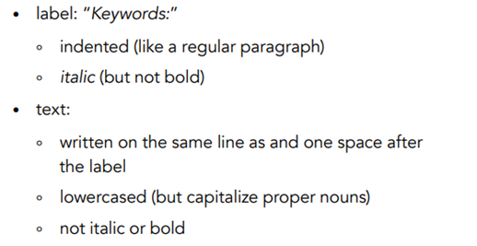

About the main body
(The text length should be over 5,000 but usually not exceed 10,000 words)
Illustrated below are the four heading levels used in the conference papers. All text paragraphs should be single-spaced, with the first line intended by 10 mm. No spaces should be placed between paragraphs. Double spacing should only be used before and after Level 1 and Level 2 headings, as shown in this example. The position and style of headings should follow the example below. Please use Times New Roman font with font size 12, and page size A4.

HEADING LEVEL 1

Heading Level 2
Heading Level 3
Heading Level 4.

1. INTRODUCTION
(Background of the study and an overview of related work in the area of the research; the problem domain; the specific problem addressed, research questions, research objectives, and expected research outcome.)

xxx……………………………………………………………………………………
……………………………………………………………………………………………
……………………………………………………………………………………………
……………………………………………………………………………………………
xxx……………………………………………………………………………………
……………………………………………………………………………………………
……………………………………………………………………………………………
……………………………………………………………………………………………
……………………………………………………………………………………………

2. LITERATURE REVIEW AND HYPOTHESIS DEVELOPMENT
(The original fundamental concepts; related literature; hypothesis/proposition of the thesis; conceptual framework of the study.)

xxx……………………………………………………………………………………
……………………………………………………………………………………………

Heading Level 2

xxx……………………………………………………………………………………
……………………………………………………………………………………………
……………………………………………………………………………………………
……………………………………………………………………………………………
Heading Level 3
xxx……………………………………………………………………………………
…………………………………………………………………………………………………………………………………………………………………………………………
……………………………………………………………………………………………

2. METHOD
(Methodological approach, e.g., population, sample, measurements, data collection method, and data analysis.)

xxx…………………………………………………………………………………………………………………………………………………………………………………

Heading Level 2

xxx…………………………………………………………………………………………………………………………………………………………………………………
……………………………………………………………………………………………
……………………………………………………………………………………………

Figure 1: (If any)
Table 1: (if any)
Sample Annotated Professional Paper in APA Style
Heading Level 3
xxx……………………………………………………………………………………
……………………………………………………………………………………………
……………………………………………………………………………………………
……………………………………………………………………………………………
Heading Level 4
xxx……………………………………………………………………………………
……………………………………………………………………………………………
……………………………………………………………………………………………
……………………………………………………………………………………………

3. FINDINGS AND DISCUSSION
(Results; discussion with previous studies.)

xxx…………………………………………………………………………………………………………………………………………………………………………………
……………………………………………………………………………………………

Heading Level 2

xxx…………………………………………………………………………………………………………………………………………………………………………………
……………………………………………………………………………………………
……………………………………………………………………………………………
Heading Level 3 xxx……………………………………………………………………………………
……………………………………………………………………………………………
……………………………………………………………………………………………

4, CONCLUSIONS
(Conclusion; expected contributions; recommendation; future studies; the research progress.)

xxx……………………………………………………………………………………
……………………………………………………………………………………………
……………………………………………………………………………………………
……………………………………………………………………………………………

REFERENCES

References are ordered alphabetically by the first author's last name. If the author is unknown, order the reference entry by the first meaningful word of the title (ignoring articles: "the," "a," or "an").
(Follow acceptable citation styles, American Psychological Association or APA Style. The following example uses double-spaced lines; however, for APMAA 2023, you need to use single-spaced lines)

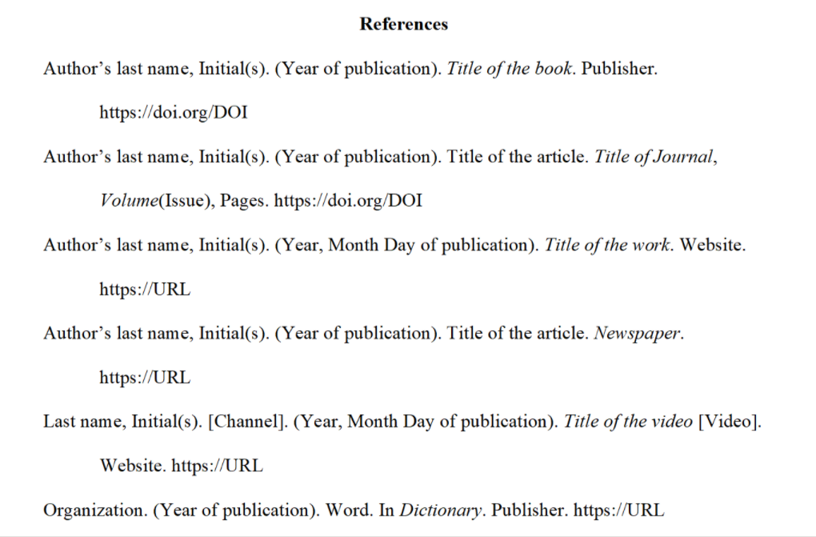

……………………………………………………………………………………………
……………………………………………………………………………………………
……………………………………………………………………………………………

How to submit your documents to the CMT.

APMAA 2023 employs the Conference Management Toolkit (CMT) that Microsoft Corporation provides to manage submitted papers.

CMT→ Author console →+Create New submission (select the Academic Paper Sessions track) →Edit "Create New Submission" page
MS-CMT Structure of the APMAA2023
(Track 1) Academic Paper Sessions → Primary subject areas (14) → Secondary subject areas
(Track 2) Doctoral Colloquium Sessions (Thesis Position Papers)
(Track 3) Other (Plenary Session, Forum, and Doctoral Seminar Speakers)
(Track 4) Organizers' Practice Track (Soley for the use of the Organizer)
We will open the CMT submission site on May 20, 2023. The Paper Submission Deadline is July 20.

Ⅱ. General Guidelines for Authors (Doctoral Colloquium)

Doctoral students and candidates are welcome to submit a "thesis-position paper" of all stages. However, we encourage particularly later-stage doctoral students (who already have at least one working paper rather than merely a research proposal) to apply. Students accepted for the Doctoral Colloquium will be required to prepare a full paper for presentation following the typical format of research papers in accounting (or their sub-areas where conventions vary).

The submitted paper should state the following:
1. An overview of related work in the area of the doctoral work
2. The original fundamental idea/hypothesis of the thesis
3. The problem domain and the specific problem addressed
4. Methodological approach
5. The expected contributions
6. Research carried out

A single file of supplemental documents:
Doctoral students interested in participating in the Student Paper Sessions of the Doctoral Colloquium should submit a single file (in both PDF and Word) of supplemental documents consisting of the following (1)-((4):
(1) An introductory letter in which you indicate what you wish to obtain from the Doctoral Colloquium and what you will bring to the Doctoral Colloquium.

(2) A one-page research statement in the research field you will pursue. This statement must answer two questions;
Question 1- Which field description characterizes your doctoral research best? [single choice]
• Management accounting and information systems
• Social, critical, organizational, and historical perspectives on accounting
• Corporate reporting and analysis, governance and auditing, and taxation
Question 2- Which methods do you use in your doctoral research? [multiple choice]
• Analytical
• Empirical Archival
• Experimental (Lab or Field)
• Interviews and other qualitative methods
• Questionnaire/Survey

(3) Your CV.

(4) A letter of recommendation from your primary dissertation advisor should state what you could contribute and gain from the doctoral consortium. (Your advisor must use the template, APMAA 23 DC Recommendation Form: Uploaded on January 31, 2023)

Notification:

1. The first author should be a doctoral student responsible for researching the topic. If the supervisor becomes a co-author, he or she should be a second or subsequent author.

2. Since this is a doctoral colloquium, students should write their thesis position papers with their supervisors and not with other fellow students.

3. The official language is English in both writing and presentation. If English is not your mother tongue (first language), check your draft by employing a professional editor and/or with a spelling- and grammar-matching application such as Grammarly before submitting your manuscript. You can download a free version on a webpage and install it on your PC. If your document is hard to read, we will decline it before sending it to our reviewer (Desk rejected).

4. Abstract should be 200-300 words on a separate page immediately preceding the text. Show five keywords below the abstract. The text should be as concise as the subject and research method permit. The text length should be about 4,000- 8,000 words. (If not, Desk Rejected). Use Times New Roman font with font size 12, page size A4, and single-spaced.

5. You should submit all manuscripts to the Doctoral Colloquium Sessions Track of the CMT (Conference Management Toolkit - Login (microsoft.com)). If you are new to CMT, please register your ID (Email) and Password in the CMT system before submitting your paper. If you have a CMT account, there is no need to make a new account. You can log in to CMT with this account. In your Author console, please click "Create new submission" and select "Doctoral Colloquium Sessions." Edit the "Create New Submission" page and submit your manuscript. We will open the submission site on May 20, 2023. The Paper Submission Deadline is July 20, 2023. Please ensure your submission meets the conference's guidelines for accepting scholarly papers.

6. The colloquium chairs will arrange the selection of the accepted papers using a peer-review process.

7. When the first author (a doctoral student) will have completed registration and submission of the camera-ready full-length paper before the due date (Sep.15, 2023), the accepted manuscripts will be included in the in-house proceedings (a collection of camera-ready full-length papers). APMAA does not allow authors to present their papers when they refuse to have full-length papers in Doctoral Colloquium proceedings.

Template for a Doctoral Colloquium Paper

Paper Title (Cover Page)
……………………………………………………………………………………………
……………………………………………………………………………………………

Name-Surname of Doctoral Student (First Author)
Studying University, Country
Course/Program
Email address and telephone number

Name-Surname of Thesis Supervisor(s)
Affiliated University, Country
Email address

Date

ABSTRACT: The abstract needs to provide a brief but comprehensive summary of the contents of your paper. It provides an overview of the paper and helps readers decide whether to read the full text. Visit and read Abstract and Keywords Guide, APA Style 7th Edition.
(200-300 words)

ABSTRACT: ……………………………………………………………………………
……………………………………………………………………………………………
……………………………………………………………………………………………
……………………………………………………………………………………………

Keywords: aging, attention, information processing, emotion, visual search
(5 keywords, lowercased (but capitalize proper nouns), not italic or bold)

Keywords need to be descriptive and capture the most important aspects of your paper. They are used for indexing in databases and as search terms for readers. Visit and read
Abstract and Keywords Guide, APA Style 7th Edition.

About main body (Overall text length should be about 4,000- 8,000 words.)

Illustrated below are the four heading levels used in the conference papers. All text paragraphs should be single-spaced, with the first line intended by 10 mm. No spaces should be placed between paragraphs. Double spacing should only be used before and after Level 1 and Level 2 headings as shown in this example. The position and style of headings should follow the example below.
Please use Times New Roman font with Font size 12, and page size A4.

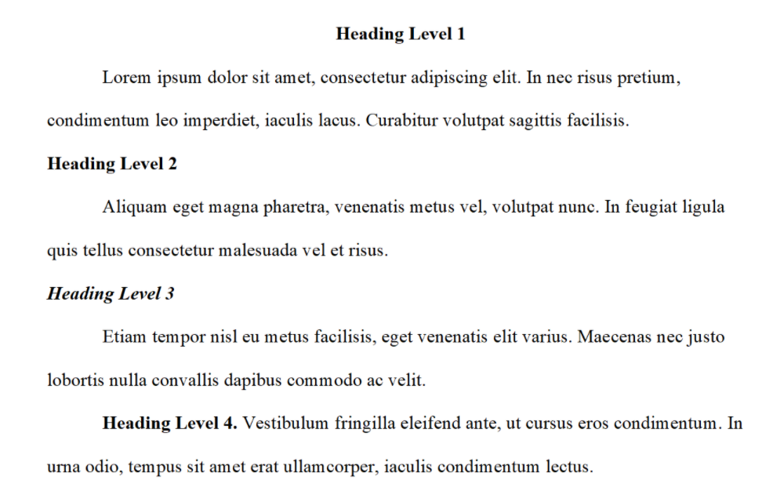

1. INTRODUCTION

(Background information and an overview of related work in the area of the doctoral work; the problem domain; the specific problem addressed, research questions, and research objectives.)

xxx……………………………………………………………………………………
……………………………………………………………………………………………
……………………………………………………………………………………………

Heading Level 2

xxx……………………………………………………………………………………
……………………………………………………………………………………………
……………………………………………………………………………………………
……………………………………………………………………………………………
……………………………………………………………………………………………
Heading Level 3
xxx……………………………………………………………………………………
……………………………………………………………………………………………
……………………………………………………………………………………………
……………………………………………………………………………………………
……………………………………………………………………………………………

- LITERATURE REVIEW AND HYPOTHESIS DEVELOPMENT

(The original fundamental concepts; related literature; hypothesis/proposition of the thesis; conceptual framework of the study.)

xxx……………………………………………………………………………………
……………………………………………………………………………………………
……………………………………………………………………………………………

Heading Level 2

xxx……………………………………………………………………………………
……………………………………………………………………………………………
……………………………………………………………………………………………
……………………………………………………………………………………………
……………………………………………………………………………………………
Heading Level 3
xxx……………………………………………………………………………………
……………………………………………………………………………………………
……………………………………………………………………………………………
……………………………………………………………………………………………
……………………………………………………………………………………………

- METHOD

(Methodological approach, e.g., population, sample, measurements, data collection method, and data analysis.)

xxx……………………………………………………………………………………
……………………………………………………………………………………………
……………………………………………………………………………………………

Heading Level 2

xxx……………………………………………………………………………………
……………………………………………………………………………………………
……………………………………………………………………………………………
……………………………………………………………………………………………
……………………………………………………………………………………………

Figure 1: (If any)
Table 1: (if any)
Sample Annotated Professional Paper in APA Style
Heading Level 3
xxx……………………………………………………………………………………
……………………………………………………………………………………………

- FINDINGS AND DISCUSSION
(Results; discussion with previous studies.)

xxx……………………………………………………………………………………
……………………………………………………………………………………………
……………………………………………………………………………………………

Heading Level 2

xxx……………………………………………………………………………………
……………………………………………………………………………………………
……………………………………………………………………………………………
……………………………………………………………………………………………
……………………………………………………………………………………………
Heading Level 3
xxx……………………………………………………………………………………
……………………………………………………………………………………………
……………………………………………………………………………………………
……………………………………………………………………………………………
……………………………………………………………………………………………

- CONCLUSIONS
(Conclusion; expected contributions; recommendation; future studies; the research progress.)

xxx……………………………………………………………………………………
……………………………………………………………………………………………
……………………………………………………………………………………………
……………………………………………………………………………………………

REFERENCES
(Follow acceptable citation styles, American Psychological Association or APA Style, but use a Single Space).

References are ordered alphabetically by the first author's last name. If the author is unknown, order the reference entry by the first meaningful word of the title (ignoring articles: "the", "a", or "an").

How to submit your documents to the CMT.

APMAA 2023 employs the Conference Management Toolkit (CMT) that Microsoft Corporation provides to manage submitted papers.

CMT→ Author console →+Create New submission (select the Doctoral Colloquium Sessions track) →Edit "Create New Submission" page
MS-CMT Structure of the APMAA2023
(Track 1) Academic Paper Sessions → Primary subject areas (14) → Secondary subject areas
(Track 2) Doctoral Colloquium Sessions (Thesis Position Papers)
(Track 3) Other (Plenary Session, Forum, and Doctoral Seminar Speakers)
(Track 4) Organizers' Practice Track (Soley for the use of the Organizer)
We will open the CMT submission site on May 20, 2023. The Paper Submission Deadline is July 20.

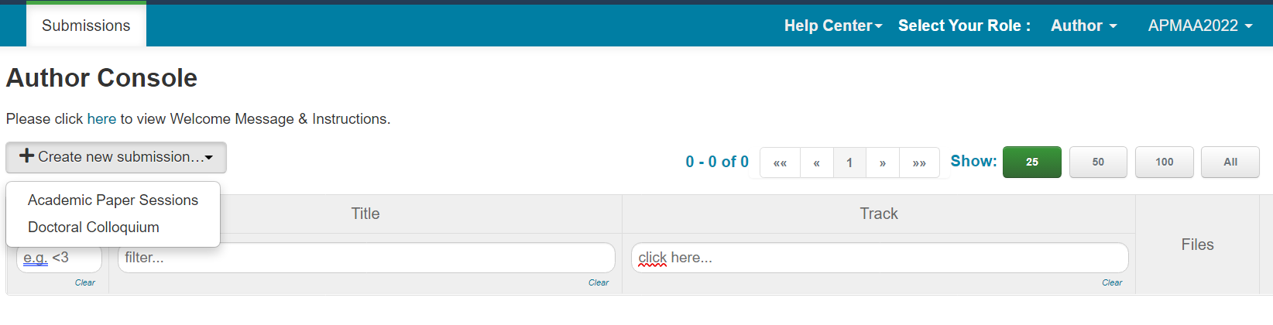

The Publication Manual offers guidance on choosing the headings, tables, figures, language, and tone that will result in powerful, concise, and elegant scholarly communication.
Publication Manual of the American Psychological Association, Seventh Edition (2020) (apa.org)
Research Paper Format | APA, MLA, & Chicago Templates (scribbr.com)

Sample Annotated Student Paper in APA Style
The following two sample papers were published in annotated format in the Publication Manual and are reproduced here for your ease of reference. The annotations draw attention to relevant content and formatting and provide users with the relevant sections of the Publication Manual (7th ed.) to consult for more information.
- Annotated student sample paper (PDF, 2MB)
- Annotated professional sample paper (PDF, 3MB)
Also below URLs offer sample papers in Microsoft Word (.docx) file format without the annotations.
- Student sample paper (DOCX, 36KB)
- Professional sample paper (DOCX, 96KB)

The single or double space between sentences argument has been an ongoing one for decades. Traditional, pre-digital typesetting required the use of double-spacing after periods and colons. This was largely due to the limitations of now-antiquated technology and was the standard style taught by most schools until around 20 years ago. With the advent of digital printing, the need for double spaces isn't really a thing, anymore. But a lot of people still adhere to the practice. Even style guides don't universally agree. The latest editions of the Chicago Manual of Style and MLA both suggest a single space. The APA guidelines currently suggest two spaces, but even they have gone back and forth over the years.

