**2024 Guideline for Authors (Formatting and Template)**

Updated on February 27, 2024: Created on March 15, 2021, by S. Ueno

**Contents**

Ⅰ. General Guidelines for Authors (Academic Paper Sessions)

Ⅱ. General Guidelines for Authors (Doctoral Colloquium)

**Ⅰ. General Guidelines for Authors** (**Academic Paper Sessions**)

The academic paper sessions at the main conference consistently serve as the focal point of the APMAA annual conferences. As in previous years, these sessions encompass many subject areas this year, inviting submissions on diverse accounting topics detailed in the "Primary and Secondary Subject Areas of the Academic Paper Sessions" document. Following the conference theme, "Management Accounting: A Decision-Support Tool for Sustainable Development and the Digitalization of Business Processes," subject area 01 has been revised to reflect this central theme. Authors are encouraged to submit papers utilizing various methodologies, including empirical (such as case studies, surveys, interviews, and observations), quantitative (including modeling, simulations, and statistical analysis), or conceptual (such as literature review, theoretical analysis, and conceptual modeling) approaches.

01. Management Accounting: A Decision-Support Tool for Sustainable Development and the Digitalization of Business Processes (accommodate a Conceptual, Empirical, Quantitative study)

* Sustainable decision-support systems in management accounting
* Sustainable business performance measurement in management accounting
* Information management and analytics for sustainability
* Building digital competencies for sustainability
* Management accounting for sustainable development and digitalization

1. Cost Management and Manufacturing Industries

* Cost accounting
* Supply chain management
* Production management
* The changing roles of management accounting in Industry 4.0

1. Performance Management

* Performance management systems and budgeting in an uncertain environment
* Data analytics, enterprise planning, and performance management
* Performance appraisal and incentives
* Multi-criteria decision-making and accounting
* Impacts of management accounting practices on forecast-based business valuation

04. Strategic Management Accounting

* Factors influencing the deployment of SMA techniques
* Strategic planning and performance management
* Profit-sharing within a supply chain
* Accounting for servitization business models
* Accounting for start-up and unicorn companies
* Intellectual capital, intangibles, and knowledge management  
    
  05. Management Accounting for Multinational Enterprises
* Transfer pricing
* International tax planning
* Performance management in MNEs
* Management accounting roles and risk management in a borderless business environment

06. Management Accounting for State-owned Companies, Public Sector, and Non-profit Organizations (NPOs)

* Management accounting in state enterprises
* Open data management for the government
* Management accounting for the third sector (NPOs and civil societies)

07. Management Accounting for SMEs and Family Businesses

* Decision-making in publicly traded vs. private companies
* Issues of business continuity and succession
* Tax planning for the family business

08. Business Reporting and Communication

* Financial reporting and business communication
* Impact of IFRS on corporate management
* Corporate social responsibility (CSR) accounting
* Social, environmental, and sustainability management (SDGs) accounting

09. Business Ethics and Internal Control

* Internal control and accountability
* Business ethics and fraud prevention and detection
* Corporate governance

10. Mathematical Models in Accounting

* Contract theory
* Capital market
* Disclosure
* Product market competition

11. Comparative (Cross-cultural) Management Accounting

* Cross-cultural comparison
* Cross-national comparison

12. Management Accounting of Islamic Business

* Management accounting of Islamic finance and banking
* Electronic transactions in Islamic banks and markets
* Islamic financial industries and sustainable development
* Sukuk, wakaf, and zakat management

13. Management Accounting Education and History

* Accounting education
* History of accounting discipline
* History of management accounting practices

14. Other Management Accounting Issue

[**2024 Guideline for Authors (Formatting and Template)**](http://s-ueno.sakura.ne.jp/APMAA_asia/2023%20Guideline%20for%20Authors%20(Formatting%20and%20Template)%20Edited%20on%20Feb.%201%20by%20ueno.docx)**:** Edited on February 25, 2024

1. All submitted manuscripts should report original, unpublished research results.

2. The official language of APMAA 2024 is **English** in both writing and presentation. If English is not your mother tongue (first language), check your draft using a professional editor and/or with a spelling- and grammar-matching application such as **Grammarly** before submitting your manuscript. You can download a free version of this application on a webpage and install it on your PC. If your document is hard to read, we will decline it before sending it to our reviewer (**Desk Reject**).

3. Manuscripts should follow **the structure of a traditional research paper,** i.e., you will need to adjust your document to the **academic format** (If not, **Desk Reject**). An empirical research paper's typical organization is Title, Abstract, Introduction, Literature Review, Methodology, Results, Discussion, Conclusion, and References.

4. Use **Times New Roman font** with **size 12, page size A4, and single-spaced font.**

5. **Abstract** should be **200-300 words** and placed preceding the text. Show **five keywords** below the abstract. The text should be **over 5,000 but usually not exceed 10,000 words** (If not, **Desk Reject**).

6. The cover page should contain the title of the paper, the author's name (first name, initial(s), and family name), position, and affiliation (capitalize the first character of each word). Also, it contains email addresses. Please indicate the **corresponding author and add** his/her phone number.

7. To promote anonymous review, authors should not identify themselves directly or indirectly in their writing.

8. A **Single author** should not use the pronoun "we." Referencing should follow the APA style [(http://www.apastyle.or](http://www.apastyle.org/)g).

9. Each author registering for the conference is **limited to two (2) full-length paper submissions** (including co-author papers) for the Academic Paper Sessions.

10. Authors who received a "Minor Revision" or "Major Revision" notification are expected to resubmit their revised (final) manuscripts before a specified date (the temporal deadline is **August 20**) to get an "Accept" notification by September 1. Our review team engages in review on a first-come-first-served basis.

11. All authors of accepted manuscripts must complete and submit their **camera-ready papers** for inclusion in the "**Proceedings"** and **abstracts** for the "**Book of Abstracts"** before the due date (Sep.15, 2024). Authors can choose a "full-length paper" or "executive summary" submission for the conference proceedings, although we recommend submitting a full-length paper. Executive summaries are more extended than abstracts, running 3–7 pages (around 1500-2,000 words). They summarize the research output's purpose, methods, results, and conclusions so that someone who reads only the summary can understand the research.

12**.**To attend and present their papers, the presenter (the **first author**) must register (pay the participation fee) for the Conference before September 16, 2024.

**Template for an Academic Paper**

**The Margin on an A4 page**

APMAA adopts the margins predefined by Microsoft Word. Authors can **choose either Normal margins or Moderate margins.**

|  |  |
| --- | --- |
| **Word: Normal** | Top 35.01 mm, Bottom 30 mm, Left 30 mm, Right 30mm |
| **Word: Moderate** | Top mm 25.4, Bottom 25.4 mm, Left 19.05 mm, Right 19.05 mm |

**Cover Page**

**Paper Title**

**……………………………………………………………………………**

**……………………………………………………………………………**

The author's name (First name, initial(s), and family name)

Position and affiliation

Affiliated University

Email address

The corresponding author's name (First name, initial(s), and family name)

Position and affiliation

Affiliated University

Email address and telephone number

**Text**

**Paper Title**

(14-point fonts; capitalize the first character of each word)

**ABSTRACT:** The abstract needs to provide a brief but comprehensive summary of the contents of your paper. It provides an overview of the paper and helps readers decide whether to read the full text. Visit and read [Abstract and Keywords Guide, APA Style 7th Edition](https://apastyle.apa.org/instructional-aids/abstract-keywords-guide.pdf).

(**200-300 words**)

**ABSTRACT:** ……………………………………………………………………………

……………………………………………………………………………………………

……………………………………………………………………………………………

……………………………………………………………………………………………

……………………………………………………………………………………………

……………………………………………………………………………………………

……………………………………………………………………………………………

……………………………………………………………………………………………

***Keywords:*** *aging, attention, information processing, emotion, Japan*

(***5 keywords*,** lowercased (but capitalize proper nouns), *italic* (but not bold)

Keywords must be descriptive and capture the most important aspects of your paper. They are used for indexing in databases and as search terms for readers. Visit and read [Abstract and Keywords Guide, APA Style 7th Edition](https://apastyle.apa.org/instructional-aids/abstract-keywords-guide.pdf).

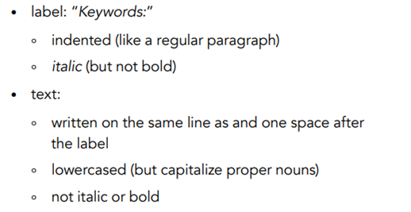

**About the main body**

(The text length should be **over 5,000 but usually not exceed 10,000 words)**

Illustrated beloware the four heading levels used in the conference papers. All text paragraphs should be **single-spaced**, with the first line intended to be 10 mm. No spaces should be placed between paragraphs. Double spacing should only be used before and after Level 1 and Level 2 headings, as shown in this example. The position and style of headings should follow the example below. Please use **Times New Roman font** with **12 font** and **page size A4.**

|  |
| --- |
| **HEADING LEVEL 1**  **Heading Level 2**  ***Heading Level 3***  **Heading Level 4.** |

**1. INTRODUCTION**

(Background of the study and an overview of related work in the area of the research; the problem domain; the specific problem addressed; research questions, research objectives, and expected research outcome.)

xxx……………………………………………………………………………………

……………………………………………………………………………………………

……………………………………………………………………………………………

……………………………………………………………………………………………

xxx……………………………………………………………………………………

……………………………………………………………………………………………

……………………………………………………………………………………………

……………………………………………………………………………………………

……………………………………………………………………………………………

**2.** **LITERATURE REVIEW AND HYPOTHESIS (HYPOTHESES)**

**DEVELOPMENT**

**(**The original fundamental concepts; related literature; hypothesis/proposition of the thesis; conceptual framework of the study.)

xxx……………………………………………………………………………………

……………………………………………………………………………………………

**Heading Level 2**

xxx……………………………………………………………………………………

……………………………………………………………………………………………

……………………………………………………………………………………………

……………………………………………………………………………………………

***Heading Level 3***

xxx……………………………………………………………………………………

…………………………………………………………………………………………………………………………………………………………………………………………

……………………………………………………………………………………………

**3. METHOD(S)**

**(**Methodological approach, e.g., population, sample, measurements, data collection method, and data analysis.)

xxx…………………………………………………………………………………………………………………………………………………………………………………

**Heading Level 2**

xxx…………………………………………………………………………………………………………………………………………………………………………………

……………………………………………………………………………………………

……………………………………………………………………………………………

Figure 1: (If any)

Table 1: (if any)

[Sample Annotated Professional Paper in APA Style](https://apastyle.apa.org/style-grammar-guidelines/paper-format/professional-annotated.pdf)

***Heading Level 3***

xxx……………………………………………………………………………………

……………………………………………………………………………………………

……………………………………………………………………………………………

……………………………………………………………………………………………

**Heading Level 4**

xxx……………………………………………………………………………………

……………………………………………………………………………………………

……………………………………………………………………………………………

……………………………………………………………………………………………

**4. FINDINGS AND DISCUSSION**

(Results; discussion with previous studies.)

xxx…………………………………………………………………………………………………………………………………………………………………………………

……………………………………………………………………………………………

**Heading Level 2**

xxx…………………………………………………………………………………………………………………………………………………………………………………

……………………………………………………………………………………………

……………………………………………………………………………………………

***Heading Level 3*** xxx……………………………………………………………………………………

……………………………………………………………………………………………

……………………………………………………………………………………………

**5. CONCLUSION(S)**

**(**Conclusion; expected contributions; recommendation; future studies; the research progress.)

xxx……………………………………………………………………………………

……………………………………………………………………………………………

……………………………………………………………………………………………

……………………………………………………………………………………………

**REFERENCES**

References are ordered alphabetically by the first author's last name. If the author is unknown, order the reference entry by the first meaningful word of the title (ignoring articles: "the," "a," or "an").

(Follow acceptable citation styles, American Psychological Association or [APA Style](https://apastyle.apa.org/). The following example uses double-spaced lines; however, for APMAA 2024, you need to use **single-spaced lines**)

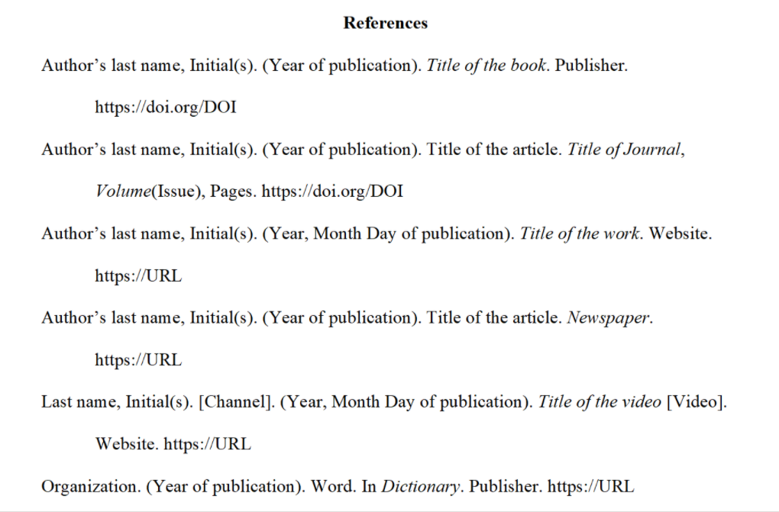

……………………………………………………………………………………………

……………………………………………………………………………………………

……………………………………………………………………………………………

|  |
| --- |
| **How do you submit your documents to the CMT?**  APMAA 2024 employs the Conference Management Toolkit (CMT) that Microsoft Corporation provides to manage submitted papers.  CMT→ Author console →+Create New submission (select the **Academic Paper Sessions track**) →Edit "Create New Submission" page  MS-CMT Structure of the APMAA2024  (Track 1) Academic Paper Sessions → Primary subject areas (14) → Secondary subject areas  (Track 2) **Doctoral Colloquium Sessions** (Research papers)  (Track 3) Other (for speakers of Plenary sessions, Forums, and Doctoral seminars)  (Track 4) Organizers' Practice (Soley for the use of the Organizer)  We will open the CMT submission site on May 1, 2024. The Paper Submission Deadline is July 15. |

**Ⅱ. General Guidelines for Authors (Doctoral Colloquium)**

The 2024 Doctoral Colloquium, held alongside the APMAA 2024 Conference, offers a unique platform for advanced doctoral students. It provides an opportunity to gain feedback from external mentors, engage in peer interaction, exchange ideas, and cultivate formal and informal collaborations across diverse research groups.

We invite doctoral students and candidates to submit "completed papers" for the 2024 Doctoral Colloquium. We particularly welcome applications from later-stage doctoral students, those who have progressed beyond the research proposal stage and have at least one working paper. Successful applicants must present a completed full paper, following the typical format of research papers in accounting or related fields, where conventions may vary.

**The submitted paper is anticipated to encompass the following key elements:**

1. A comprehensive review of pertinent literature within the doctoral work's purview, establishing a distinctive positioning for the submitted paper within the field.  
  
2. Clear articulation of the primary conceptual framework or hypothesis underpinning the paper, highlighting its originality.

3. Precise elucidation of the problem domain and a focused exploration of the specific problem addressed in the research.

4. A detailed description of the methodological approach employed to investigate and resolve the identified problem.

5. Identification and thorough discussion of the expected contributions that the paper is poised to make to the existing body of knowledge in the field.

6. An in-depth account of the research activities undertaken, accentuating key findings and insights derived from the conducted investigations.

**A single Word file of supplemental documents:**

In addition to the research paper, a consolidated file of supplemental documents is required. The doctoral student, serving as the primary author, is asked to submit a single Word file containing the following supplemental documents (1)-(4):

(1) An introductory letter in which you indicate what you wish to obtain from the Doctoral Colloquium and what you will bring to the Doctoral Colloquium.

(2) A one-page research statement in your research field. This statement must answer the following two questions

Question 1- Which field description characterizes your doctoral research best? [single choice]　  
　• Management accounting and information systems  
　• Social, critical, organizational, and historical perspectives on accounting  
　• Corporate reporting and analysis, governance and auditing, and taxation  
 Question 2- Which methods do you use in your doctoral research? [multiple choice]  
　• Analytical  
　• Empirical Archival  
　• Experimental (Lab or Field)  
　• Interviews and other qualitative methods  
　• Questionnaire/Survey

(3) Your CV.

(4) An official letter of recommendation from your **primary dissertation advisor**. It should state what you could contribute and gain from the doctoral consortium. (Your advisor must use the template,APMAA2024 DC Recommendation Form (revised on Feb.25, 2024) at .

**Notification**

1. **The primary (first author)** should be a doctoral student responsible for researching the topic. If the supervisor contributes as a co-author, they should be listed as a second or subsequent author. As this is a doctoral colloquium, students can only collaborate on their research papers with their supervisors, not fellow students.

2. The official language is English in both writing and presentation. If English is not your mother tongue (first language), check your draft by employing a professional editor and/or with a spelling- and grammar-matching application such as Grammarly before submitting your manuscript. You can download a free version on a webpage and install it on your PC. If your document is hard to read, we will decline it (Desk rejected).

3. **Abstract** should be **200-300 words** on a separate page preceding the text. Show **five keywords** below the abstract. **The text** should be as concise as the subject and research method permit. The text length should be about 4,000- 8,000 words. (If not, **Desk Rejected**). Use **Times New Roman font** with **font size 12**, **page size A4**, and **single-spaced** ("**2024 Guideline for Authors (Formatting and Template)"** on [APMAA 2024 (Asia-Pacific Management Accounting Association) (s-ueno.sakura.ne.jp)](http://s-ueno.sakura.ne.jp/APMAA_asia/2024_conference.htm).

4. You should submit all manuscripts to the Doctoral Colloquium Sessions Track of the CMT

([Conference Management Toolkit - Login (microsoft.com)](https://cmt3.research.microsoft.com/User/Login?ReturnUrl=%2FAPMAA2023)). If you are new to CMT, please create your account by registering your ID (Email) and Password in the CMT system before submitting your paper. If you have a CMT account, there is no need to make a new account. You can log in to CMT with the account. Please click "Create new submission" in your Author console and select "Doctoral Colloquium Sessions." Edit the "Create New Submission" page and submit your manuscript. We will open the submission site on May 1, 2024. The Paper Submission Deadline is July 15, 2024. Please ensure your submission meets the conference's guidelines for accepting scholarly papers.

5. The **Doctoral Colloquium Chairs** will arrange the selection of the accepted papers using a peer-review process and assign a mentor to the accepted one.

6. When the **first author** (a **doctoral student**) has completed registration and submission of the camera-ready full-length paper before the due date (Sep.15, 2024), the accepted manuscripts will be included in the in-house proceedings (a collection of camera-ready full-length papers). APMAA does **not allow** authors to present their papers when they refuse to have full-length papers in Doctoral Colloquium proceedings.

7. Each paper of the 2024 Doctoral Colloquium will be given **35 min.** (5 min. Introduction by the mentor, 15 min. Presentation by the student, 10 min. Discussion by the mentor, and 5 min. Q&A). Note that the **first author** (**doctoral student**) must present.

**Template for a Doctoral Colloquium Paper**

**Paper Title (Cover Page)**

**……………………………………………………………………………………………**

**………………………………………………………………………****…………****…………**

Name-Surname of Doctoral Student (First Author)

Studying University, Country

Course/Program

Email address and telephone number

Name-Surname of Thesis Supervisor(s)

Affiliated University, Country

Email address

Date

**ABSTRACT:** The abstract needs to provide a brief but comprehensive summary of the contents of your paper. It provides an overview of the paper and helps readers decide whether to read the full text. Visit and read [Abstract and Keywords Guide, APA Style 7th Edition](https://apastyle.apa.org/instructional-aids/abstract-keywords-guide.pdf).

(**200-300 words**)

**ABSTRACT:** ……………………………………………………………………………

……………………………………………………………………………………………

……………………………………………………………………………………………

……………………………………………………………………………………………

***Keywords:*** *aging, attention, information processing, emotion, Japan*

(***5 keywords*,** lowercased (but capitalize proper nouns), *italic* (but not bold)

Keywords must be descriptive and capture the most important aspects of your paper. They are used for indexing in databases and as search terms for readers. Visit and read [Abstract and Keywords Guide, APA Style 7th Edition](https://apastyle.apa.org/instructional-aids/abstract-keywords-guide.pdf).



**About the main body** (Overall text length should be about **4,000- 8,000 words**.)

Illustrated beloware the four heading levels used in the conference papers. All text paragraphs should be **single-spaced**, with the first line intended by 10 mm. No spaces should be placed between paragraphs. Double spacing should only be used before and after Level 1 and Level 2 headings as shown in this example. The position and style of headings should follow the example below.

Please use **Times New Roman font** with **Font size 12**, and **page size A4.**

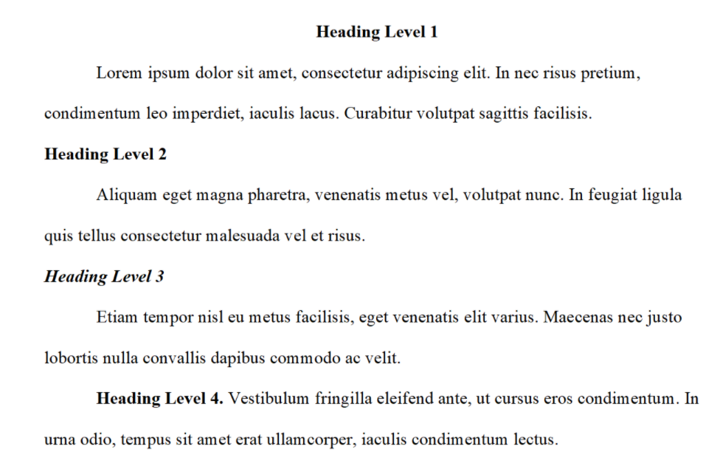

**1. INTRODUCTION**

(Background information and an overview of related work in the doctoral work; the problem domain; the specific problem addressed; research questions; and research objectives.)

xxx……………………………………………………………………………………

……………………………………………………………………………………………

……………………………………………………………………………………………

**Heading Level 2**

xxx……………………………………………………………………………………

……………………………………………………………………………………………

……………………………………………………………………………………………

……………………………………………………………………………………………

……………………………………………………………………………………………

***Heading Level 3***

xxx……………………………………………………………………………………

……………………………………………………………………………………………

……………………………………………………………………………………………

……………………………………………………………………………………………

……………………………………………………………………………………………

**2. LITERATURE REVIEW AND HYPOTHESIS (HYPOTHESES) DEVELOPMENT**

**(**The original fundamental concepts; related literature; hypothesis/proposition of the thesis; conceptual framework of the study.)

xxx……………………………………………………………………………………

……………………………………………………………………………………………

……………………………………………………………………………………………

**Heading Level 2**

xxx……………………………………………………………………………………

……………………………………………………………………………………………

……………………………………………………………………………………………

……………………………………………………………………………………………

……………………………………………………………………………………………

***Heading Level 3***

xxx……………………………………………………………………………………

……………………………………………………………………………………………

……………………………………………………………………………………………

……………………………………………………………………………………………

……………………………………………………………………………………………

**3. METHOD(S)**

(Methodological approach, e.g., population, sample, measurements, data collection method, and data analysis.)

xxx……………………………………………………………………………………

……………………………………………………………………………………………

……………………………………………………………………………………………

**Heading Level 2**

xxx……………………………………………………………………………………

……………………………………………………………………………………………

……………………………………………………………………………………………

……………………………………………………………………………………………

……………………………………………………………………………………………

Figure 1: (If any)

Table 1: (if any)

[Sample Annotated Professional Paper in APA Style](https://apastyle.apa.org/style-grammar-guidelines/paper-format/professional-annotated.pdf)

***Heading Level 3***

xxx……………………………………………………………………………………

……………………………………………………………………………………………

**4. FINDINGS AND DISCUSSION**

(Results; discussion with previous studies.)

xxx……………………………………………………………………………………

……………………………………………………………………………………………

……………………………………………………………………………………………

**Heading Level 2**

xxx……………………………………………………………………………………

……………………………………………………………………………………………

……………………………………………………………………………………………

……………………………………………………………………………………………

……………………………………………………………………………………………

***Heading Level 3***

xxx……………………………………………………………………………………

……………………………………………………………………………………………

……………………………………………………………………………………………

……………………………………………………………………………………………

……………………………………………………………………………………………

**5. CONCLUSION(S)**

**(**Conclusion; expected contributions; recommendation; future studies; the research progress.)

xxx……………………………………………………………………………………

……………………………………………………………………………………………

……………………………………………………………………………………………

……………………………………………………………………………………………

**REFERENCES**

(Follow acceptable citation styles, American Psychological Association or [APA Style](https://apastyle.apa.org/), **but use a Single Space**).

References are ordered alphabetically by the first author's last name. If the author is unknown, order the reference entry by the first meaningful word of the title (ignoring articles: "the," "a," or "an").



|  |
| --- |
| **How do you submit your documents to the CMT?**  APMAA 2024 employs the Conference Management Toolkit (CMT) that Microsoft Corporation provides to manage submitted papers.  CMT→ Author console →+Create New submission (select the **Academic Paper Sessions track**) →Edit "Create New Submission" page  MS-CMT Structure of the APMAA2024  (Track 1) Academic Paper Sessions → Primary subject areas (14) → Secondary subject areas  (Track 2) **Doctoral Colloquium Sessions** (Research papers)  (Track 3) Other (for speakers of Plenary sessions, Forums, and Doctoral seminar )  (Track 4) Organizers' Practice (Soley for the use of the Organizer)  We will open the CMT submission site on May 1, 2024. The Paper Submission Deadline is July 15. |

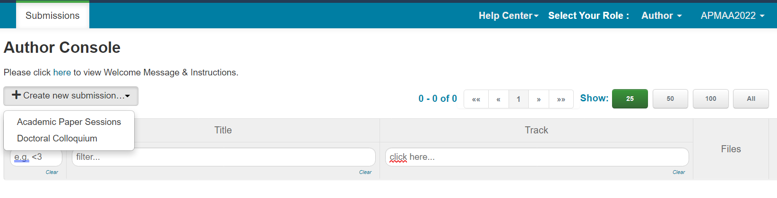

**The Publication Manual** offers guidance on choosing the headings, tables, figures, language, and tone that will result in powerful, concise, and elegant scholarly communication.

[Publication Manual of the American Psychological Association, Seventh Edition (2020) (apa.org)](https://apastyle.apa.org/products/publication-manual-7th-edition)

[Research Paper Format | APA, MLA, & Chicago Templates (scribbr.com)](https://www.scribbr.com/research-paper/research-paper-format/)

[**Sample Annotated Student Paper in APA Style**](https://apastyle.apa.org/style-grammar-guidelines/paper-format/student-annotated.pdf)

The following two sample papers were published in annotated format in the *Publication Manual* and are reproduced here for your ease of reference. The annotations draw attention to relevant content and formatting and provide users with the relevant sections of the *Publication Manual* (7th ed.) to consult for more information.

* [Annotated student sample paper (PDF, 2MB)](https://apastyle.apa.org/style-grammar-guidelines/paper-format/student-annotated.pdf)
* [Annotated professional sample paper (PDF, 3MB)](https://apastyle.apa.org/style-grammar-guidelines/paper-format/professional-annotated.pdf)

Also, URLs below offer sample papers in Microsoft Word (.docx) file format without the annotations.

* [Student sample paper (DOCX, 36KB)](https://apastyle.apa.org/style-grammar-guidelines/paper-format/student-paper.docx)
* [Professional sample paper (DOCX, 96KB)](https://apastyle.apa.org/style-grammar-guidelines/paper-format/professional-paper.docx)

**The single or double space between sentences** argument has been ongoing for decades. Traditional, pre-digital typesetting required the use of double-spacing after periods and colons. This was largely due to the limitations of now-antiquated technology and was the standard style taught by most schools until around 20 years ago. With the advent of digital printing, the need for double spaces isn't really a thing, anymore. But a lot of people still adhere to the practice. Even style guides don't universally agree. The latest editions of the [Chicago Manual of Style](http://www.chicagomanualofstyle.org/qanda/data/faq/topics/OneSpaceorTwo/faq0001.html) and [MLA](https://style.mla.org/number-of-spaces-after-period/) both suggest a single space. The [APA guidelines](https://owl.english.purdue.edu/owl/resource/560/24/) currently suggest two spaces, but even they have gone back and forth over the years.