
Asia-Pacific Management Accounting Association

APMAA NEWS: January 1, 2024, Issue

Contents
1. New Year Greetings from the APMAA Chairperson
2. 2024 Proposed APMAA Activities
3. Organizational Structure for 2024 APMAA
4. Commitments from 2024 APMAA Director Candidates
5. Insights from Head Leads of 2024 Teams and Local Chapters
6. Exploratory Essays and Articles

1. New Year Greetings from the APMAA Chairperson

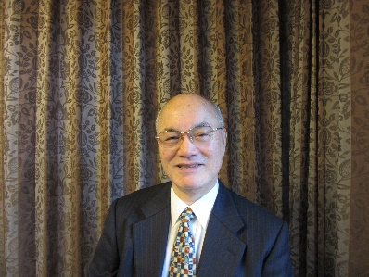

Susumu Ueno
ueno@konan-u.ac.jp,
Professor Emeritus, Konan University, Japan

Happy New Year to our vibrant APMAA community! May this year foster greater unity in knowledge, collaboration, and success.

As we embark on a new year, an exciting opportunity beckons! APMAA invites all members to propose ideas for a dynamic and impactful 2024.

Mark your calendars for APMAA 2024: a vibrant October 28-31 conference at the University of Economics & Business, Vietnam National University-Hanoi (VNU-UEB). This esteemed institution, VNU, founded in 1906 and boasting unique government collaboration, will provide the perfect backdrop for our shared knowledge exchange.

Your creativity is invaluable! We encourage you to propose engaging forums, seminars, and other events for APMAA 2024. Share this call with your colleagues.

Beyond the conference, even more awaits! Consider hosting webinars and seminars within your chapters. The APMAA platform and branding are here to support you, helping you attract renowned speakers and a global audience. I'm thrilled to announce the first webinar proposal, led by Dr. Farhana Begum from the Bangladesh Chapter – a testament to her chapter's initiative!

Your contributions are the cornerstone of APMAA's success. From shaping conference events to webinars and collaborative initiatives, your engagement will define our 2024 journey. Submit your chapter proposals, and let's work together to make this year a testament to pioneering achievements and enduring partnerships.

Thank you! Together, we'll make 2024 an unforgettable year for APMAA.
January 1, 2024
Asia-Pacific Management Accounting Association (APMAA) Official Site (s-ueno.sakura.ne.jp)



2. 2024 Proposed APMAA Activities
We are delighted to announce that the University of Economics & Business, Vietnam National University-Hanoi (VNU-UEB), will cohost the 2024 annual conference (APMAA 2024). The conference will occur from October 28 to 31, 2024. In addition to the meeting, local chapters will be hosting webinars during the year.
2-1. 2024 Annual Conference in Hanoi: October 28 to 31st, 2024
APMAA 2024 (Asia-Pacific Management Accounting Association) (s-ueno.sakura.ne.jp)

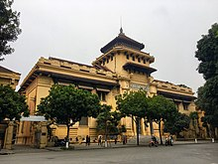

Greetings from the cohosting institution!

It is with great honor that we announce our cohosting of the 2024 Annual Conference of the Asia-Pacific Accounting Association, APMAA 2024, at Vietnam National University- Hanoi. Kindly mark your calendars for October 28 to 31, 2024, as we prepare for an exceptional gathering.
Our commitment is to create a dynamic conference, fostering continuous productivity and leaving an enduring impact on all participants. We are devoted to tailoring a program that meets the diverse needs and expectations of APMAA members worldwide. Please share your expectations and suggestions with Thuy Nguyen Thi Hong (nhthuykt@gmail.com; nththuy@vnu.edu.vn), the local lead for this conference.
Your support and participation play a pivotal role in shaping the success of the APMAA 2024 conference in Vietnam. We eagerly anticipate welcoming you this autumn!

Best regards,


Nguyen Thi Hong Thuy, Phd
Dean, Faculty of Accounting and Auditing

University of Economics & Business, Vietnam National University-Hanoi (VNU-UEB).
VIETNAM NATIONAL UNIVERSITY (vnu.edu.vn)
Contact persons at VNU (APMAA 2024)
Bui Phuong Chi (chibui@vnu.edu.vn)
Binh Vu (vuthebinh236@gmail.com), Linh Le (thuylinhlt@vnu.edu.vn)

Actions | Date Scheduled | Status | Person Assigned
Cohost proposal from VNU | November 2, 2019 | Accepted | Thuy
Apply APMAA2024 CMT site to Microsoft | December 10, 2023 | To Be Revised | Thuy
Zoom Meetings for Preparing a Call for Papers | Every week in Jan. 2024 | To Be Scheduled | Thuy
The first distribution of the Call for Papers | February 1, 2024 |  | Thuy
The first Issue of APMAA Conference News | March 1, 2024 |  | Thuy
VNU Home page opens | April 1, 2024 |  | Thuy
Training for gatekeepers and reviewers  (Reviewer's Guidelines, CMT operations) | Every other week in March and April |  | Thuy
Open the 2023 CMT submission site. | May 1, 2024 |  | Thuy
Deadline for manuscript submissions | July 15, 2024 |  | Thuy
Registration site opens | August 1, 2024 |  | Thuy
Last day of acceptance/rejection notification | September 1, 2024 |  | Thuy
Camera-ready paper submission deadline | September 15, 2024 |  | Thuy
Completion of Book of Abstracts | September 16, 2024 |  | Thuy
Registration deadline for accepted authors | September 16, 2024 |  | Thuy
Completion of a tentative program | October 5, 2024 |  | Thuy
Completion of proceedings | October 5, 2024 |  | Thuy
Rehearsals for presenters and all | October 17-19, 2024 |  | Thuy
Conference execution in Hanoi | October 28-31, 2024 |  | Thuy
Vietnam National University Team for Organizing APMAA 2024
Nguyen Thi Hong Thuy (nhthuykt@gmail.com), Vietnam National University
Bui Phuong Chi (chibui@vnu.edu.vn), Vietnam National University
Key Reminders:
Assign specific dates and persons as soon as possible.
Track progress regularly and update the table accordingly.
Communicate effectively with the Headquarters and stakeholders.


With a rich history beginning with the 1906 founding of the University of Indochina, Vietnam National University (VNU) stands as one of Vietnam's oldest and most prestigious institutions. Over the years, it has undergone various transformations, evolving from the Vietnam National University established in 1945 to the University of Hanoi in 1956. Finally, in 1993, VNU assumed its current form, encompassing the former University of Hanoi and other leading universities in the capital city. Today, VNU occupies a unique position within Vietnam's higher education landscape. As the nation's largest and most comprehensive university and research center, it operates under a special regulation granted by the Prime Minister. This unique status allows VNU to collaborate directly with government ministries, agencies, and local authorities on matters related to its mission.

VIETNAM NATIONAL UNIVERSITY (vnu.edu.vn)
https://english.ueb.edu.vn/INTRODUCTION/history/1835
List of universities in Vietnam - Wikipedia
Vietnam National University, Hanoi | Campus Tour | Ranking | Courses | Fees | EasyShiksha.com (youtube.com)

2-2. 2024 Webinars APMAA Webinars (2023, 2022, and 2021) (s-ueno.sakura.ne.jp)
Please explore the possibility of hosting webinars and seminars within your chapters. The APMAA platform and its branding are dedicated to supporting you and attracting distinguished speakers and a worldwide audience.

We're excited to share that we've received the inaugural 2024 webinar proposal below from Dr. Farhana Begum (farhanaju@yahoo.com) of the APMAA Bangladesh Chapter. The webinar, cohosted by the Bangladesh Accounting Association (Bangladesh Accounting Association (baa-bd.org), is scheduled for June 1, 2024.

2024 Asia-Pacific Management Accounting Association Webinar- Bangladesh Chapter
Theme: "ACCOUNTING FOR THE RAPIDLY CHANGING WORLD"
13:45 – 16.45 (GMT+6), June 1, 2024
(Media: Zoom)
This webinar provides an opportunity to engage with experts on the impact of a new horizon of innovations surrounding accounting education and the profession.
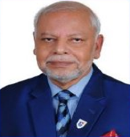
Prof. M. Harunur Rashid, Webinar Chair
President, Bangladesh Accounting Association


Dr. Farhana Begum, Webinar Cochair
APMAA Director, Bangladesh Chapter

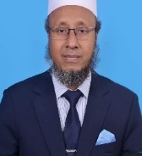
Md. Sayaduzzaman
General Secretary Bangladesh Accounting Association



3. Organizational Structure for 2024 APMAA
3-1. Regional Chapters (Prospective chapter servants)
The main tasks of the 2024 Chapter Leaders are (1) to expand the membership structure, (2) to elevate the APMAA brand and reputation, and (3) to promote the 2024 APMAA conference and webinars.
 | 2024 APMAA Chapter Leaders (tentative and provisional)
 | Chapter names | http://s-ueno.sakura.ne.jp/APMAA_asia/membership.htm.
 | APMAA Japan | Susumu Ueno (ueno@konan-u.ac.jp)  Shoichiro Hosomi (hosomi@tmu.ac.jp)  Masumi Nakashima (mnakashima@bgu.ac.jp)  Fumiko Takeda (takeda@tmi.t.u-tokyo.ac.jp)  Jaewook Kim (jaewookk@hiroshima-u.ac.jp)  Keita Tanahashi, (kt-tana@hue.ac.jp), Hiroshima University of Economics  Kohsuke Matsuoka (matsuoka@mail.tohoku-gakuin.ac.jp)
 | APMAA  Malaysia, South & Southeast Asia | Sofiah Md-Auzair (sofiah@ukm.edu.my), UKM, Malaysia  Normah Omar (normah.omar@gmail.com), UiTM, Malaysia  Nam Sang Cheng (nscheng@smu.edu.sg), Singapore  Tuan Mat, Tuan Zainun (tuanz693@uitm.edu.my), UiTM, Malaysia  Sharifah Norzehan Syed Yusuf (shari893@uitm.edu.my), UiTM, Malaysia
 | APMAA Indonesia | Sekar Mayangsari (sekar_mayangsari@trisakti.ac.id)  Grahita Chandrarin (grahitac@gmail.com), (grahitac@unmer.ac.id)  Mimba, Ni Putu Sri Harta (p.mimba@unud.ac.id)  Diana Zuhroh (diana.zuhroh@unmer.ac.id), Universitas Merdeka Malang
 | APMAA Vietnam | Nguyen Thi Phuong Dzung (phuongdung2311@gmail.com), Hanoi University of Science and Technology  Nguyen Thi Hong Thuy (nhthuykt@gmail.com), VNU  Bui Phuong Chi (chibui@vnu.edu.vn)  Nguyen Thi Huong Lien (liennth78@gmail.com), VinUniversity, Hanoi, Vietnam
 | APMAA Taiwan | Hsuan-Lien Chu (lien@gm.ntpu.edu.tw), National Taipei University  Bi-Huei Tsai (bhtsai@faculty.edu.tw), National Yang Ming Chiao Tung University
 | APMAA Thailand | Kanitsorn Terdpaopong (kanitsorn@rsu.ac.th)  Kanibhatti Nitirojntanad (kanibhatti@cbs.cula.ac.th)  Leela Tiangsoongnern (leela.tin@dpu.ac.th)
APMAA Korea |  | Sera Choi (srchoi@knou.ac.kr)
 | APMAA China | Yasheng Chen (yshchen@xmu.edu.cn), Xiamen University
 | APMAA Middle East and Africa | Elgammal Mohammed (m.elgammal@qu.edu.qa), Qatar
 | APMAA Bangladesh | Farhana Begum (farhanaju@yahoo.com), Ministry of Education
 | APMAA Oceania | Bulend Terzioglu (bulend.terzioglu@gmail.com), Australia
 | APMAA Europe | Wnuk-Pel Tomasz (tomwnuk@uni.lodz.pl), Poland  Gregory Wegmann (gregory.wegmann@gmail.com), France  Żaneta Kielanowicz (zaneta.kielanowicz@uni.lodz.pl), Poland  Robert C. Rickards (rrickards@hs-harz.de), Germany  Jan Kurt Alpenberg (jan.alpenberg@lnu.se), Sweden  Subačienė Rasa (rasa.subaciene@evaf.vu.lt), Vilnius University, Lithuania  Tamulevičienė Daiva (daiva.tamuleviciene@evaf.vu.lt), Vilnius University, Lithuania
 | APMAA America | Paul Scarbrough (pscarbrough@brocku.ca), Canada

3-3. 2023 Administration Teams

3-3-1. Conference Quality Control Team
The team's roles are (1) to develop the 2024 Call for Papers, Guidelines for Authors, and Guideline for Reviewers, and (2) to provide training for the CMT operation and construct the APMAA2024 CMT site. Furthermore, the team will run the APMAA 2024 and oversee its whole process, from organizing to executing. The team will gather at an online meeting monthly to achieve the roles above.

(Vietnam Team: APMAA2024) To be considered
APMAA 2024 (Asia-Pacific Management Accounting Association) (s-ueno.sakura.ne.jp)
Nguyen Thi Hong Thuy (nhthuykt@gmail.com), Vietnam National University
Bui Phuong Chi (chibui@vnu.edu.vn), Vietnam National University
Nguyen Thi Phuong Dzung (phuongdung2311@gmail.com), Hanoi University of Science and Technology
Nguyen Thi Huong Lien (liennth78@gmail.com, lien.nth@vinuni.edu.vn), VinUniversity, Hanoi, Vietnam
(Malaysia Team: APMAA 2025 ) To be considered
Normah Omar (normah.omar@gmail.com), Universiti Teknologi MARA
Tuan Zainun Tuan Mat (tuanz693@uitm.edu.my) Universiti Teknologi MARA
Sofiah Md-Auzair, sofiah@ukm.edu.my, National University of Malaysia (UKM)

3-3-2. (Half a day) Webinar Team To be considered
APMAA Webinars (2023, 2022, and 2021) (s-ueno.sakura.ne.jp)
The team develops "Guidelines for Organizing Webinars" and organizes 2024 webinars.
Farhana Begum (farhanaju@yahoo.com), Bangladesh
Mohammed Elgammal (m.elgammal@qu.edu.qa), Qatar
3-3-3. Membership Team To be considered
Membership of the Asia-Pacific Management Accounting Association (s-ueno.sakura.ne.jp)
Manage membership and APMAA funds. Issue a Certificate of Membership.
Sekar Mayangsari (sekar_mayangsari@trisakti.ac.id), Indonesia
Susumu Ueno (ueno@konan-u.ac.jp), Japan

3-3-4. APMAA NEWS and Homepage Editing Team To be considered
Publication (APMAA News, Conference News, Conference, APMAJ) (s-ueno.sakura.ne.jp)
Susumu Ueno (ueno@konan-u.ac.jp), Japan

4. Commitments from 2024 APMAA Directors
APMAA Key People, Asia-Pacific Management Accounting Association (sakura.ne.jp)

The Director plays a crucial role in molding the 2024 APMAA activities. Essential qualifications for the 2024 director position include being a 2023 member actively engaged in APMAA events, such as the annual meeting and webinars, and maintaining a strong attendance record at board meetings.

(Japan)
Susumu Ueno, ueno@konan-u.ac.jp, Konan University
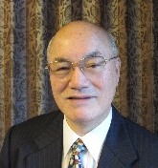
I will continue building a space that encourages academic discourse and solid bonds for APMAA members.

Shoichiro Hosomi, hosomi@tmu.ac.jp, Tokyo Metropolitan University

I am also a director of the Japanese Association of Management Accounting(JAMA), so I would like to continue promoting APMAA activities at JAMA and recruiting new members from Japan.

Masumi Nakashima, mnakashima@bgu.ac.jp, Bunkyo Gakuin University

I will serve as a director to increase the number of members and strengthen links with other academic associations.

Fumiko Takeda, ftakeda@keio.jp, Keio University

I will contribute to advancing excellence in accounting research and fostering collaborative research partnerships that empower professionals across the region to navigate dynamic business landscapes with cutting-edge practices and ethical integrity.

Jaewook Kim, jaewookk@hiroshima-u.ac.jp, Hiroshima University.
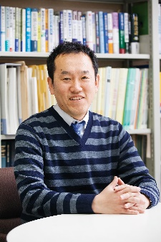
It is an honor to contribute as a member of APMAA in 2024, and I will do my best to develop APMAA.

Keita Tanahashi, kt-tana@hue.ac.jp, Hiroshima University of Economics
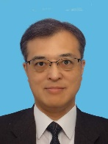
I'm committed to fostering an environment that nurtures scholarly discussions and fosters connections among our members.

Kohsuke Matsuoka (matsuoka@mail.tohoku-gakuin.ac.jp)

I am honored to be appointed as Director and look forward to contributing to the development of APMAA.

(Indonesia)
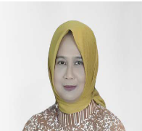
Sekar Mayangsari, sekar_mayangsari@trisakti.ac.id, Trisakti University
I am committed to strengthening and expanding APMAA's network and continue to support all APMAA activities.

Diana Zuhroh, diana.zuhroh@unmer.ac.id, Universitas Merdeka Malang

I am very proud to be part of an international community like APMAA. I hope to contribute to APMAA's mission to deliver knowledge, experience, friendship, and cooperation.

Grahita Chandrarin, grahitac@unmer.ac.id, University of Merdeka Malang

It is always great to actively participate in APMAA activities and expand its network, especially research collaboration and publication.

Ni Putu Sri Harta Mimba, p.mimba@unud.ac.id, Udayana University

I am committed to enhancing the involvement of young and senior international researchers in various APMAA activities. Have a sparkling and joyful New Year 2024🙏

(Malaysia)
Normah Omar, normah.omar@gmail.com. Universiti Teknologi MARA

I will help the Malaysian team organize and host the onsite APMAA Conference in 2025 and get new members from other Asian countries.


Sofiah Md-Auzair, sofiah@ukm.edu.my, National University of Malaysia (Universiti Kebangsaan Malaysia; UKM)
I will participate in reviewing the conference papers and assist as a discussant or mentor for the doctoral colloquium.

Tuan Zainun Tuan Mat, tuanz693@uitm.edu.my, Universiti Teknologi MARA

I will continue to enthusiastically engage and support the team to make this association an excellent place for academic discourse.

(Vietnam)
Nguyen Thi Hong Thuy, nhthuykt@gmail.com, Vietnam National University
The 2024 APMAA Conference in Vietnam is pivotal for strengthening bonds and expanding our cooperative endeavors. I eagerly anticipate the opportunity to enhance our partnership and contribute to shared success at this landmark event.

Nguyen Thi Phuong Dzung, phuongdung2311@gmail.com, Hanoi University of Science and Technology

Happy New Year! I hope 2024 brings you and your family lots of love, laughter, and success.

Nguyen Thi Huong Lien, liennth78@gmail.com, lien.nth@vinuni.edu.vn, VinUniversity, Hanoi, Vietnam


I am committed to closely coordinating with related parties to organize the conference successfully. Warmly welcome to the 2024 APMAA Conference in Vietnam!

(Poland)
Tomasz Wnuk-Pel, tomasz.wnuk@uni.lodz.pl, University of Lodz

I am planning to support APMAA activities in 2024 by attending the APMAA conference and webinars, and probably in 2025, together with my TARC friends, I will try to organize APMAA/TARC PhD colloquium in the similar way we did in 2023.

Żaneta Kielanowicz. zaneta.kielanowicz@uni.lodz.pl, University of Lodz

I plan to support APMAA's activity in 2024 by participating in APMAA webinars and conferences and disseminating information about them; in 2025, I also plan to link the Ph.D. colloquium organized as part of the next edition of TARC in Poland (similarly to what happened this year in Sweden).

(Taiwan)
Hsuan-Lien Chu, lien@gm.ntpu.edu.tw, National Taipei University

I will facilitate the distribution of APMAA information among Taiwanese scholars, actively encouraging their participation in the annual APMAA conference.

Bi-Huei Tsai, bhtsai@faculty.edu.tw, National Yang Ming Chiao Tung University

I will support the 2024 APMAA conference by promoting it in Taiwan.

(Thailand)
Kanitsorn Terdpaopong, kanitsorn@rsu.ac.th, Rangsit University
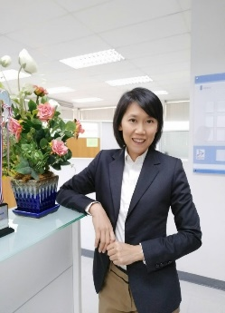
With my passion and experience in management accounting, I am eager to engage in and add value to our initiatives, fostering knowledge exchange and professional development in the region.

(Qatar)
Mohammed Mohammed Elmetw Elgammal, m.elgammal@qu.edu.qa, Qatar University

I will attend and support the 2024 conference and work with the webinar committee to ensure we have ongoing research activities in different APMAA chapters.

(Bangladesh)
Farhana Begum, farhana_postdoc@ru.ac.bd, DSHE, Ministry of Education

Devoted to amplifying and diversifying the APMAA network, I am eager to support all association activities and play a proactive role in expanding membership, enthusiastically taking on any tasks on behalf of the APMAA.

(Korea)
Sera Choi, srchoi@knou.ac.kr, Korea National Open University

I am dedicated to fostering an environment that promotes academic discourse and drives meaningful change for the advancement of APMAA.

(Singapore)
Nam Sang Cheng, nscheng@smu.edu.sg, Singapore Management University

Having been a member since 2011, I look forward to witnessing the continuous growth of APMAA and contributing as much as possible within my constraints.

(China)
Yasheng Chen, yshchen@xmu.edu.cn, Xiamen University

I will devote my effort to promoting management accounting research from the Asia-Pacific region and enhancing the global influence of APMAA.

(Australia)
Bulend Terzioglu, bulend.terzioglu@gmail.com, Central Queensland University

I will wholeheartedly continue to support APMAA's philosophy of fostering collegiality and solidarity among academics from diverse backgrounds in pursuit of academic excellence.

(Canada)
Paul Scarbrough, pscarbrough@brocku.ca, Brock University

I look forward to contributing to APMAA by assisting Professor Ueno with communications as needed, and by acting as a reviewer for the APMAA convention as well as submitting a paper to the convention.


(Sweden)
Jan Kurt Alpenberg, jan.alpenberg@lnu.se, Linnaeus University
I am supporting the continued growth of APMAA activities in 2024 by attending the APMAA conference and webinars. In 2025, together with my colleagues at the TARC network, we intend to organize an APMAA/TARC PhD-colloquium in a similar way we did in 2023.

(France)
Gregory Wegmann, gregory.wegmann@gmail.com, University of Burgundy

I will continue to support the APMAA association by participating in conferences and promoting its activities.

(Germany)
Robert C. Rickards, rrickards@hs-harz.de, German Police University

I shall publicize APMAA in Germany (and elsewhere in Europe) and continue to recruit new members (most recently from Russia and Ukraine).

5. Insights from Head Leads of 2024 Teams and Local Chapters

5-1. Messages from Webinar Team Head Leads
Mohammed Mohammed Elmetw Elgammal, m.elgammal@qu.edu.qa, Qatar University
I have brought substantial experience to the APMAA community since 2014. Over the years, I've consistently contributed to all annual conferences, steadfastly supporting diverse APMAA initiatives. I chaired the esteemed APMAA 2019 event in Doha and led the Webinar Committee, orchestrating impactful webinars for the past three years. However, my commitment transcends these achievements. I am focusing on closely collaborating with webinar committee members and driving ongoing research initiatives across diverse APMAA chapters. My dedication lies in fostering continuous growth and enhancing engagement within our APMAA community.

Farhana Begum, farhana_postdoc@ru.ac.bd, DSHE, Ministry of Education, Bangladesh
My journey with APMAA began with the first APMAA Webinar in 2020, and I organized a webinar in 2023. I will schedule another webinar in 2024; following that, I have committed to fortifying the APMAA network. I eagerly support all association activities and am enthusiastic about increasing membership and network outreach. I am ready to undertake any assigned tasks with dedication, which will remain the same for 2024. I aim to contribute effectively to the organization's growth and proactively advance APMAA's mission.
2024 APMAA Webinar Application Form (Send your proposal to ueno@konan-u.ac.jp)
Organizer (Chair and Cochair's names and their email addresses)
Webinar Date
Webinar Theme
Objective and target audiences
Webinar promotion tools (program and flyer), channels, and schedule
Sample Half-a-day Plan (6 speakers: 240 min= 5+100+30+100+5/or 4 speakers)
Opening (5 min): Welcome, Overview of the webinar theme and objectives
Session 1 (100 min: 5+30 +30+30)
Session theme and introduction by the Session 1 chair (5 min)
Speaker 1, Speaker 2, Speaker 3 (15 min. presentation, 10 min. discussion, 5 min. Q&A)
Break (30 min.)
Session 2 (100 min: 5+30 +30+30)
Session theme and introduction by the Session 2 chair (5 min)
Speaker 1, Speaker 2, Speaker 3 (15 min. presentation, 10 min. discussion, 5 min. Q&A)
Closing(5 min): Summary of the key takeaways from the webinar. Thank you and closing remarks.

5-2. Messages from the Local Chapter Head Leads

(Indonesia Chapter Head Leads)
Sekar Mayangsari, sekar_mayangsari@trisakti.ac.id, Trisakti University
Subject: Continuing Dedication to APMAA - Indonesia Chapter
My journey with APMAA commenced in 2012 during the Xiamen Conference in China, marking the inception of my commitment to promoting APMAA in Indonesia and beyond. As we approach 2024, my unwavering dedication to APMAA remains steadfast. I am fully devoted to supporting all APMAA initiatives, from advertising to hosting events and assisting in APMAA management affairs. I pledge to continue advocating for APMAA's growth and prominence within Indonesia, striving to bolster our chapter's contributions to the larger APMAA community.

Grahita Chandrarin, grahitac@gmail.com, grahitac@unmer.ac.id, University of Merdeka Malang

This year marks my 13 years of involvement at APMAA. In 2010, I was the only Indonesian participant at the APMAA Annual Conference in Taiwan. Indeed, it was a priceless experience. So far, my Indonesian colleagues and I have been involved in some APMAA activities, including the APMAA Annual Conference (2015, 2021, and 2023) and APMAA Webinar (2023). APMAA Webinar – Local Chapter is a pretty new program; however, APMAA Directors have responded positively to it, and I believe the Webinars have had good academic impacts on all of us.

(Taiwan Chapter Head Lead)
Hsuan-Lien Chu, lien@gm.ntpu.edu.tw, National Taipei University
I've been a member of the APMAA Board of Directors since 2015. I had the pleasure of hosting the 12th annual APMAA conference in Taiwan, and since then, I've been actively promoting APMAA in Taiwan. I'll continue to support all APMAA activities, personally distributing APMAA newsletters and Call for Papers and utilizing local academic accounting associations' mailing lists.

(Japan Chapter Head Leads)
Shoichiro Hosomi, hosomi@tmu.ac.jp, Tokyo Metropolitan University
I'm a dedicated APMAA member, attending every conference since 2011 (starting in Kuala Lumpur) and serving on the Board of Directors since 2014. My continued conference participation strengthens APMAA activities. As a JAMA director, I'll ensure ongoing APMAA promotion and membership recruitment. I will actively publish APMAA materials in Japanese professional journals and plan to invite Japanese researchers to the next APMAA conference. My commitment extends beyond attendance, driving APMAA's growth and impact through diverse channels.

Masumi Nakashima, mnakashima@bgu.ac.jp, Bunkyo Gakuin University
I have been a dedicated APMAA Board of Directors member since 2017. My goal is to enhance sustainable growth and collaboration in the APMAA community. To attain this goal, I have actively promoted the APMAA conference events and webinars to researchers in Japan, Europe, and the United States. I will also work with members of the Japanese accounting society, such as the Japanese Accounting Association (JAA), the Accounting and Economic Association of Japan (AEAJ), and the American Accounting Association (AAA) to increase the number of accounting professionals. I will continue to support all activities for the development of APMAA.

(Malaysia Chapter Head Lead)
Normah Omar, normah.omar@gmail.com. Universiti Teknologi MARA
As one of the founding members of APMAA, I am committed to helping the Malaysian team host the onsite APMAA Conference 2025 in Malaysia. Besides Universiti Teknologi MARA (UiTM), we will invite other local universities, such as Universiti Kebangsaan Malaysia (UKM) and Universiti Sains Malaysia (USM), to coordinate some events and activities. We will present our proposal at the forthcoming APMAA 2024 Conference in Vietnam. The proposal will include the conference theme, conference program as a special issue of the Asia-Pacific Management Accounting Journal (APMAJ) for selected papers from the conference. We will also invite new potential members from the Philippines and Pakistan to attend the APMAA Conference 2025.

6. Exploratory Essays and Articles

Paul Scarbrough, pscarbrough@brocku.ca, Brock University
Cheating! In North America, there has been a tidal wave of cheating related to COVID and distance "learning". However, I do not consider cheating itself to be the problem. Wide-spread cheating is a sign that students lack confidence in themselves and/or trust in the system. It is this lack of confidence that is the main problem. Cheating is just a symptom, and stopping cheating with controls does not target the main issue of lack of confidence. Because the current level of technology enabled "cheating" is new, I do not have a deep understanding of how to increase student confidence, however in the term starting in January, I am adding sessions of independent problem solving in an attempt to take some action on this. What I am doing is set up a study session where students will be asked to work difficult problems to completion and be able to revise and rework after seeing a solution. Yes, this is just what we think of as good study habits, but I think that some of the underlying study habits are not developed and this has led to the lack of confidence. It is just a guess, but worth a try.

Masumi Nakashima, mnakashima@bgu.ac.jp, Bunkyo Gakuin University, Japan

In the chaotic year 2023, when war rages in some parts of the world, we, the members of APMAA, would like to work together to disseminate our academic progress and take a step toward world peace. Though the power of each individual is small, teamwork with academic knowledge can transform the world.

APMAA News January 1, 2024 Issue (No.40)
Editor: Susumu Ueno (ueno@konan-u.ac.jp)
APMAA warmly encourages the submission of concise articles or essays limited to less than one page. We are keenly interested in well-researched accounting, management, professional ethics, and education features. Moreover, we enthusiastically welcome thought-provoking essays exploring topics of interest to our APMAA members.

Asia-Pacific Management Accounting Association (APMAA) Official Site (s-ueno.sakura.ne.jp)
History of APMAA Edited on December 30. 2022
APMAA's Journey Uploaded on November 13, 2023

2023 APMAA Events
Annual Conference: APMAA 2023, 2023 Bonference (s-ueno.sakura.ne.jp)
Webinars: APMAA Webinars (2023, 2022, and 2021) (s-ueno.sakura.ne.jp)

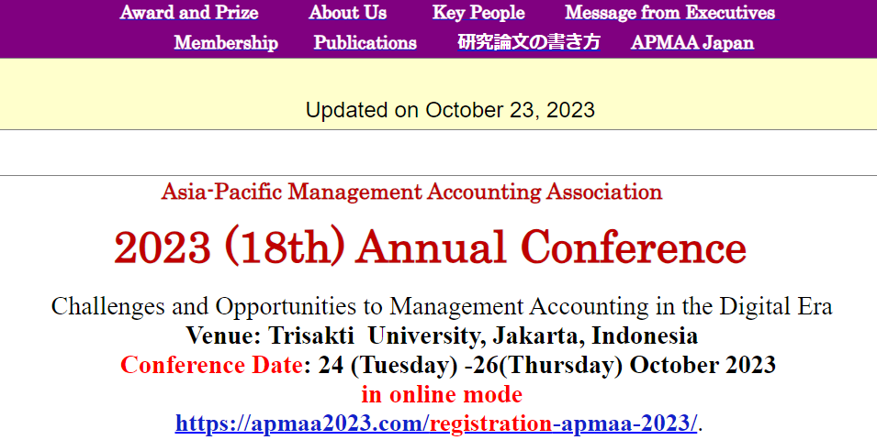

Organizing Team of the 2023 APMAA Annual Conference (24 -26 October 2023)
Head Office
Ueno, Susumu, ueno@konan-u.ac.jp (Professor Emeritus, Konan University, Japan), APMAA Board Chair
Indonesia Chapter
Mayangsari, Sekar, sekar_mayangsari@trisakti.ac.id (Trisakti University, Indonesia), APMAA 2023 Chair
Chandrarin, Grahita, grahitac@unmer.ac.id; grahitac@gmail.com (University of Merdeka Malang, Indonesia)
Mimba, Ni Putu Sri Harta, p.mimba@unud.ac.id (Udayana University, Indonesia)

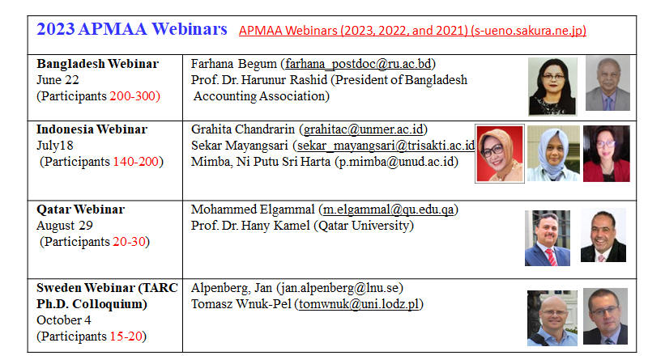
2023 APMAA Member List (2023 term: January 1, 2023 – December 31, 2023)

ISSN (Online): To be assigned
Published by:
Asia-Pacific Management Accounting Association (APMAA)
3-7-47 Shinjo-machi, Toyama-shi, Japan 930-0992
https://s-ueno.sakura.ne.jp/APMAA_asia/APMAA_publication.htm

