
APMAA January 4th Webinar – Emerging Issues in Corporate Communication & Health Accounting
Dear APMAA Colleague,
We are delighted to invite you to the 2026 Asia-Pacific Management Accounting Association (APMAA) Webinar – Bangladesh Chapter, themed “Innovation, Integrity, and Accountability in the Digital Age.”
Date: Sunday, January 4, 2026
🕒 Time: 11:00 AM – 2:30 PM (Bangladesh Standard Time)
📍 Mode: Hybrid (On-site + Zoom)
🏛️ Venue: Bangladesh Medical University, Shahbag, Dhaka 1000
💻 Zoom Link: https://bdren.zoom.us/j/91704613134
✅ Register now to secure your spot: https://forms.gle/XE8vT6A4GxWUxcqL8
Join Us for an Insightful Webinar: Corporate communication and health accounting are experiencing rapid transformation driven by digital technologies, artificial intelligence, and evolving stakeholder expectations. Organizations today face growing challenges related to transparency, data privacy, and financial sustainability. This webinar will explore innovative strategies, ethical considerations, and technological advancements shaping these fields in the digital era. Participants will gain valuable insights into emerging trends, moral dilemmas, and practical solutions for navigating the complexities of corporate and healthcare finance in the digital age.
Program Highlights
11:00 AM – 11:20 AM: Registration & Documentary: Beautiful Bangladesh
11:20 AM – 11:30 AM: Patriotic Song Presentation
11:30 AM – 11:35 AM: Welcome Speech – Prof. Dr. Farhana Begum
11:35 AM – 11:45 AM: Opening Speech – Prof. Emeritus Dr. Susumu Ueno, APMAA Board Chair
11:45 AM – 12:45 PM: Session 1: Integrity in Corporate Communication
Speakers:
Prof. Emeritus Dr. Normah Omar, CMA, Professor Emeritus, ARI, Universiti Teknologi MARA, Malaysia
Corporate Integrity at Workplaces
Prof. Dr. Masumi Nakashima, Professor of Accountancy, Bunkyo Gakuin University, Japan
Integrity in Corporate Communication: A Multidimensional AI Approach
Session Chair:
Prof. Dr. Mosaddak Ahmed Chowdhury, Professor, Department of Business Administration, Shahjalal University of Science and Technology, Sylhet, Bangladesh12:45 PM – 1:00 PM
Poster Presentation & APMAA Documentary (Lunch Break)
1:00 PM – 2:00 PM: Panel Session 2: Accounting for Health: This session explores emerging issues in health accounting, focusing on integrating technology to enhance financial management and decision-making in increasingly complex healthcare systems. Topics include accurate cost allocation, financial transparency, evolving regulations, and the use of data analytics, AI, and blockchain in streamlining budgeting, forecasting, and auditing. Panelists will address challenges related to rising care costs, reimbursement models, financial sustainability, and ethical issues, including patient data protection and the balance between profitability and quality care.
Panelists:
Prof. Dr. Md. Shahinul Alam, Vice Chancellor, Bangladesh Medical University, Dhaka
Prof. Dr. Shahzad Uddin, Professor of Accounting, Essex Business School, University of Essex, UK
Session Chairs:
Prof. Dr. Syed Abdul Hamid, Institute of Health Economics, University of Dhaka, Bangladesh
Prof. Dr. Mosaddak Ahmed Chowdhury, Department of Business Administration, Shahjalal University of Science and Technology, Sylhet, Bangladesh
2:00 PM – 2:15 PM: Best Poster Award Presentation
2:15 PM – 2:30 PM: Closing Remarks
Prof. Dr. Md. Abul Kalam Azad, Webinar Co-Chair, Pro Vice Chancellor, Bangladesh Medical University, Dhaka
Prof. Emeritus Dr. Normah Omar, CMA, Professor Emeritus, ARI, Universiti Teknologi MARA, Malaysia
Director, Asia-Pacific Management Accounting Association

For inquiries, please contact:
Prof./A Dr. Farhana Begum
📧 farhanaju05@gmail.com | farhanaju@yahoo.com
Organized by: APMAA Bangladesh Chapter in collaboration with the Bangladesh Accounting Association
About the Organizer: Dr. Farhana Begum is a recognized leader in accounting and management research. She serves as an Associate Professor at DSHE, Ministry of Education, Bangladesh, and as the Director of APMAA. With a PhD in Accounting and postdoctoral research funded by IsDB, she has earned global recognition, including the 2022 Womani Award from Cambridge IFA (UK). Her work spans leading international journals, and she actively contributes to professional bodies such as APMAA and the Bangladesh Accounting Association. Passionate about advancing management accounting, Dr. Farhana combines academic excellence with impactful research and leadership.

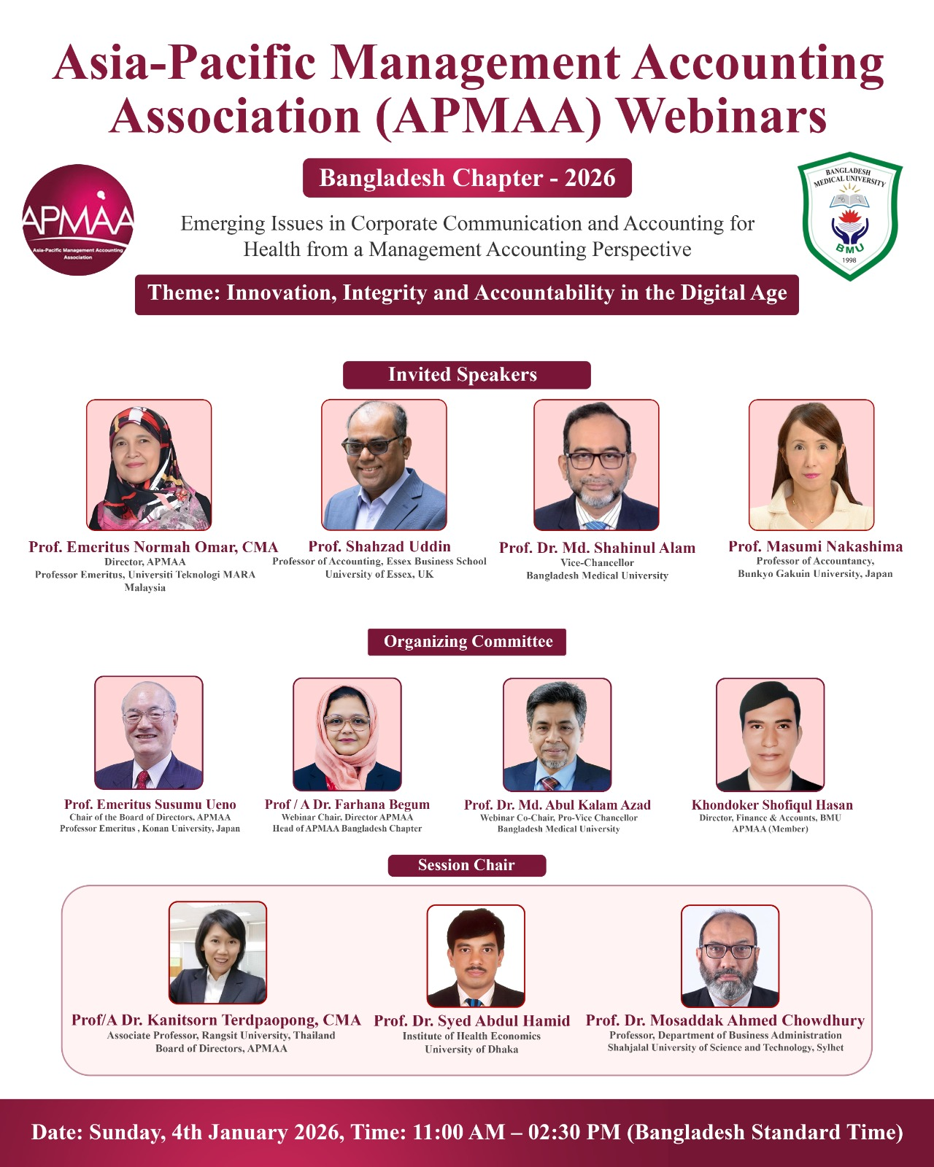

APMAA Bangladesh Chapter Webinars Report
APMAA (Asia-Pacific Management Accounting Association) webinars since 2021

June 22, 2023 Webinar
Theme: Management Accounting (Education) in the Resurgent Era: Role of Academics and Professionals
The inaugural Bangladesh Chapter webinar was held in collaboration with the Bangladesh Accounting Association (BAA), marking APMAA's first-ever webinar in Bangladesh.
Session 1: Chaired by Prof. Bhabatosh Banerjee - Featured speakers from ICMAB and the Indian Accounting Association on educational objectives and teaching quality.
Session 2: Chaired by Prof. M. Harunur Rashid - Speakers from Dhaka University and Birmingham University addressed management accounting education in the technology era.
Leadership: Prof. Harunur Rashid (Chair) and Dr. Farhana Begum (Co-chair).

June 1, 2024 Webinar
Theme: Accounting in the Changing Environment
Organized by APMAA Bangladesh Chapter with BAA and ICMAB.
Session 1: Chaired by Prof. Md. Salim Uddin - Topics on ESG disclosure and triple bottom line accounting.
Session 2: Chaired by Prof. Dr. S.M. Sohrab Uddin - Focused on international publication tips and fraud-detection models.
Participation: 200+ professors from 14 countries attended.
Leadership: Dr. Farhana Begum (Webinar Team Lead) and Prof. Dr. M. Harunur Rashid (BAA President).

