(Updated on July 5, 2021: Created on August 24, 2018, by S. Ueno)
Guidelines for the APMAA Annual Conference Paper Review
Information provided by the APMAA
http://apmaa.org/APMAA/index.htm
http://s-ueno.sakura.ne.jp/APMAA_asia/
Official Guide to APMAA 2021 (Annual Conference of the Asia-Pacific Management Accounting Association)

Contents:
1.The Mission and Role of the APMAA Paper Review Team
2. Reviewer Application Note: To the Volunteers
3. Registering to the CMT system: Creating your CMT account and logging in
4. Parallel-session paper review process with the CMT (pp.4-9)
5. Reviewer's Criteria for evaluation
6. Guidelines for Mentors of the APMAA Doctoral Colloquium
Appendix 1: Reviewing a CS conference paper (Stephen Mann, April 2009)
- The Mission and Role of the APMAA Paper Review Team
- The team's mission is to create a parallel session composed of three quality papers in a similar subject area.
- Gatekeeper's initial review checks a paper's academic format (organization, figures, references, etc.) and English.
- Reviewers' task is to provide information on paper quality to help Gatekeepers create a three-papers group for the parallel sessions. Do not demand authors too much! We are reviewing a conference paper (but not a journal paper).
- Detailed discussions of a presentation paper are the task of Discussants.
Visit and read Appendix 1: Reviewing a CS conference paper (Stephen Mann, April 2009).

People who attend the annual conference or consult our conference proceedings must be confident that the research results reported are honest and accurate and can be relied upon. The role of reviewers is to ensure the quality of conference papers.
The APMAA paper review team must ensure the integrity and reliability of the research manuscripts in the proceedings. There exist broad variations in quality (relating to contents, writings, etc.) among papers submitted to APMAA parallel sessions. Some papers are very good, i.e., may be at the level that a good scholarly journal will accept. On the other hand, some papers' quality and writing styles are far from good and hardly to say a scholarly paper.
Our reviewers, however, are not just scrutinizers, but rather, they are also facilitators. The role of reviewers is to help authors develop their work effectively. With a generous spirit, our reviews must provide authors constructive suggestions to improve their papers.
It is easy to do when the paper is good but is still desirable even when the paper is not. We know that many hours of work — in some cases, years of work —have been put into research and writing the paper we review. As honest reviewers of conference papers, please do your best to read papers with care and sympathy, even if a paper is bad.

Asia-Pacific Management Accounting Association Official Site
http://apmaa.org/APMAA/
Primary subject areas: Official Guide to APMAA 2021 (Annual Conference of the Asia-Pacific Management Accounting Association)

- How can you apply the Reviewer Volunteers? An Application Note

APMAA 2021 selects reviewers basically among the volunteers who submit an official Application Note to the Head Office. Therefore, please visit our Official Webpage, Asia-Pacific Management Accounting Association (APMAA) Offical Site (sakura.ne.jp), to learn about our association before you apply for the post.
The Application Note should include (1) (Prof. Dr. Given name; Family name), (Role: Reviewer and/or mentor), Email address, University name, Country, (2) Subject areas that you want to take on, and (3) a brief profile with a photo.
Select 2-4 subject areas you want to take on among the 15 areas listed on the Official Guide to APMAA 2021 (Annual Conference of the Asia-Pacific Management Accounting Association). We welcome your application to multiple subject areas and roles.
Please email the Application Note written in "Word" (shorter than one page) as an attachment to Prof. Ueno, Prof. Omar, and Prof. Mayangsari (to all) very soon. Note that the Head Office examines each candidate concerning his/her commitment and suitability as the Reviewer of rigorous scholarly papers.
APMAA 2021 uses the Conference Management Toolkit (CMT) that Microsoft Corporation provides to manage submitted papers. You will be added to the conference only if you complete a simple instruction written in the CMT invitation email.
Your name will appear in the "Reviewers List" of the APPMAA 2021 Program Book if you complete an assigned review.
-Reviewers: we encourage you to apply before May 30.
-Mentors of the Doctoral Colloquium: we encourage you to apply before June 30.
-Moderators and Discussants: we encourage you to apply before August 30. Note that we give reviewers and presenters a priority to serve as a moderator.
(Official) Application (Acceptance) Note
(Prof. Dr. Given name; Family name), (Role: Reviewer and/or mentor*), Email address, University name, Country.
Subject areas that I want to take on.
02. Cost management and Manufacturing Industries
03. Performance Management
Look at Official Guide to APMAA 2021 (Annual Conference of the Asia-Pacific Management Accounting Association)
Position, Affiliation, Country
Several-line (short) profile (or a profile URL) with your photo
-List your two published (first-author) papers in scholarly English journals
-We do not request your photo if you are a director of the 2021APMAA Board.
*A mentor is a person who friendly supports the doctoral student assigned by the Colloquium Chair to complete his/her presentation from an early stage after the paper submission. He/she works as a reviewer, a moderator, and one of the discussants. The CMT role of a mentor is "Reviewer." The mentor does not assign any paper to anyone. The Colloquium Chair (or moderator) sends the proceedings paper to the discussant designated by the Colloquium Chair.

- Registering to the CMT system: Creating your CMT account and logging in.
APMAA 2021 employs the Conference Management Toolkit (CMT) that Microsoft Corporation provides to manage submitted papers. As an author and/or a reviewer, please use the APMAA 2021 conference site on the CMT by creating your CMT account and logging in. You can do so at the page, https://cmt3.research.microsoft.com/APMAA2021/Submission/Index.
If you have no CMT account, please make it by registering your Email and Password at Conference Management Toolkit - Create New Account (microsoft.com). After then, log in to CMT with the account.
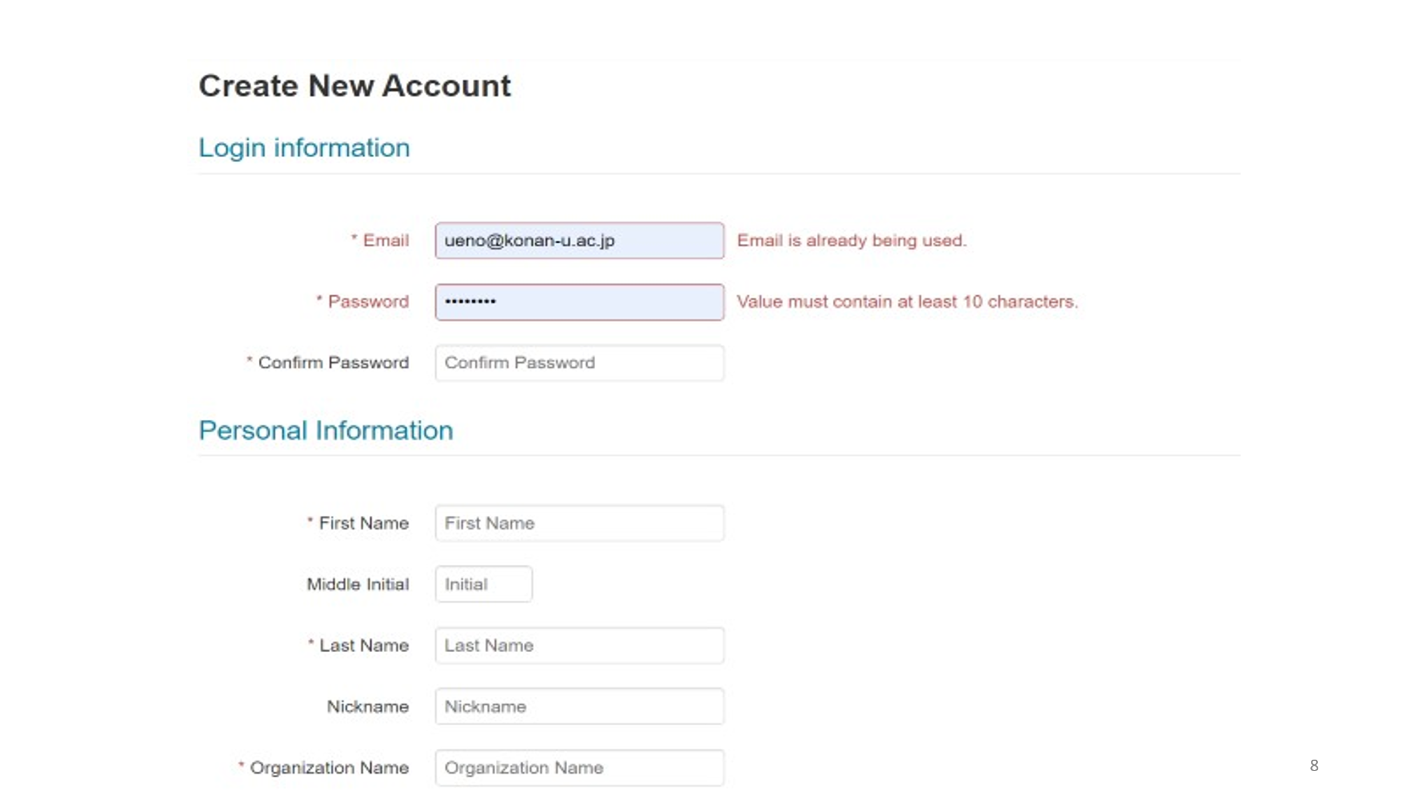
When we accept you as the potential APMAA paper reviewer, we will send you an invitation email via CMT. If you are not a registered CMT user, when you receive our invitation email, you will be directed to create your CMT account upon accepting. Note that you are a potential reviewer and can not serve before you complete all CMT processes.
Guidance about the CMT provided by the Microsoft Com.
Workflow Management | Microsoft Conference Management Toolkit Documentation
User Roles | Microsoft Conference Management Toolkit Documentation

From: susumu ueno
Sent: Saturday, May 22, 2021 7:56 AM
Subject: Expanding the recipients of the gatekeeper emails
The process of parallel session review on the CMT system is complex and requests us many skills, experience, and expertise to run it effectively. I have developed various materials and instructions and provided them to you. It is up to you to use these materials effectively to help your conference preparation.
Sharing my experience with you is very important. The biggest issue is to recruit competent and enthusiastic administration staff (5-10 persons), reviewers (30-50 persons), and gatekeepers (5-10 persons). Intensive training of them is also essential.

I hope the future annual conference organizers will start their preparation as early as possible, explicitly focusing on recruiting highly dedicated, enthusiastic, and talented persons.

- Parallel-session paper review process with the CMT
All submissions (contributions) are firstly assessed by the gatekeepers (Meta-Reviewer), who have sufficiently mastered the APMAA mission and paper review process for suitability for the presentations and proceedings. At the initial assessment, the gatekeepers make a professional judgment by skimming through the paper and checking writing (English and format), introduction, conclusion, and bibliography. Papers deemed suitable are then sent to an expert reviewer (s) to assess their scientific quality.

The flow of the parallel sessions review process is as follows:
- The Chief Gatekeeper (Review Team Chair: Senior Meta Reviewer) notifies Authors of the receipt of the paper via CMT email.
- The Chief Gatekeeper allocates a paper to the Meta Reviewer Console of a Gatekeeper.
- A Gatekeeper checks the paper's academic format (organization, figures, references, etc.) and English.
- If a paper fails to satisfy minimum standards, the Gatekeeper edits the "Desk Rejected" recommendation (around 100 words) at the Edit Meta-Review page and submit it.
- The Chief gatekeeper notifies, via CMT email, the corresponding Author of the "Desk Rejected" decision with the comments text of the Gatekeeper and recommends the authors a modification or withdrawal. Authors can resubmit a disk rejected paper to the CMT by July 15 after significant improvement. Also, inform the Author of availability of Author Feedback, "View Meta-Review" at the Author Console, by making "Requested For Author Feedback" to "yes" at the (Track) Chair Console.
- If a paper satisfies minimum standards (in original Submission or resubmission), the Gatekeepers assign a (one) reviewer using the CMT system and send a notice via CMT email (using a template prepared). Note that all evaluation and instruction are contained in the "Edit Review" page of the Reviewer Console of the CMT system.
- Assign only one Reviewer to each paper.
- Do not assign a paper to the Reviewer from Author's same Country.
- Do not assign a Reviewer more than two papers (maximum two papers).
- The Reviewer completes the "Edit Review" page, answering questions and writing descriptive comments and suggestions in the text box. After the review submission, the Reviewer notifies it to the Gatekeeper via CMT email.
- When the Gatekeeper received a "Submitted" notification from the Reviewer, send a Thank You letter to the Reviewer via CMT email.
- When the recommendation is "Minor Revision" or "Major Revision," the Gatekeeper notifies the Author of the review results via CMT email and asks an author to replace with the revision paper by August 20. Also, after making "Requested For Author Feedback" to "yes" at the (Track) Chair Console, inform the Author of availability of Author Feedback, "View Reviews" at the Author Console.
-Author uploads his/her revision (edited) paper, i.e., deletes the old file and uploads the new file at the files section of the Edit Submission page (Click Edit Submission at the Actions column. At the files section of the Edit Submission page, delete the old file and upload a new file. Then, save changes.)
- The Gatekeeper (or Reviewer) checks (reviews) a minor and major "revision (edited) paper that Author edited on the Author Console before August 20 (tentative). Reviewer updates Edit Review at the Reviewer Console and notifies it to the Meta-Reviewer (Gatekeeper).
- Gatekeepers edit the Meta-Review from his/her Meta-Reviewer Console and submit the Meta Review. Also, notify the Submission to the Senior Meta-Reviewer (Chief Gatekeeper) via CMT email.
- The Chief gatekeeper notifies an "Accepted" or "Rejected" decision with the Meta-Reviewer's comments text to the corresponding Author via CMT email by September 1. Also, after making "Requested For Author Feedback" to "yes" at the (Track) Chair Console, inform the Author of availability of Author Feedback, "View Meta-Review" and "View Reviews" at the Author Console.
Submission | Gate-keeper | Reviewer | Gate-keeper | Author | Gate-keeper | Reviewer | Gate-keeper | Chief
Awaiting Decision | Desk Rejected |  |  |  |  |  | Report |  | Rejected
Awaiting Decision | Assign Reviewer | Review Results | Major Revision | Resubmit | Assign Reviewer | Review Results | Report |  | Accepted/  Rejected
Awaiting Decision | Assign Reviewer | Review Results | Minor Revision | Resubmit | Confirm  revisions |  | Report |  | Accepted/
Awaiting Decision | Assign Reviewers | Review Results | Accepted |  |  |  | Report |  | Accepted

Author Feedback at the (Track) Chair Console:
Requested For Author Feedback (yes) at the (Track) Chair Console (Gatekeepers needs to be a track chair)
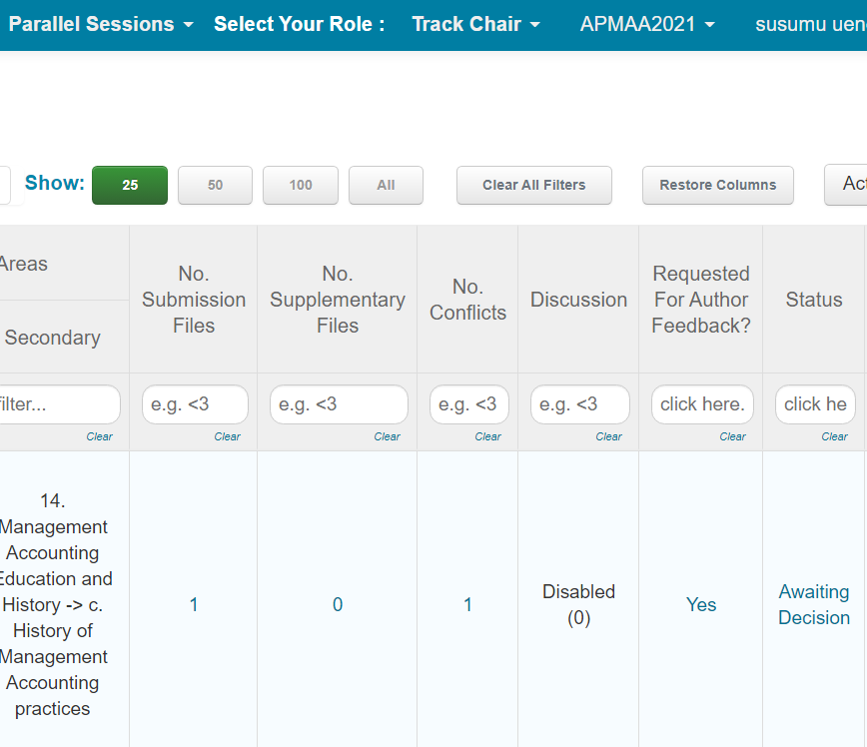

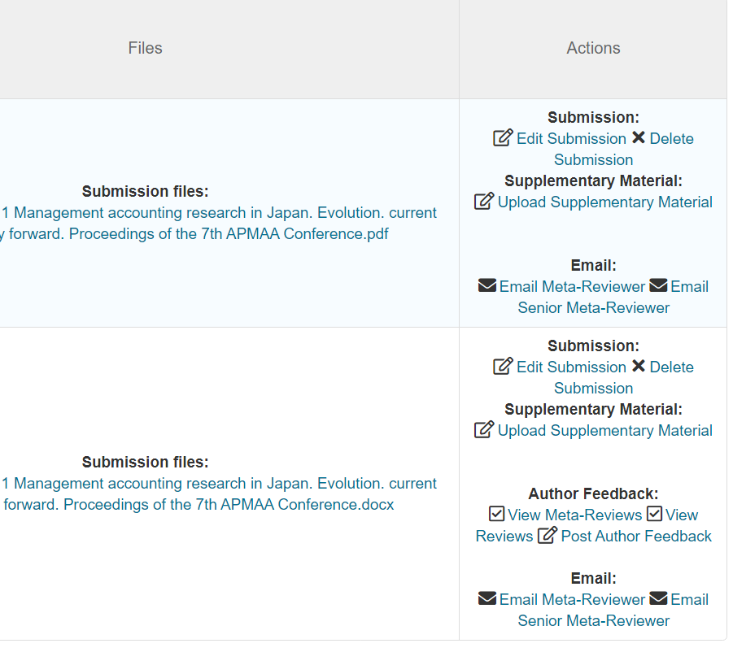
Author Feedback: "View Meta-Review" and "View Reviews" at the Author Console, after making Requested For Author Feedback to "yes" at the (Track) Chair Console
CMT review process for the Gatekeepers (Meta Reviewer Console/Track Chair console?)
Thank you for serving as the parallel session gatekeeper. Please visit the http://s-ueno.sakura.ne.jp/APMAA_asia/2021_Jakarta_Conference.1.htm and read the "Guidelines for the APMAA Annual Conference Paper Review" on the page before you engage in your work. Your comments and suggestions in the comments box are visible to authors after notification, visible to reviewers, visible to meta-reviewers. The length of the text should be 100 words or more and help authors to improve the paper. Please complete the first review process in three weeks after being assigned the review.
The review process on the CMT is as follows:
- The chief Gatekeeper allocates a paper to the Meta Reviewer Console of a gatekeeper.
- Gatekeeper assigns a Reviewer at the Meta Reviewer Console using the "Edit Assignments" function at Actions if the paper satisfies the minimum standards.
- Send an Assign Notification email to the Reviewer using the template (Notice of paper assignment to a reviewer) (Meta Reviewer Console→Actions→ more →Email Reviewers ).
Ask the Reviewer to edit his/her Enter Review page (at the Reviewer Console) and submit the page in two weeks.
- When Gatekeeper received a "Submitted" notification from the Reviewer, send a "Thank You" letter to the Reviewer by "Email Reviewers" (more, Action) at the Meta Reviewer Console.
- When the recommendation is "Minor Revision" or "Major Revision," the Gatekeeper notifies the Author of the review results via CMT email and asks the Author to replace with the revision (edited) paper by August 20. Also, after making "Requested For Author Feedback" to "yes" at the (Track) Chair Console, inform the Author of availability of Author Feedback, "View Reviews," at the Author Console.
- The Gatekeeper checks (confirms) an edited Minor Revision Paper uploaded before August 20 (tentative) when received a notice from the Author. About the edited Major Revision paper, assign the same Reviewer immediately.
- Gatekeeper edite the Edit Meta-Review page and submits the page. The text should be compact (but no less than 100 words) and sufficiently reflect the Reviewer's comments. Note that the comments of both Gatekeeper and Reviewer are visible to the Author at "View Meta-Review" and "View Reviews" of the Author Console (Author Feedback), after making "Requested For Author Feedback" to "yes" at the (Track) Chair Console.
(8) Gatekeeper sends a Thank You email to the Reviewer for his/her review support and cooperation (Action →more→Email Author, at the Meta Reviewer Console).
- After making "Requested For Author Feedback" to "yes" at the (Track) Chair Console, Chief Gatekeepers' email to the Author with the information of availability of Author Feedback, "View Meta-Review" and "View Reviews" at the Author Console.
- On September 1, make enable the "Author Notification."

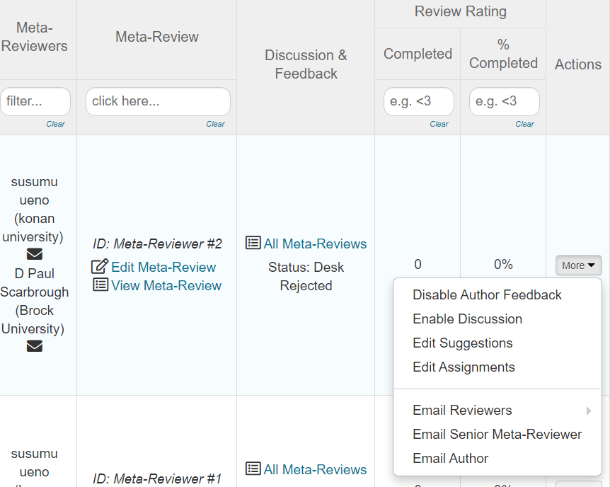

CMT review process for the Reviewers (Reviewer Console)
Thank you for serving as the parallel session reviewer. Please visit the http://s-ueno.sakura.ne.jp/APMAA_asia/2021_Jakarta_Conference.1.htm and read the "Guidelines for the APMAA Annual Conference Paper Review" on the page before you engage in your review work. Your comments and suggestions in the text box should be compact (but no less than 100 words) and help authors improve the paper.
APMAA 2021 uses the CMT platform. The review process is as follows:
(1) When Reviewer received a "Notice of paper assignment to a reviewer" from a Gatekeeper (Meta-Reviewer), visit Reviewer Console (CMT) and download the paper at Title Column.
(2) Send a "review" accept or reject note in a couple of days to the Meta Reviewer (Gatekeeper ) at Review & Discussion Column on your Reviewer Console.
(3) Edit your review on the Edit Review page by clicking Enter Review of Review & Discussion Column. After completing the Enter Review page, click Submit button. Please complete your review within two weeks.
(4) Please send a "Review Completed" note to the Meta Reviewer from Review & Discussion Column.
(5) When notified of the resubmission of the Major Revision Paper, the Reviewer updates Edit Review at the Reviewer Console and tells it to the Meta-Reviewer (Gatekeeper).

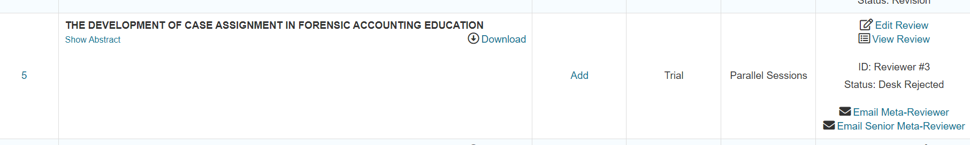
CMT process for the Author (Author Console)
The CMT process for an Author is as follows:
(1) Submit a paper from the Author Console. In your Author console, please select an appropriate subject area by checking a primary button at the bottom of the Edit Submission page. Check a secondary area button also when you find an additional relevant area.
(2) Being notified the receipt of the paper from the Chief Gatekeeper (Review Team Chair: Senior Meta-Reviewer) via CMT email.
(3) When the notice is Disk Rejected, the Author is informed an availability of Author Feedback, "View Meta-Review," at the Author Console from the Senior Meta Reviewer (Chief Gatekeeper). Authors can resubmit a revision paper to the CMT by July 15 after significant improvement.
(4) When notified "Minor Revision" or "Major Revision," the Author modifies the paper and replaces the old file with the revised (edited) file by August 20 (Click Edit Submission at the Actions column. At the file section of the Edit Submission page, delete the old file and upload a new file. Then, save changes.). Also, notify the editing to the Meta-Reviewer. When editing, please refer to the Author Feedback, "View Reviews" from the Author Console.
(5) Author receives an "Accepted" or "Rejected" notice from the Chief gatekeeper and, also, is informed of the availability of Author Feedback, "View Meta-Review" and "View Reviews" at the Author Console.
(6) When received the "Accepted" decision, the Author must edit and submit a "Proceedings Paper" and make the "conference registration" by September 15.

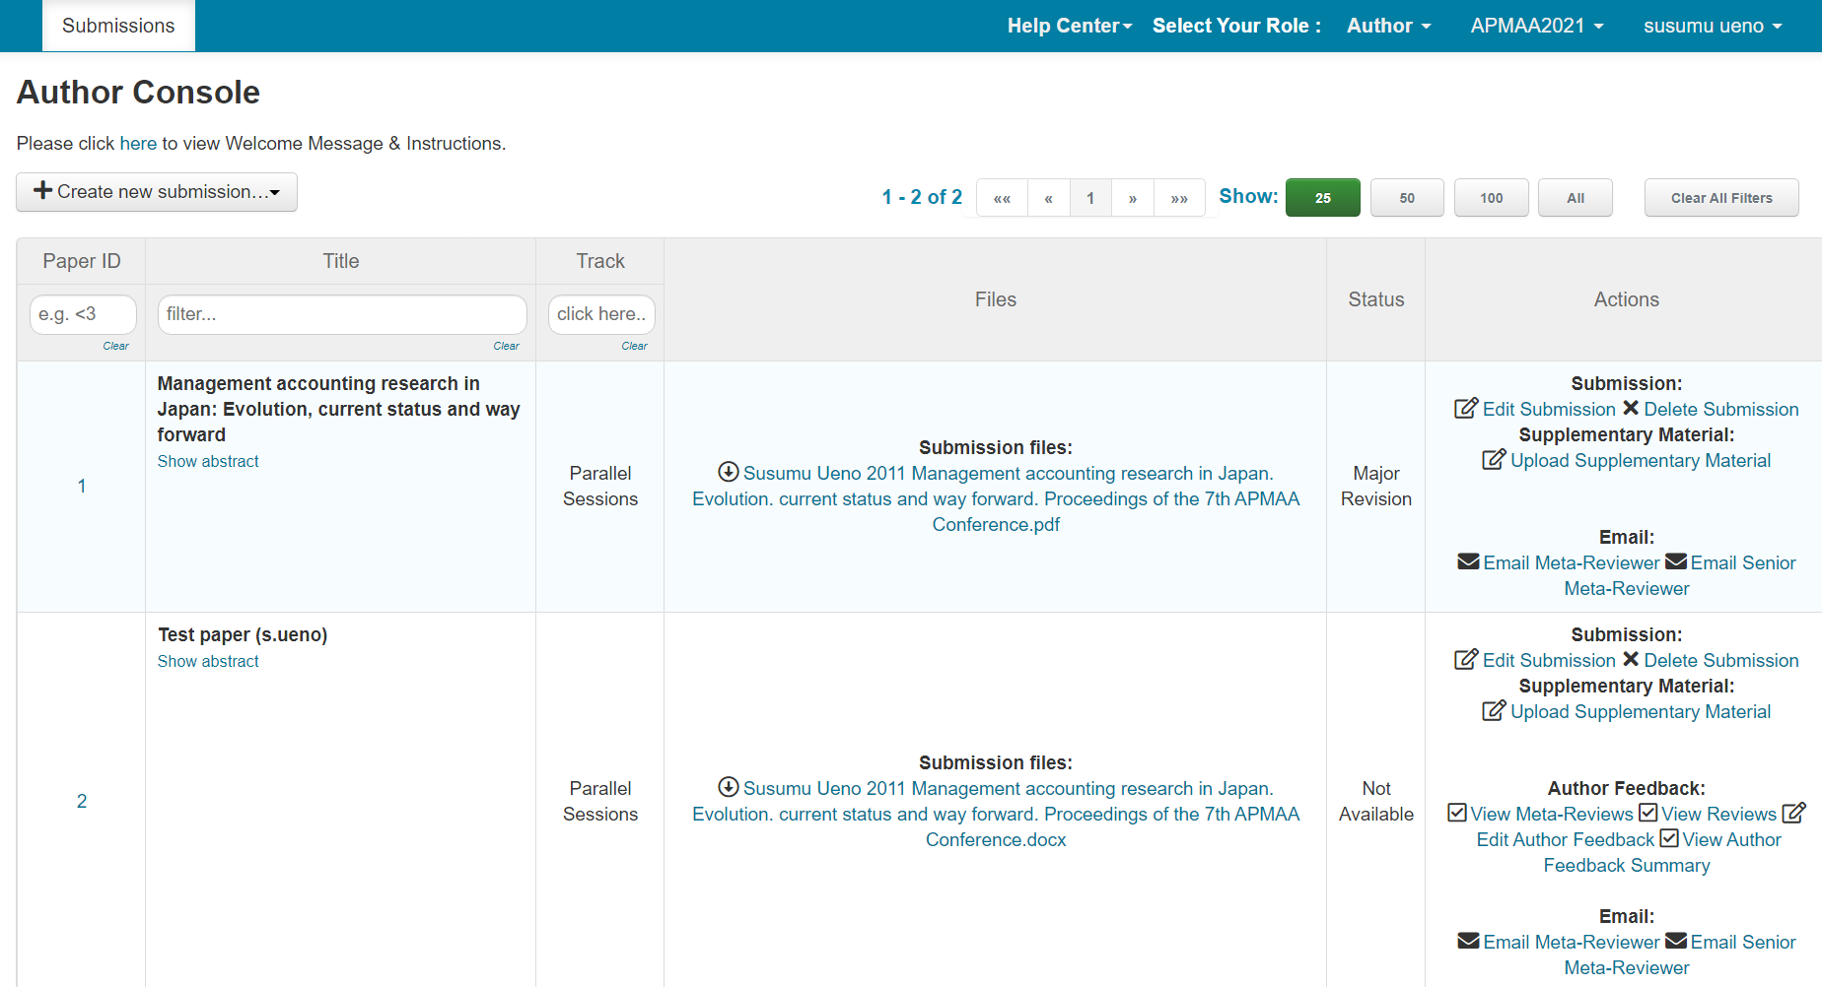
Note that Gatekeepers and the Chief gatekeeper are jointly responsible for the final decisions regarding the acceptance or rejection of manuscripts. The last review report notified to authors is edited by the Chief gatekeeper.

(CMT template) Notify (all) authors of the receipt of the first submission paper sent from the Chief Gatekeeper
Receipt of Manuscript (sent by the (Chief) Gatekeeper and Doctoral Colloquium chair)

Dear Dr. (Mr.Ms){Recipient.Name},

We are pleased to notify you that we received your manuscript, Paper ID: {Submission.Id} {Submission.Title}, submitted on {Submission.CreateDate}. We will inform you of our review result by September 1, 2021.

Best regards,

Prof. Dr. Susumu Ueno
APMAA 2021 Review Team Chief Gatekeeper
ueno@konan-u.ac.jp

(CMT template) Notice of paper assignment to a gatekeeper from the Chief gatekeeper

Notice of paper assignment to the Gatekeeper

Dear Gatekeeper, {Recipient.Name},

I assign you the manuscript, Paper ID: {Submission.Id} {Submission.Title}, submitted on {Submission.CreateDate}. Please visit the Meta-Reviewer Console of the CMT system and get this manuscript at “Actions” on the console.

A Gatekeeper checks a paper's academic format (organization, figures, references, etc.) and English. When the paper satisfies minimum standards, please assign a (one) reviewer in the latest "Reviewer List" and notify the assignment to him/her (using the email template prepared by Prof. Ueno). Ask him/her to return the review results (via CMT system) in two weeks. I expected you to complete "Edit Meta-Review" (in Meta-Reviewer Console) and notify it to me within three weeks from today.
(Notes)
-Assign only one Reviewer to each paper.
-Do not assign a paper to the Reviewer from Author's same Country.
-Do not assign a Reviewer more than two papers (maximum two papers).

For a more detailed review process on the CMT, please visit the "Guidelines for APMAA 2021 Annual Conference Paper Review" on the webpage http://s-ueno.sakura.ne.jp/APMAA_asia/2021_Jakarta_Conference.1.htm. Thank you.

Best regards,

Prof. Dr. Susumu Ueno
Ueno@konan-u.ac.jp
Chief Gatekeeper, APMAA 2021 Review Team

(CMT template) Notice of paper assignment to a Reviewer from the Gatekeeper
-Assign only one Reviewer to each paper.
-Do not assign a paper to the Reviewer from Author's same Country.
-Do not assign a Reviewer more than two papers (maximum two papers).
We assign a reviewer listed in the "Reviewers List" because we value their expertise. But we recognize that he/she has other commitments, and sometimes the timing is infeasible. Ask him/her to respond to the invitation very soon. The delaying response has an impact on the time of a review team decision. Accepting implies that the Reviewer will be able to deliver review results within the allotted time. If the Reviewer is willing to review but cannot do so by the due date, please let him/her ask the review team (Gatekeeper) for a reasonable extension.
Notice of paper assignment to a reviewer (from the Gatekeeper)

Dear Reviewer Prof. Dr.{Recipient.Name},

I'd like to ask you to review the manuscript, Paper ID: {Submission.Id} {Submission.Title}, submitted on {Submission.CreateDate}. Please visit the CMT system and choose the reviewer role and open the Reviewer Console to get this manuscript.

Please edit your review report at the CMT Reviewer Console (Enter Review) and submit it there in 2 weeks. There is a set of questions for you to reply to. We expect, in the comments box on the Edit Review page, your text of 100 words or more that encourages authors to improve the paper.

Gatekeeper's initial review roughly checked the paper's academic format (organization, figures, references, etc.) and English. Your task as a Reviewer is to provide information on paper quality to help Gatekeepers create a three-papers group for the parallel sessions. Do not demand authors too much! We are reviewing a conference paper (but not a journal paper).

Please notify me in a couple of days if you can take this review. If the manuscript is not your area, please let me know soon to assign it to another reviewer.

APMAA 2021 uses the CMT platform. The review process is as follows:
(1) When you (Reviewer) received a "Notice of paper assignment to a reviewer" from a Gatekeeper (Meta-Reviewer), visit Reviewer Console (CMT) and download the paper at Title Column.
(2) Send a "review" accept or reject note in a couple of days to the Meta Reviewer (Gatekeeper ) at Review & Discussion Column on your Reviewer Console.
(3) Edit your review on the Edit Review page by clicking Enter Review of Review & Discussion Column. After completing the Enter Review page, click Submit button. Please complete your review within two weeks.
(4) Please send a "Review Completed" note to the Meta Reviewer from Review & Discussion Column.
(5) When notified of the resubmission of the Major Revision Paper, the Reviewer updates Edit Review at the Reviewer Console and tells it to the Meta-Reviewer (Gatekeeper).

For a more detailed review process on the CMT, please visit the "Guidelines for APMAA 2021 Annual Conference Paper Review" on the webpage http://s-ueno.sakura.ne.jp/APMAA_asia/2021_Jakarta_Conference.1.htm. I would appreciate your support. Thank you.

Best regards,

Prof. Dr. Susumu Ueno
APMAA 2021 Review Team gatekeeper
ueno@konan-u.ac.jp

5. Reviewer's Criteria for evaluation: Excerpt from https://www.icahdq.org/members/group_content_view.asp?group=186109&id=633473
1. Originality of ideas/approach and level of innovativeness
When evaluating this criterion, please consider the following questions to make an assessment:
-Are the ideas advanced in - the paper actually new?
-If conceptual, does the paper expand our understanding of a new domain?
-Does the paper introduce new constructs or concepts that broaden our ideological understanding?
A replication study involves repeating a study using the same methods but with different subjects and experimenters. The researchers will apply the existing theory to new situations to determine generalizability to different subjects, age groups, races, locations, cultures, or any such variables.

2. Quality of theoretical argument
Does the paper address a theoretical or empirical problem? When evaluating this criterion, please consider the following questions to make an assessment:
-Does the paper present a clear, precise and complete review of relevant literature?
-Does the theoretical argument engage the conceptual/ empirical investigation appropriately?
-Does the paper involve the relevant literature?

3. Quality of empirical or conceptual design
If the paper is EMPIRICAL, please consider the following questions:
-Are the methods used to collect and analyze data appropriate to the research questions asked?
-Are the data collection and analysis methods clearly explained and without major flaws?
If the paper is CONCEPTUAL, please consider the following questions:
-Do(es) the Author (s) provide a clear argument for why it is important to discuss, define, and/or question specific concepts, models, and/or ideas?

4. Quality of development and support for the propositions/hypotheses
If the paper is EMPIRICAL, please consider the following questions:
-Does the paper establish a clear link between theory and evidence?
-ONLY FOR FULL PAPERS: Does the Author conclude beyond what the data support?
If the paper is CONCEPTUAL, please consider the following questions:
-Does the paper develop adequate and innovative propositions to clarify, define, and question core concepts in a field and/or to develop a new theory or perspective?

5. Presentation: Coherence and clarity of structure and thought
When evaluating this criterion, please consider the following questions to make an assessment:
-Are relevant terms and concepts explained?
-Does the paper have a clear line of argument?
-Does the paper use accessible and understandable language?

6. Contribution to theory building
When evaluating this criterion, please consider the following questions to make an assessment:
-Does the paper discuss possible implications for the new theory?
-Does the paper clearly spell out its own original theory contribution?

It is the responsibility of authors to ensure that submissions satisfy the formatting requirements below.
Formatting Requirements (Guidance to Authors)
- The official language of APMAA 2021 is English in both writing and presentation. If English is not your mother tongue (first language), check your draft using a professional editor and/or with a spelling and grammar matching application such as Grammarly before submitting your manuscript. (Actually, do the same even if English is your mother language!) You can download a free version on a webpage and install it on your PC. If your document is hard to read, we will decline before sending it to our Reviewer (Desk Reject).
- Manuscripts should follow the structure of a traditional research paper, i.e., you will need to adjust your document to the academic format. An empirical research paper's typical organization is as follows; Title, Abstract, Introduction, Literature Review, Methodology, Results, Discussion, Conclusion, and References (APMAA Conference proceedings paper (camera-ready paper) format: proceedings papers (sakura.ne.jp)).

- Manuscripts should be written in Times New Roman font with font size 12, page size A4, single-spaced with an abstract of 200-300 words, and five keywords. The abstract should be on a separate page immediately preceding the text.
- Manuscripts should be as concise as the subject and research method permits. The length of the text should be over 5,000 but usually not exceed 10,000 words.
- To promote anonymous review, authors should not identify themselves directly or indirectly in their writing.
- Single authors should not use the pronoun "we." Referencing should follow the APA style (http://www.apastyle.org).
- The cover page should contain the title of the paper (all bold capitals), the Author's name (first name, initial(s), and family name), title and affiliation, email address, and phone numbers.
-----------
Each Author who registers for the conference is limited to two (2) full paper submissions (including co-author papers) for the parallel sessions.

Reviewer's report to the Gatekeeper edited by the Reviewer
Please use "Edit Review" of the Reviewer Console, the CMT when you edit and send your review results to your Gatekeeper,
Reviewer's report to the Gatekeeper (edited by the Reviewer)
(This report is in "Edit Review" of the Reviewer Console, the CMT)

Dear Gatekeeper, {Recipient.Name},

I have read the manuscript, Paper ID: {submission.Id} {Submission.Title}, submitted on {Submission.CreateDate} and recommend that it should be (Please choose only one and delete others.)
_____ Accepted without change.
_____ Minor Revision and resubmission required before ACCEPTANCE
_____ Major Revision and resubmission required before ACCEPTANCE
_____ Rejected
My recommendation is based on the following:
1. Is the paper structured in an academic format (Abstract, Introduction, Literature Review, Methodology, Results, Discussion, Conclusion, and References)? YES / NO
2. Is the paper written in clear and correct English? YES / NO
3. Is the abstract (with the title of the paper) specific and concise, yet indicative of the scope of the paper? YES / NO
4. Does the paper confirm existing information? YES / NO
5. Are the analytical techniques sound? YES / NO
6. So far as you can see are the numerical data accurately computed? YES / NO
7. Are all the table well-presented and necessary? YES / NO
8. Are the conclusions paper justified by the results or arguments presented? YES/NO
9. Are references to sources of ideas and information adequately cited
and acknowledged? YES / NO
10. Does this paper attempt to make a conceptual advance? YES / NO
Please describe your comments and suggestions below (100 words or more).
-Note that we will send the authors your comments and suggestions. Provide comments and suggestions in 100 words or more that help authors to improve the paper.

-Gatekeeper must create and record the quality ranking, per each accepted paper, to group a three-papers for a parallel session. We organize the group by focusing on similarity in theme and paper quality, presenter's time zone and culture (country diversity).
When your recommendation is "accepted," please evaluate the paper quality using the word below.
Excellent: Journal of Management Accounting Research Level
Good: Asia-Pacific Management Accounting Journal level
Average:
Marginal: The paper has minor flaws still.

Best regards,
Susumu Ueno (Reviewer of Paper ID. 38)
ueno@konan-u.ac.jp

Five Types of Decision Results: Disk Rejected, Accepted, Minor Revision, Major Revision, or Rejected recommendation
Desk Rejected
A Gatekeeper checks the paper's academic format (organization, figures, references, etc.) and English. When the paper fails to satisfy minimum standards, the Gatekeeper recommends "Desk Rejected" to the Chief gatekeeper with the review report that includes his/her comments and constructive suggestions. Authors can resubmit a Disk Rejected paper by July 15 after significant improvement.
Accepted
Reviewers rarely choose this option in the first round. This option should only be chosen if the Reviewer is completely satisfied with all aspects of the paper and no improvements can be made.
Minor Revision
A Reviewer recommends Minor Revision if the paper's contributions and methods are clear and the paper is close to the "Accepted." Typically, a minor revisions recommendation implies that the Reviewer has only "suggestions" (i.e., not "deal breaker") comments. Recommending a minor revision implies that the Reviewer does not feel s/he needs to see a revised and resubmitted manuscript to check anymore.
Major Revision
"Major Revision" should be considered if the paper might be acceptable with significant changes. An author who received a "Major Revision" notification can submit a revised version by August 20 (tentative).
Rejected
Reviewers recommend "Rejected" if Revision is unlikely to resolve the major shortcomings in the paper. An author, who received a "Rejected" notification, does not obtain the presentation opportunity at the 2021 parallel sessions.

(CMT template) "Desk-Rejected" Notification (edited by the Chief gatekeeper)
"Desk-Rejected" Notification (Chief gatekeeper)
Dear Dr.{Recipient.Name},
Thank you for your manuscript submission to the APMAA 2021 Parallel Sessions. We regret to notify you that your manuscript, Paper ID {Submission.Id} {Submission.Title}, submitted on {Submission.CreateDate}, is not accepted for the 2021 Parallel Sessions. It does not satisfy our standards concerning the structure of a research paper (the academic format) and/or readability.
About the reviewer' comments, Author Feedback is available at "View Meta-Review" of your Author Console. Note that we could review your revised manuscript if you resubmit it by July 15 after significant modification.
We welcome your participation in the 2021 Doctoral Colloquium and Conference as an attendee. Thank you.

Best regards,
Prof. Dr. Susumu Ueno
APMAA 2021 Parallel Session Review Team Chair
ueno@konan-u.ac.jp

(CMT template) "Withdrawn" Notification (edited by the Chief gatekeeper)
"Withdrawn" Notification (from the Chief gatekeeper)
Dear Dr.{Recipient.Name},
We confirm the withdran of your manuscript Paper ID {Submission.Id} {Submission.Title}, submitted on {Submission.CreateDate}.
We welcome your participation in the 2021 Doctoral Colloquium and Conference as an attendee. Thank you.

Best regards,
Prof. Dr. Susumu Ueno
APMAA 2021 Parallel Session Review Team Chair
ueno@konan-u.ac.jp

"Awaiting Decision" notification (from the Chief gatekeeper)
" Awaiting Decision " notification (from the Chief gatekeeper)
Dear Dr.{Recipient.Name},

We confirm that your manuscript Paper ID {Submission.Id} {Submission.Title}, submitted on {Submission.CreateDate} is under the review process. Please wait for a while until we receive a recommendation from our Reviewer. Thank you.

Best regards,
Prof. Dr. Susumu Ueno
APMAA 2021 Parallel Session Review Team Chair
ueno@konan-u.ac.jp

A case of very lenient review standards is applied (a double standard case: Marginal paper)
APMAA must think about appropriate international representation in the list of presenters. Therefore, we intentionally apply very lenient standards to some submissions, mostly from developing countries. We believe this very lenient treatment provides an opportunity for them to develop the knowledge and skills to mature as scholars in the international sphere.
Desk Rejected →Major Revision
Add the "references" section. The topic of the paper is interesting. However, this paper needs to be re-edited and elaborated. The overall clarity and English of the paper are much improved by using professional editing services.

"Accepted" recommendation report (Edited by a gatekeeper→send to the Chief gatekeeper)
The Gatekeeper must create and record the quality ranking, per each accepted paper, to group a three-papers into a parallel session. A parallel session is organized by similarity in theme and paper quality, presenter's time zone, and culture (from different countries). The paper quality ranking is as follows:
Excellent: Management Accounting Research Level
Good: Asia-Pacific Management Accounting Journal level
Average:
Marginal: The paper has minor flows still.
In your "Accepted" recommendation (report) to the Chief gatekeeper, please clearly address the quality of each paper (in ranking). Keep in mind that the information is critical to the gatekeeper team, who builds a parallel session (of a three-papers group). Read and evaluate each assigned paper carefully. Here is a reminder on what to bear in mind when evaluating a research article:
- Research question 2) Sample 3) Control of confounding variables 4) Research designs 5) Criteria and criteria measures 6) Data analysis 7) Discussion and conclusions 8) Ethics.

How to create a parallel session of three papers

We create a parallel session of three papers, focusing on the similarity in paper theme (subject area) and quality, presenter's time zone and culture (from different countries), and others.

Each Gatekeeper must create and record the quality ranking, per each accepted paper, to organize a three-papers parallel session. Paper quality is ranked as follows:
Excellent: Management Accounting Research Level
Good: Asia-Pacific Management Accounting Journal level
Average:
Marginal: The paper has minor flaws still.

(CMT template) "Accepted" notification (Edited by the Chief gatekeeper)
Accepted notice (from the Chief gatekeeper)

Dear Dr. {Recipient.Name},

We are pleased to notify you that your manuscript, Paper ID: {Submission.Id} {Submission.Title}, submitted on {Submission.CreateDate} is accepted as a parallel session paper. Your presentation (paper title, names of authors, affiliations) will be announced in the conference program book.

About the reviewer' comments, Author Feedback is available at "View Meta-Review" and "View Reviews" at your Author Console. Please take into consideration these when you develop your proceedings paper (camera-ready paper).

Note that you will lose the opportunity of your presentation at the APMAA 2021 if you do not pay the participation fee until September 15 and if you do not submit a proceedings paper before September 15. At least one of the main authors needs to register for the conference by September 15 and present the work at the corresponding session. Thank you.

Best regards,

Susumu Ueno (APMAA 2021 review team chair)
ueno@konan-u.ac.jp

Minor Revision and Major Revision notice (Edited by the Gatekeeper)
An author, who received a "Major/minor revision" notice, is required to polish the paper and resubmit a revised version by August 20 so that the organizer can finish the review and notifies him/her of the "Acceptance" Decision by September 1.

"Minor Revision" notice (edited by the Gatekeeper)

Dear Dr.{Recipient.Name},

We notify you that the review results of your manuscript, Paper ID {Submission.Id} {Submission.Title}, submitted on {Submission.CreateDate}, is "Minor Revision." Minor Revision implies that the Reviewer does not feel she/he needs to see a revised and resubmitted manuscript to review anymore.

Author Feedback is available at "View Reviews" at your Author Console about the Reviewer's comments. Please modify your paper by August 20 by referring to the Author Feedback, "View Reviews," from the Author Console. To upload your revision paper, delete the old file and upload the new file at the files section of the Edit Submission page (Click Edit Submission at the Actions column. At the file section of the Edit Submission page, delete the old file and upload a new file. Then, save changes.)

Also, notify this edit (replacement) to the Meta-Reviewer by August 20 so that our team can finish the review and inform you of the "Accepted" Decision by September 1.

Best regards,

Prof. Dr. Susumu Ueno
APMAA Parallel Session Review Team Gatekeeper
ueno@konan-u.ac.jp

"Major Revision" (Awaiting Decision) notice (edited by the Gatekeeper)

Dear Dr.{Recipient.Name},

We notify you that the review results of your manuscript, Paper ID {Submission.Id} {Submission.Title}, submitted on {Submission.CreateDate}, is "Major Revision." The decision implies that the paper might be acceptable with significant changes.

Author Feedback is available at "View Reviews" at your Author Console about the Reviewer's comments. Please modify your paper by August 20 by referring to the Author Feedback, "View Reviews," from the Author Console. To upload your revision paper, delete the old file and upload the new file at the files section of the Edit Submission page (Click Edit Submission at the Actions column. At the file section of the Edit Submission page, delete the old file and upload a new file. Then, save changes.)

Also, notify this edit (replacement) to the Meta-Reviewer by August 20 so that our team can finish the review and inform you of the "Accepted" Decision by September 1.

Thank you for your cooperation.

Best regards,

Prof. Dr. Susumu Ueno
APMAA Parallel Session Review Team Gatekeeper
ueno@konan-u.ac.jp

Reasons for major/minor revisions
The topic of the paper is interesting. However, further editing is expected to become the final version. The conclusion section is weak. The section should be re-written. Many grammatical mistakes in English are found. Editing by good native English speakers is expected.

Research questions should be clearly described in an early section. The conclusion section should discuss the contributions of your study concerning the research questions you set at the outset. The meaning of the sentence "The purpose of this study is to determine the development of financial technology companies towards Islamic banking financing and Islamic banking strategy" (in the abstract) is unclear.

Readability should be improved throughout the paper. You must briefly explain terminologies such as Types of contracts in Table 1, UBS, UUS, UPRS in Table 2, etc. These words are new to most international readers.

"Revision Paper" resubmission from the Author
Receipt of Revision Paper Notice (to the Author from the Gatekeeper)
Receipt of Revision Paper (to the Author from the Gatekeeper)

Dear Dr. (Mr.Ms){Recipient.Name},

We are pleased to notify you that we received your revision manuscript, Paper ID: {Submission.Id} {Submission.Title}, edited on {Submission.UpdateDate}. We will inform you of our review result by September 1, 2021.

Best regards,

Prof. Dr. Normah Omar
APMAA 2021 Review Team Gatekeeper
normah.omar@gmail.com

Notice of the Revision Paper assignment to a Reviewer from the Gatekeeper
(for the Major Revision only)
Notice of Revision Paper assignment to a Reviewer (for the Major Revision)

Dear Reviewer Prof. Dr.{Recipient.Name},

I'd like to ask you to review the reivision manuscript, Paper ID: {Submission.Id} {Submission.Title}, edited on {Submission.UpdateDate} by the author.
Please update your Enter Review at the Reviewer Consoleere in 1 week and notify me when you have completed the update. Do not demand authors too much!
I would appreciate your support. Thank you.

Best regards,

Prof. Dr. Susumu Ueno
APMAA 2021 Review Team gatekeeper
ueno@konan-u.ac.jp

(CMT template) "Rejected" notification (sent from the Chief gatekeeper)
"Rejected" Notification (edited by the Chief gatekeeper)

Dear Dr.{Recipient.Name},

We regret to notify you that your manuscript, Paper ID {Submission.Id} {Submission.Title}, submitted on {Submission.CreateDate}, is not accepted for presentation.
About the reviewer' comments, Author Feedback is available at "View Meta-Review" and "View Reviews" at your Author Console.

We welcome your participation in the 2021 Doctoral Colloquium and Conference as an attendee. Thank you for your cooperation.

Best regards,
Prof. Dr. Susumu Ueno
APMAA Parallel Session Review Team Chair
ueno@konan-u.ac.jp

"Rejected" notification and International representation
APMAA, as an international academic association founded in Asia, has a special mission to provide regional researchers an easy-to-access platform for communicating their research results with overseas colleagues. The historical strengths of the APMAA annual conference have been the multinational range of authors contributing to the meeting.
The APMAA Head Office (the chief Gatekeeper) has paid careful attention to the balance of quality and numbers of the conference papers. Conference organizers must think about the appropriate international representation in the list of presenters.

- Guidelines for Mentors of the APMAA Doctoral Colloquium
The APMAA Doctoral Colloquium's main objective is to offer doctoral students an opportunity to receive high-quality feedback from external mentors (advisers), interact with peers, exchange ideas, discuss concepts, and establish (in)formal cooperation with various research groups. A more experienced or more knowledgeable person helps guide a less experienced or less knowledgeable person in mentorship.
Mentors support a doctoral student to complete his/her presentation from an early stage after the paper submission. During the presentation session, he moderates the session and provides constructive comments that help the student improve his/her manuscript. Since this year's colloquium is conducted under the hybrid model, timekeeping is critical. Participate in online rehearsals scheduled two weeks and two days before the conference date. You will have an online meeting at both rehearsals with the colloquium chair, other mentors, discussants, and presenters to ensure you can do your role well at the APMAA 2021 hybrid doctoral colloquium parallel sessions.
If you apply to the role, please send Colloquium-chair Assoc. Prof. Ni Putu Sri Harta Mimba and Prof. Ueno an Application Note in "Word" (shorter than one page) that includes your brief profile with a photo and a list of scholarly achievements before June 30.

Players in the APMAA Doctoral Colloquium
- Colloquium chair (The Gatekeeper: Prof. Mimba)
Screen submissions, assign a mentor and a discussant to the accepted paper.
- Mentor (=Moderator) A mentor of the Doctoral Colloquium is a person who friendly supports the doctoral student assigned by the Colloquium Chair to complete his/her presentation from an early stage after the paper submission. He/she works as a reviewer, a moderator, and one of the discussants. He/she does not assign any paper to anyone. The Colloquium Chair (Prof. Mimba) sends the proceedings paper to the discussant designated by the Colloquium Chair. The CMT role of a mentor is "Reviewer."
40 min. session
2 min. Mentor (=Moderator) Introduce oneself, presenter, and discussant
15 min. Presentation
7 min. Talk and Discussion from Mentor
5 min. Discussion by the discussant (one)
5 min. Presenter's response to the discussions of the mentor and discussant
6 min. Q & A (with the Floor)
Doctoral students interested in participating in the Doctoral Colloquium should submit a single PDF file consisting of:
1. An introductory letter in which you indicate what you wish to obtain from the Doctoral Colloquium and what you will be bringing to the Doctoral Colloquium.
2. A one-page research statement in the research field you will pursue. If you are at the doctoral dissertation stage, this statement should focus on the dissertation.
3. Your CV.
4. A letter of recommendation from your primary dissertation advisor should state what you could contribute and gain from the doctoral consortium.
5.Your paper (The text should be about 4,000- 8,000 words.).
The submitted paper should clearly state:
・An overview of related work in the area of the doctoral work
・The original fundamental idea/hypothesis of the thesis
・The problem domain and the specific problem addressed
・Methodological approach
・The expected contributions
・Research carried out

Important Dates for Authors:
Full-paper Submission Deadline: July 10, 2018
Paper Acceptance Notification: by September 1, 2018
Conference Registration and Fee Payment Deadline: September 15, 2018
Proceedings Paper Submission Deadline: September 15, 2018

//// Appendix 1: Reviewing a CS conference paper (Stephen Mann, April 2009) //////////
https://cs.uwaterloo.ca/~smann/Research/review-conference.txt
Reviewing a conference paper is a non-trivial task. Often, reviewers have to read and review more than one paper, usually under a tight deadline. Regardless, there is a right way to review a paper and many wrong things. This document contains my thought on the "right way" and points out several mistakes that many (or even most) reviewers make. The following is a list of principles to use; I'll elaborate on each of these below:
1. Review the paper
2. Review to accept papers
3. Don't demand too much
4. Write a review
5. Note little things, but don't make them your review
6. Things to avoid
Much of this is subjective and is based on my reviewing experiences (from both sides) in Computer Graphics and Geometric Modeling. Things may differ in your area, and you may have a different opinion. Feel free to send me email about this, although please apply the criteria below when composing your message.
1. Review the paper
This may sound obvious, but it's harder to do than it sounds. The grossest violation of this principle is the reviews that say "the authors should have done this instead." But your review should not be about what should have been done; rather, it should be a critique of what the authors actually did. If you feel the authors should have done something else, accept the paper and discuss it with them at the conference. But reviewing the paper is hard for an important reason: usually, the authors are too close to their work and thus have difficulties stating precisely what they did, why it's of interest, and why it's important. "Reviewing the paper" means reading to a level that you understand what the authors did, why it's interesting, and why it's important. As part of your review, you should note these things. And you should accept or reject the paper based on whether you think the *contribution* is significant enough. If you think the paper is poorly written, or the contribution is poorly described, state that, but do not make it your basis for rejecting the paper.
This rule is usually violated because reviewers are overloaded and under time pressure. A poorly stated result may be hard to tease out of the paper, but if you're not going to take the time to do so, then you shouldn't be reviewing the paper, and if you don't have the time to do so, you need to reduce your reviewing load.
[NOTE TO AUTHORS: to help ensure that reviewers can determine what you did, etc., spell it out. Mention it in the abstract; state it in the introduction; and restate it in the conclusions, where you should link back to the body of text to support your statements.]

2. Review to accept papers.
When you read a paper, try to find reasons to accept the paper. If nothing else, if you're following the first principle (Read the paper), you should spot what is good about the paper and highlight that in your review. If you don't like the approach, fine, but try to decide what about the authors paper makes it acceptable for publication (presentation). Yes, not all papers are worth publishing, but almost all papers have an idea that the Author is promoting, and you should review to accept that idea. Sometimes the idea is bad/wrong/already-been-done. And that's fine - the paper can't be accepted. But read the paper looking for a reason to accept it, and don't reject it unless that reason doesn't exist. And sometimes, an idea is clearly half-done. The temptation is to reject the paper with the recommendation that it be resubmitted when the research is complete. But often, it's the idea itself that is the research contribution. And if it's a good idea, then consider accepting the paper on that basis. This becomes particularly important when you realize that a lot of research is done by graduate students, and papers submitted on their work may be all that ever gets done on it. By rejecting a great idea because it wasn't perfectly polished, the idea may never get published despite being worthy of the publication since that student's work is done. Related to this is when you write your review, write with the mindset "how to improve this paper" rather than "here's a list of things that are wrong with this paper."

3. Don't demand too much
The paper is a conference submission, and there are page limits. Don't write a review saying "the authors should include the following," where "the following" would push the paper well past the page limits. If there is something so critical that it MUST be included, suggest something to remove/reduce so that the authors can kept to the page limits. Likewise, don't demand any additional work that can't be done in the time between acceptance notification and the final submission deadline. While analysis can sometimes be redone, it's unlikely that another experiment can be run or significant code can be written.

4. Write a review
Review forms have checkboxes, and there is a temptation is rely on the checkboxes with minimal comments. But your written comments are really the important part of your review, and you should write comments that help both the program committee and the authors. State your recommendation and why. Also, state ways to improve the paper, but don't ask too much.
5. Note little things, but don't make them your review
"The authors should include the following references."
"The grammar needs to be improved."
"The figures are poor quality."
No paper is perfect. There will be details that are wrong, often of the above variety, but sometimes of a bit more substance ("the authors give the wrong formula for X"). These are not reasons to reject a paper (although if you can NOT read a paper because the grammar is terrible, you have no choice but to reject it for that reason). Again, focus on the contribution and base your recommendation on the contribution and not the writing details. You should note the small things, but ideally, place them at the end of your review in a separate section as "details to improve."
6. Things to avoid
Here's a list of miscellaneous things to watch out for in your reviews.
A. Usually, you get to rank the paper on a scale like 1 to 5 as to whether or not the paper should be accepted. Around 2/3 your rankings should be 1 or 5, around 1/3 should be 2 or 4, and you should rarely, rarely, rarely give a rating of 3, which should be considered a reject anyway. If you can't give a strong recommendation, then you likely didn't understand the paper well enough to review it.
I have heard the statement, "I never give a 1 because I don't want to hurt the authors' feelings." That just makes "2" the new "1", and you won't have spared anyone's feelings. If you don't want to hurt the authors' feelings, then do a good job of understanding the paper and base your decision on what the authors did, and write your review as "how to improve the paper" rather than "bash the paper".
B. Some people will try to tell you that for some conferences, the conference papers are the same quality as a journal paper. This is wrong for several reasons: there is usually an explicit page limit, and there is no chance for resubmission (resubmitting the paper to a future conference is different than resubmitting a journal paper). The result is a lower quality paper than a journal paper. This doesn't mean conference papers are terrible, nor does it mean they are worthless. Making a distinction between the two is important since you review a journal submission with different standards/criteria/etc. In particular, a journal paper needs to be more complete than a conference paper: there needs to be a better literature review; there needs to be a more complete result; there needs to be a more in-depth analysis of the result. Understanding the difference will help improve your conference paper reviews.
C. Don't be insulting, be positive. Other review guidelines usually state the former; I've never seen an insulting review, but I guess it happens. More of a problem is being positive: the authors put a lot of effort into writing the paper and will be sensitive to (and even insulted by) criticism. So phrase things positively. In general, write your entire review in a tone of having accepted a paper, even when you're not recommending acceptance. This will help change what you subconsciously write as condemning criticism to helpful comments.

//// Appendix 2: Submission Deadline Extension /////////////////////
Submission Deadline Extensions (2018 Conference)
Some people request Deadline Extensions when the Submission due date (June 10) is approaching. The conference organizer sometimes accepts an extension request by an individual. The extension period should be less than three weeks (by July 28). Otherwise, the organizer falls into trouble in developing the parallel session program in time.
The program developing process includes a variety of time-consuming tasks such as:
- reviewing papers,
- asking for revisions,
- resubmissions by the due date,
- reviewing revised papers,
- notifying of "Acceptance" Decision (by September 1),
- requesting proceeding papers and registrations (before September 15),
- finishing the assignment of discussants and session chairs (by October 10),
- assigning presentation rooms,
- developing a final conference program and its printing, etc.
Note that assigning proper discussants and session chairs is a highly complex task in addition to being time-consuming. This whole process takes around four months.
APMAA parallel sessions receive more than 100 paper submissions every year. Members of a review team engage in reviews on a first-come-first-served basis. The team chair notifies authors of review results soon after a review completion. It allows authors enough time to polish their papers. Authors who received a "Minor Revision" or "Major Revision" notification are requested to resubmit their revised paper before August 20 to get an "Acceptance" notification by September 1.

