Asia-Pacific Management Accounting Association
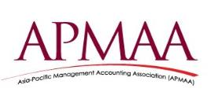
Asia-Pacific Management Accounting Association

Special Issue, APMAA News No.24, January 1, 2017 (New Year Statements of Commitment from the APMAA 2017 Board of Directors)
1. Commitment Statements from the 2017 APMAA Board Members
2. Greeting from the APMAA 2017 Conference Organizer in Shanghai
3. Greetings from the 2016 Annual Conference Organizer in Taipei, Taiwan
4. 2017 APMAA Steering Committee Members
===============================================================
1. Commitment Statements from the 2017 APMAA Board Members

A Happy New Year! This issue presents you a collection of New Year Statements of Commitment from all APMAA 2017 Board Directors. The 2017 directors promise to lead the Asia-Pacific Management Accounting Association towards being a more attractive and friendly academic association.
Directors’ Commitment to the Responsibilities in APMAA
Representative Directors’ Commitment
Growth strategy and planning
Full support of all conferences
Executive Senior Directors’ Commitment
Full efforts for the hosted conference
Reviewers, moderators and discussants at 2017 Shanghai conference
International member expansion, etc.
Senior Directors’ Commitment
Reviewers, moderators and discussants at 2017 Shanghai conference
International member expansion, etc.
Directors’ Commitment
Reviewers, moderators and discussants at 2017 Shanghai conference
International member expansion

- Commitment Statements: Representative Directors
Chair of the Board of Directors
Susumu Ueno, ueno@konan-u.ac.jp (Professor Emeritus, Konan University, Japan) (2016, 2015, 2014 APMAA Board Chair; 2013, 2012, 2011, 2010 President)

Happy New Year!
It is a great honor for me to serve as the Chair of the APMAA Board of Directors. I will do my best to share my experience in planning and managing APMAA strategies and activities.

APMAA was established in 2004 and since then has grown steadily but very slowly. I succeeded Prof. Dr. Akira Nishimura, the first president on January 1, 2010. In the Opening Remark at APMAA 2010 held in Taipei on November 5, 2010, I disclosed the policy below:
“APMAA is a very young academic organization, and it is still at its infant stage. In order to further develop the organization and to ensure its growth, APMAA must attract more people to join us as members.”
At the 2016 annual conference in Taipei we attracted around 160 participants from different parts of the world. I am extremely impressed by the effort and dedication of the Conference Chair, Professor Chu, Hsuan-Lien and her conference organizing team at the School of Accountancy of National Taipei University. They orchestrated the entire four-day conference at a professional level so that every single participant could have a custom-fit experience. Congratulations on completing the APMAA 2016 Conference and making it a great success!
APMAA has chosen Dr. Hu, Yiming, Professor of Shanghai Jiao Tong University, China (2017 Conference Chair) as the 2017 President. She speaks about the importance of building bridges, from what we as an association have achieved in the past, to what we will achieve in the future.
My colleagues at the APMAA board have always inspired me throughout my tenure of office. In fact, I have loved every minute (almost!) of every hour of my work at APMAA. I am thankful for the honor of being allowed to serve as the APMAA board chair this year again. Let’s work together to make this Association a great one!

My best wishes, and see you at APMAA 2017 in Shanghai, China.

Deputy Chair of the Board of Directors
Omar, Normah, normah645@salam.uitm.edu.my (Universiti Teknologi MARA (UiTM), Malaysia) (Chief Editor of the Asia-Pacific Management Accounting Journal (APMAJ); 2016 Board Deputy Chair; 2015 President; 2014 Executive Vice President)
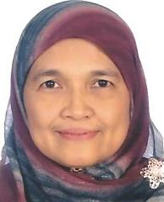
As the Editor in Chief of the Asia-Pacific Management Accounting Journal (APMAJ), I am committed to getting the journal visible and cited by management accounting scholars globally. By the end of 2017, I hope to submit APMAJ for both SCOPUS and Thomson Reuters indexing. We will strengthen our journal online system (OJS) to enable members and prospective authors to submit and track their articles through the system. Once a submission is received and approved by the editor-in-chief for reviewing, we are committed to complete the process and to give our decision to the author(s) within four months. Upon request, a special issue of the journal will be published in March of the following year to accommodate papers presented during the latest annual APMAA conference.
For the 2017 Shanghai conference, I am committed to bring ten participants from Malaysia and to promote the conference to five paper presenters from other parts of the Asia-Pacific region.
Vice Chair of the Board of Directors
Tsay, Yang-Tzong (Jimmy), yttsay@ntu.edu.tw (Professor Emeritus, NTU, Taiwan) (2016 Board Vice Chair; 2014 APMAA President; 2010 Conference Chair )

As you know, the 2017 APMAA annual conference will be held in Shanghai China. There are many management accounting professors and practitioners in China, however it seems that the participation and involvement in APMAA activities from China is far less than that from other countries.
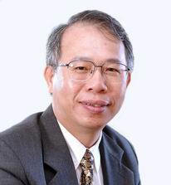
Taking the advantage of holding our conference in Shanghai, I believe 2017 would be a good time for us to recruit more members from China. Especially now, China is one of the manufacturing centers of the world. How management accounting is taught in school, how management accounting is implemented in helping business, what innovations in management accounting have been developed, and many other issues, would attract interest and attention from our profession. We expect more of our Chinese colleagues would share with us their knowledge and insights not only in the 2017 conference but also in the years ahead.
I would be more than happy to share my experience with the conference organizing team in Shanghai. In addition, I would also be delighted to promote the APMAA activities to our colleagues in China and to encourage them join the APMAA as on-going members.

b. Commitment Statements: Executive Senior Directors
President
Hu, Yiming, huym@sjtu.edu.cn (Shanghai Jiao Tong University, China) (2017 Conference Chair)
I am a professor of Antai College of Economics and Management, Shanghai Jiao Tong University. I received my PhD from Xiamen University in China, and have engaged in teaching and research in management accounting for more than 20 years. My major research interests in management accounting are performance measurement and incentives.
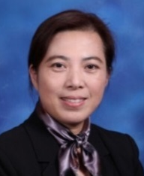
It is with great honor that I was chosen as 2017 APMAA President. I understand this entails tremendous responsibility, and I have to commit myself with on-going efforts to further develop our Association. Recently I have been very lucky to work with many APMAA executives, directors and members. Throughout the years I have witnessed how our leaders have endeavored to grow our association and to contribute to the management accounting profession. I personally have benefited and learned from their hard work and achievements.
At this point APMAA is a small but cozy and energetic professional association. Obviously many things need to be done and should be done in the following years. We are very fortunate that we have an excellent tradition and rich culture in the organization. I assure you that I will devote a great deal of my time and efforts to APMAA. Let’s work together to make this Association a great one. I definitely need your kind support and help.
The 13th APMAA conference will be held at Shanghai Jiao Tong University on November 6th - 9th, 2017. As the chair of 2017 APMAA Conference, I’ll try my best to support the conference, provide necessary financial resources, contact important organizations in management accounting in China, and lead our organizing conference committee to work efficiently. The objective of the APMAA conference is to promote the advancement of management accounting theory and practice with particular reference to Asia-Pacific accounting issues. I’ll continue my efforts into achieving the objective.
Past President
Chandrarin, Grahita, grahitac@gmail.com (University of Merdeka Malang, Indonesia) (2016 APMAA President; 2015 Conference Co-chair)

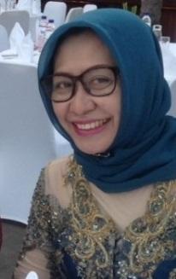
Since my first APMAA involvement at the 2010 APMAA Annual Conference in Taiwan, I have seen that every year the Association has significantly grown and developed. To the Shanghai Team, I believe you all have been preparing the next year Annual Conference (2017 APMAA Conference) the best you can do. Keep the good work. As for my commitment, I would like to continously give my sincere contribution by socializing and promoting APMAA and its annual conference to any regional or national and international events I attend and participate. To all of you: Happy holidays and may the New Year bring joy, peace, happiness to you and family.
See you in Shanghai Conference next year!

Executive Vice President
Chu, Hsuan-Lien, lien@gm.ntpu.edu.tw (Professor and Chair, Department of Accountancy, College of Commerce, National Taipei University, Taiwan) (2016 Conference Chair)

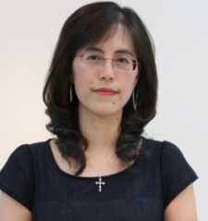
Warm greetings from National Taipei University!
On behalf of the APMAA 2016 conference organizing committee, I would like to thank you for your contributions to the APMAA 2016 annual conference. It was our great pleasure to welcome you to Taipei.
I sincerely admire the APMAA Board Directors for their dedication and strong determination toward the growth of the APMAA. They have taught me a great
deal. It has been a great honor for me to serve as the Executive Vice President of the APMAA. I will continue to support APMAA events and activities, especially the APMAA 2017 annual conference that will be held in Shanghai. I will do my best to help, and to share my experience arranging and managing the APMAA 2016 annual conference with the Shanghai conference organizing team. I will also be promoting all events related to the APMAA 2017 annual conference, as well as continuing to encourage our colleagues here in Taiwan to join the APMAA. It’s my hope that our combined efforts can strengthen the APMAA to become a more and more successful global platform not only for sharing research ideas, but also for building lasting friendships.
Vice President
Tsuji, Masao, mtsuji@waseda.jp (Professor, Nagoya University of Commerce & Business; Professor Emeritus of Waseda University, Japan) (2018 Conference)

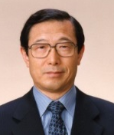
I am currently the associate dean and a professor at the Graduate School of Nagoya University of Commerce and Business (NUCB). I moved from Waseda to Nagoya last April. I have been teaching management accounting and value-base management by using the cases of Harvard and Ivey at NUCB. My major research areas are ① management control including performance measurement within and across organizations, ② business analysis and valuation, and ③ accounting policies by management. Last year I published Accounting standards and managerial behavior: Theories of accounting policies and empirical studies. The book investigated managerial behaviors related to accounting policy making on application of the newly settled accounting standards in Japan from the perspective of management accounting. It also presented empirical studies to clarify how the policymaking by the managers affected the performance and financial positons of companies during the period of the “Accounting Big Bang.” It is a great pleasure for me to serve on the board of APMAA as a senior director in 2017. Also, I would be most honored if I could work as a coordinator and a discussant at the 2017 conference as I did at the last conference. I would like to continue sharing and exchanging the research results among our members and encouraging my colleagues to take part in the APMAA activities.

Vice President
Elgammal, Mohammed, m.elgammal@qu.edu.qa (Qatar University, Qatar) (2019 Conference Chair)
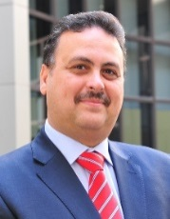
Dear Colleagues, it is always my pleasure to share with you in serving our great association. The APMAA Taiwan 2016 conference was outstanding and creates a lot of challenges for organizers for forthcoming conferences. The outstanding quality of the papers presented in 2016 conference reflects the growth of our association in terms of numbers and quality and coverage. It is very good to see our association growing internationally and even accommodating researchers from other areas related to management accounting applications like finance and management.
We are working hard at Qatar University to prepare for the APMAA 2019 conference in Doha. It will be the first time for our conference in the GCC. The main theme for the 2019 conference is “Management Accounting and Finance in the 21st Century: Challenges and Perspectives.” However, manuscripts may encompass any topical area of management accounting and finance including:
- Management Accounting and Control
- Management Accounting for Multinational Enterprises
- Management Accounting for State-owned Companies and Non-profit Organizations
- Management Accounting and Organizational Culture
- Financial Reporting
- Financial Markets and Risk Management
- Islamic Accounting and Finance
- Internal control and Accountability: Professional and Business Ethics
- Corporate Governance
- Intellectual Capital and Knowledge Management
- Social and Environmental Accounting
- Accounting and Finance for Hydro-carbon based economy.
See you in Shanghai in 2017 where we can give you more information about APMAA 2019!

- Commitment Statements: Senior Directors
Xia, Lijun, ljxia@sjtu.edu.cn, (Professor, Chair of Department of Accounting, Shanghai Jiao Tong University, China) (2017 Conference Co-Chair)

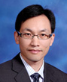
The APMAA’s annual meeting provides a platform for global scholars in management accounting to exchange their ideas and network with each other. Under the leadership of executive committee members of the Asia Pacific Management Accounting Association (APMAA), the association has grown at a steady pace during the past a few years and become an important academic association specialized in management accounting research. I’m the professor and the Chair of the Department of Accounting of Shanghai Jiao Tong University. I’m very pleased to serve as a board member, and commit to actively participate in the activities related to APMAA 2017 conference and APMAA development. Furthermore, I commit to promote APMAA and assume my responsibilities in serving as a member of the board.
Aoki, Masaaki, maoki@econ.tohoku.ac.jp (Professor, Tohoku University, Japan) (2018 Conference)
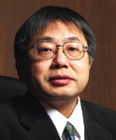
I am now a director of Tohoku University of Accounting School. So, I would like to discuss with other members about Management Accounting Education in our Accounting School. As I accept foreign Ph.D. candidate students constantly, I would also like to support the Ph.D. colloquium. What is the most important thing for APMAA Japan members is the APMAA 2018 conference held in Japan. I concentrate on the preparation of this conference. I would like to cooperate with other Japanese members to build a basic framework of the 2018 conference.
Suzana Sulaiman, suzana1110@salam.uitm (Universiti Teknologi MARA (UiTM), Malaysia) (Executive Editor of the Asia-Pacific Management Accounting Journal (APMAJ); 2020 Conference Chair; 2011 Conference Co-chair)
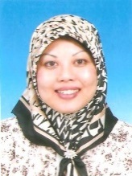
Dear Colleagues, it is always my pleasure of the Executive Editor of the Asia-Pacific Management Accounting Journal (APMAJ), since 2006 to serve our great association. The team and I are committed in ensuring the continuity and sustainability of the journal. We are also committed to submit APMAJ for reputable indexing. We are honoured to host the APMAA 2020 conference in Malaysia. This will be a second time for us to host this privilege conference which the first was successfully organized in. We are committed in ensuring the success of this coming conference. The conference will be a platform for both practitioners and academicians to share their experiences and exchange ideas on latest management accounting related issues. We are also planning to include an industry visit during this conference and encourage more international participants.

Oshika, Tomoki, oshikat@waseda.jp(Professor, Faculty of Commerce, Waseda University, Japan) (2018 Conference)

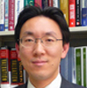
As we expect to hold the 2018 APMAA conference in Japan, I have no doubt that the 2017 conference in Shanghai will be really important to us. I will try to gather all available information on every stage of organizing the Shanghai conference to make sure that the 2018 conference will be perfectly prepared.

Lin,Hsiao-Lun, hllin@mail.ntpu.edu.tw (Associate professor, National Taipei University, Taiwan) (2016 Doctoral Colloquium Chair)
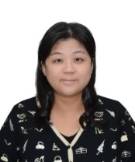
As a team member of the APMAA 2016 organizing committee, I would like to thank you for the contributions of all participants. Without your support, the success of the APMAA 2016 would not have been possible.
It is my honor to serve on the board of APMAA 2017 conference. I would like to share my experience in 2016 with the conference organizing team at Shanghai Jiao Tong University. I would also commit to promoting the APMAA 2017 conference and encourage more Taiwanese PhD students and professors to join the APMAA 2017 conference in China.
Mimba, Ni Putu Sri Harta, sriharta@gmail.com (Udayana University, Indonesia) (2015 Doctoral Colloquium Chair)

I will do my best to reserve my schedule for the APMAA 2017 conference. I have planned to attend and to support the conference by accepting the proposal to be a moderator and a discussant as well as other requested roles.

In addition, it is my great pleasure to inform and invite colleagues in Indonesia to attend this conference. I would inform them about this conference much in advance. Hence, it is expected that more and more colleagues from Indonesia will be able to submit their papers and participate in the conference.
As the person who in charge of developing an international network at my university, I will also spread the word about the APMAA 2017 conference to my international colleagues through their international offices or directly inform those who have an accounting background. This is an excellent opportunity to have more international scholars in the conference.
Wish you all a very happy New Year 2017, and wish all the best for the organizing committee for the 2017 APMAA Conference.

Hosomi, Shoichiro, hosomi@tmu.ac.jp (Professor of Management Accounting, School of Social Science, Tokyo Metropolitan University, Tokyo Japan) (2018 Conference)
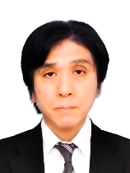
I am a Professor of Management Accounting at Tokyo Metropolitan University, Faculty of Business Administration and Graduate School of Social Science (including Business School), Tokyo, Japan. I also teach the Fundamentals of Management Accounting at the University of the Air, Japan. My current research theme is to clarify the relationship between Intellectual Capital and corporate performance and how to manage them. I am an editorial board member of The Journal of Management Accounting (Japan). In addition, I am currently an Associate Research Fellow of SKOPE, University of Oxford (2013- ).
It has been a great honor for me to serve as a Senior Director of the APMAA. I'd like to support the APMAA2017 conference in Shanghai to be successful as a reviewer, a moderator or a discussant. I hope the APMAA to become a more successful global academic conference.

Kishita, Tetsuhiro, kishita@biz.ryukoku.ac.jp (Professor of Business Administration at Ryukoku University, Kyoto Japan) (2018 Conference)
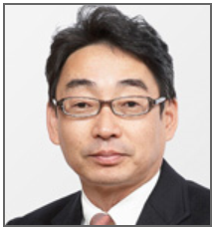
Current research interests: Reward management and Chinese MNEs OFDI.
Nimen Hao ! I am excited to see you all at the 2017 annual conference in Shanghai. I hope that APMAA develops more in our academic global society. For that, we need to get more people involved in our gatherings. The more people, the more fun. I am going to beat the drum for the Shanghai conference everywhere, and take more friends to the conference.
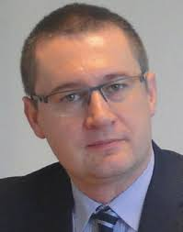
Tomasz, Wnuk-Pel, tomwnuk@uni.lodz.pl (Associate Professor, Department of Accounting, Faculty of Management, University of Łódź, Poland)

I still think how lucky I was to meet all my APMAA friends in beautiful Taipei this year. It is a privilege for me to be part of APMAA family and to take part in yearly conferences which are exceptional both for level of presented papers and discussions and also organization and friendly atmosphere.
This year was good for my academic work. I got affiliation at Linnaeus University, Sweden (Center for Management Accounting Research). I have just finished three books with tests and short case studies based on my consulting experience in Operational Controlling, Cost Controlling and Strategic Controlling. They are in Polish but I hope to have them translated into English and published abroad. For this I need a sponsor university unfortunately…
It will be great privilege to serve as Senior Board Director of APMAA in 2017. It would be my pleasure also to be a reviewer, discussant or session chair at the next conference, just in the same way I was before. I hope I will meet you all in Shanghai!

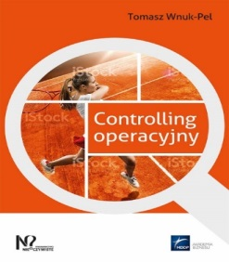
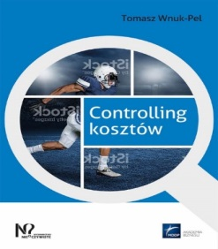
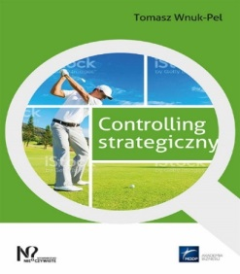
Nakashima, Masumi, masumink@cuc.ac.jp (Professor, Chiba University of Commerce, Japan) (2018 Conference)
I am a Chair and Professor of Accountancy in the Graduate School of Accounting and Finance at the Chiba University of Commerce in Japan and a Professor of Financial Analysis and Valuation at the Doctoral Program at Graduate School of Policy Studies. My research interests are the association between earnings management and corporate governance, and fraud theory and managerial ethics.

I would express my sincere appreciation to 2016 the National Taipei University team for leading the conference so successfully. Without the team’s dedication, the conference would not have been able to complete everything. Especially, I was impressed with 2016 APMAA Chair, Hsuan-lien Chu’s outstanding leadership. I really appreciate her dedication and hospitality for us.
I am ready for supporting the 2017 Shanghai conference. I will be happy to commit not only the conference itself but also the preparation for the conference such as serving as a reviewer. It is a great honor for me to serve as moderator or discussant at the conference. We will make 2017 APMAA 2017 Shanghai conference a great success with our tight partnership!

Mayangsari, Sekar, sekar@hotmail.com (Trisakti University, Indonesia) (2015 Conference Co-chair)
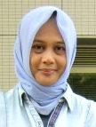
It was really sorry that I miss 2016 APMAA Conference. Hopefully, I can attend 2017 Shanghai Conference. Even, though I could not attend the last APMAA Conference, my commitment for APMAA still full, and was supported by my dean. My commitment to the 2017 Shanghai Conference with full efforts for submitted papers, reviewers, moderators and being a discussant at the conference. I will also continue promoting the APMAA to all my colleagues in Indonesia and abroad, and endorse them to submit paper, as well.
Nitirojntanad, Kanibhatti, kanibhatti@cbs.chula.ac.th (Chulalongkorn University, Thailand) (2014 Conference Cahir)
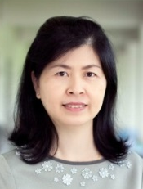
It’s my great pleasure to be an APMAA board member since 2011. It has also been a great honor for me to serve as the Chair of the 2014 APMAA Conference in Thailand. Although I was not able to participate in the last APMAA conference in Taipei, I will be very happy to commit my support to the success of the 2017 APMAA conference in Shanghai. In addition, I will be glad to support APMAA various activities for the growth and success of APMAA organization.
Fu, Yuanlue, ylfu@xmu.edu.cn (Professor, Xiamen University, China) (2012 Conference Chair)
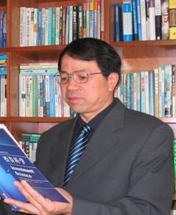
It has been a great honor for me to serve as the Chair of the 2012 APMAA Conference. There are a series of application guides on management accounting to be issued by the Ministry of Finance of China in 2017 and there have been many successful application cases of management accounting in China since 2008. I believe 2017 would be a good time for us to recruit more members from this conference in Shanghai. I will continue to support APMAA events and activities, especially the APMAA 2017 annual conference in Shanghai. I will do my best to help, and to share my experience arranging and managing the APMAA 2012 annual conference in Xiamen University. In addition, I would be delighted to recommend our colleagues to take part the APMAA 2017 annual conference.

Rahman, Ibrahim Kamal Abdul (ibrahimkamal@unikl.edu.my) Universiti Kuala, Lumpur, Malaysia (2011 Conference Co-chair)
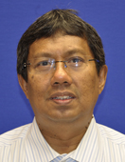
I will attract management accounting lecturers in Malaysia to join and be active with the APMAA. I will also try to get them to attend the annual conference organize by the association.

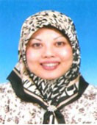
Sulaiman, Suzana, suzana1110@salam.uitm.edu.my(UniversitiTeknologi MARA (UiTM), Malaysia),(2011 Conference Co-chair), (2020 Conference Chair)
Dear Colleagues, it is always my pleasure of the Executive Editor of the Asia-Pacific Management Accounting Journal (APMAJ), since 2006 to serve our great association. The team and I are committed in ensuring the continuity and sustainability of the journal. We are also committed to submit APMAJ for reputable indexing. We are honoured to host the APMAA 2020 conference in Malaysia. This will be a second time for us to host this privilege conference which the first was successfully organized in 2011. We are committed in ensuring the success of this coming conference. The conference will be a platform for both practitioners and academicians to share their experiences and exchange ideas on latest management accounting related issues. We are also planning to include an industry visit during this conference and encourage more international participants.

Scarbrough, Paul, pscarbrough@brocku.ca (Associate Professor, Department of Accounting, Goodman School of Business, Brock University, Canada)

It has been wonderful to see APMAA develop. I look forward to seeing you all in Shanghai in November and contributing to the growth of our community of colleagues. I will attend the 2017 conference and urge my Canadian colleagues to submit papers.
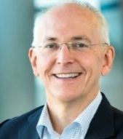
Alpenberg, Jan, jan.alpenberg@lnu.se (Dean at the School of Business and Economics, Senior lecturer in Management Accounting and Finance, Linnaeus University, Sweden)

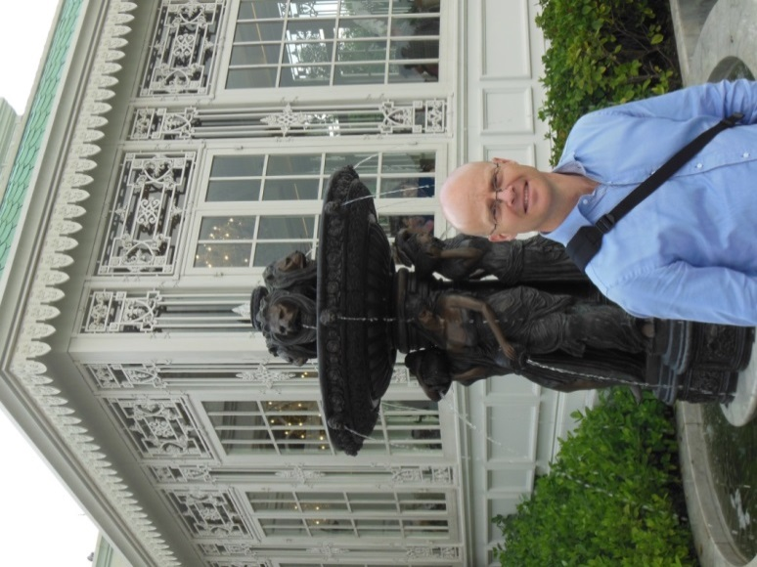
I have enjoyed and benefited from my connection with APMAA. I commit to spreading information about APMAA in the Nordic countries, and to participate in APMAA 2017 in Shanghai by submitting a paper and being a reviewer and discussant. To my many friends at APMAA, See you in Shanghai!

Elbanna , Said, selbanna@qu.edu.qa (Professor of Strategic Management, Qatar University, Qatar) (2019 Conference)

I am committed to support the 2017 APMAA conference in Shanghai, China. I will be glad to play different roles in this conference such as reviewing papers on performance measurement/management as well as strategic management related topics. Discussing papers and chairing sessions are other possible contributions toward the Shanghai conference. In addition to promoting the conference among my colleagues, I intend to present a paper on performance measurement in the Shanghai conference.
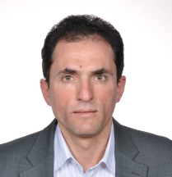

d. Commitment Statements: Directors
Li-Chun, Kuo, lckuo@mail.ntpu.edu.tw(Assistant Professor, Department of Accountancy, National Taipei University, Taiwan) (Chair of APMAA 2016 Conference News)
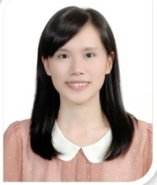
I would like to express my sincere gratitude again to APMAA for giving us this opportunity to hold APMAA 2016 in Taipei. It is great to have a wonderful opportunity to exchange research ideas with all of the participants, learn new managerial accounting concepts, and be aware of the problems in the practical areas. It is my honor to serve as an APMAA 2017 board member. I commit to promote APMAA 2017 and encourage the scholars and Ph. D. students in Taiwan to join APMAA 2017 in Shanghai. I wish AMPAA 2017 in Shanghai a successful conference!
Mori, Yuji, yujimori@u-shizuoka-ken.ac.jp (Associate professor of School of Management and Information, University of Shizuoka, Japan) (2018 Conference)

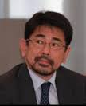
It is my pleasure to work in an international environment with local emphasis as APMAA does. My major research has focused on public accountability. I am still stimulated by the importance of the “locality” on the accountability concept. I believe this research area is a good opportunity to investigate deeply with our colleagues in Shanghai to compare with one of the largest organizations in the world, Chinese governmental bodies. I hope to offer some, even if minor, contribution to any aspect of the Shanghai conference. I look forward to seeing you in Shanghai.

Abdel-Maksoud, Ahmed Bahgat, aabdelmaksoud@uaeu.ac.ae(United Arab Emirates University (UAEU), United Arab Emirates)

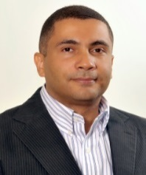
I am an Associate Professor of Management Accounting at the College of Business and Economics, United Arab Emirates University (UAEU), United Arab Emirates (UAE). I joined the APMAA Board of Directors in 2012. APMAA board members are truly dedicated and devote valuable efforts to achieve the association’s strategic goals. This has built up a strong association’s network, which makes considerable contributions to both academia and professionally in the region and beyond.
I commit to liaise with academicians at universities in Gulf Council Cooperation (GCC) countries and Middle East North Africa (MENA) region for the APMAA Annual Conference in Shanghai, 2017. I, also, explore potential research collaborations within APMAA’s GCC/MENA network.

Cheng, Nam Sang, nscheng@smu.edu.sg (Associate Professor of Accounting (Practice), School of Accountancy, Singapore Management University, Singapore)

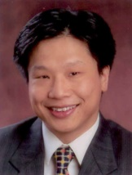
APMAA is a big, warm family promoting management accounting research and practices. Under the strong leadership of the Chair, Deputy and Vice Chairs, President, Vice Presidents, and all past office bearers, APMAA has been growing at an encouraging rate. Hosts of the annual conferences always provided delegates with well-run events and overwhelming hospitality. Rendering my service through reviewing papers and attending conferences are the least I can do to support such a wonderful organization.

Omran, Mohammed Fawzy (mfomran2013@gmail.com) Nile University, Egypt

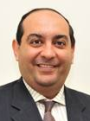
I am Professor of Financial Economics at Nile University in Cairo, Egypt. Nile University was established in 2007 as a not-for-profit institution with the objective of contributing to the economic development of Egypt by providing and encouraging innovations and entrepreneurship. I have been involved with APMAA for several years while I was a Professor at Qatar University. I encouraged my fellow colleagues at Qatar University to join APMAA and helped in getting the conference to be offered there in 2019. I have all trust in my ex-colleagues at Qatar University that they will do their best to make the 2019 conference a success. I pledge my full support for the APMAA activities in 2017. I will make myself available for conference papers reviewing and also for reviewing some of the papers that are submitted to the APMAA journal.

Terdpaopong, Kanitsorn, kanitsorn@rsu.ac.th Rungsit University, Thailand.

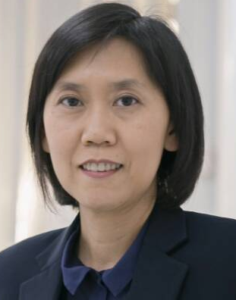
Being an academician, one of the things to help us to maintain enthusiasm, inspire our research interest and network us with colleagues is attending good conferences regularly. The APMAA conference is a great example of such a good conference. I regularly attend the APMAA conference and Shanghai AMPAA Conference in 2017 is a conference that I am looking forward to. See you all in Shanghai.

Shi, Guifeng, shigfeng@sjtu.edu.cn (Associate Professor, Department of Accounting, Shanghai Jiao Tong University, China) (2017 Conference)

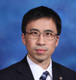
My commitment to 2017 Shanghai conference APMAA, being a leading association of scholars and specialists in this field, is my obligation to keep on growing and embracing innovative theories, ideas, techniques and experiences relating to all aspects of management accounting. As an professor of Department of Accounting of Shanghai Jiao Tong University, I am very pleased to be a board member of APMAA, and commit to extend the influence of APMAA in China and the world, to actively participate in the activities related to APMAA 2017 conference, especially the Doctoral Colloquium.

- Emeritus Director
Nishimura, Akira, bepp@aki.nifty.jp (Professor Emeritus of Kyushu University, Japan).
2004-2009 APMAA President )

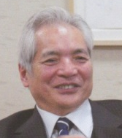
Nishimura, Akira is the Founding President of Asia-Pacific Management Accounting Association (APMAA). The proposal to form the Asian Management Accounting Association was first mooted at the convention of Asian Management Forum, which was held on 3rd and 4th November 2002 in Fukuoka, Japan under the inspiration of Professor Dr. Akira Nishimura. Since then, the founder members from countries of the Asia-Pacific region continue to meet annually to share the same vision of advancing management and accounting research and practices with particular reference to the Asia-Pacific region.
In November 2004, Asia-Pacific Management Accounting Association was officially established.

2. Greeting from the APMAA 2017 Conference Organizer in Shanghai
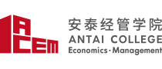
2017 (13th) Annual Conference Asia-Pacific Management Accounting Association
Nov. 6-9, 2017
Xuhui Campus of Shanghai Jiao Tong University, China

Warm greetings from the Department of Accounting of Shanghai Jiao Tong University!
Message from the Chair, APMAA 2017 Conference:
The Department of Accounting of Shanghai Jiao Tong University will host the 13th APMAA conference from November 6th - 9th, 2017. On behalf of the APMAA 2017 Conference Organizing Committee, I would like to thank the APMAA Board of Directors for providing us the opportunity to host the upcoming conference.
We have a capable and experienced team on our organizing conference committee. Professor Lijun Xia, the Chair of Department of Accounting, Professor Xiaodong Xu, Professor Shengquan Hao, Professor Guifeng Shi, and my colleagues Dr. Renhui Fu, Dr. Wen Li, Dr. Wenyun Shi and Dr. Yu Chen are included in this committee.
The theme of the APMAA 2017 is “Management Accounting and Society: A Global Perspective". The purpose of this conference is to enhance the understanding of current management accounting issues in various countries. The conference will provide a plenary session, a panel session, parallel sessions, and cultural visit.
The conference venue is in the campus of Shanghai Jiao Tong University, which is located near a transportation hub of Xujiahui, one of the major commercial centers in Shanghai. We have contacted several suitable hotels around the campus. To provide outstanding computer service, we located a computer company to design the 2017 conference website. The website will be open on November 1, 2016. We also contacted some accounting institutes and firms and have their agreements to be our sponsors.
To promote the influence of 2017 APMAA conference, the members of our conference team have brought the message of the forthcoming conference to many important academic meetings such as the annual conferences of American Accounting Association, European Accounting Association, and CANAPA, etc. We hope to attract more fresh participants all over the world to our conference.
In the 2017 major program, we plan to have two or more plenary and panel sessions. One of them will be a special session for CEOs and CFOs to present their cases of management accounting practices. Therefore, we need to invite a group of excellent scholars and professionals to be our keynote speakers and moderators. Fortunately, we have good responses from outstanding professors and professionals.
The objective of the APMAA conference is to promote the advancement of management accounting theory and practice with particular reference to Asia-Pacific accounting issues. We are now going to take more efforts to achieve this goal. My team and I have been pleased to learn and grow with APMAA through participation in all of these activities. I promise to continue working hard on the conference.
I believe this event in 2017 will provide you with a productive opportunity to hear about the latest insights in many areas of research into management accounting and allow interaction with the participants from all over the world. Please mark your calendar now. We look forward to seeing you in Shanghai in Fall, 2017.
Best regards,

Yiming Hu, Ph.D.
APMAA 2017 President
Chair of 2017 APMAA conference
Professor, Department of Accounting,
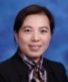
Shanghai Jiao Tong University

APMAA 2017 Conference Committee
Name | E-mail
Professor Yiming Hu(Chair of APMAA 2017) | huym@sjtu.edu.cn
Professor Lijun Xia (Co-Chair of APMAA 2017) | ljxia@sjtu.edu.cn
Professor Xiaodong Xu  (Vice-Chair of APMAA 2017) | xuxd@sjtu.edu.cn
Associate Professor Shenquan Hao  (Chair, Doctoral Colloquium) | sqhao@sjtu.edu.cn
Associate Professor Guifeng Shi  (Vice-Chair, Doctoral Colloquium) | shigfeng@sjtu.edu.cn
Assistant Professor Renhui Fu  (Vice-Chair of APMAA 2017) | renhuifu@sjtu.edu.cn
Assistant Professor Wenyun Shi  (Vice-Chair of APMAA 2017) | wenyun_shi@sjtu.edu.cn
Assistant Professor Wen Li | wendyli@sjtu.edu.cn
Assistant Professor Yu Chen | yu_chen@sjtu.edu.cn
Conference Coordinator Yi Wang | yi.wang@sjtu.edu.cn
Address: Antai College of Economics & Management, Shanghai Jiao Tong University, No. 1954 Huashan Road, Shanghai, China. Phone: (86) 21-52301575, (86) 21-52302052

3. Greetings from the 2016 Annual Conference Organizer in Taipei, Taiwan

On behalf of our organizing committees, I want to express our gratitude that APMAA gave us the opportunity to host this joint conference. We would like to extend special thanks to Professor Ueno and the APMAA Board of Directors for giving us the benefit of their experience with managing and arranging a conference.
I’d also like to extend our thanks to all of you who attended the APMAA 2016 conference. It was a fruitful conference for all of us, and we hope you enjoyed all of the events and activities we arranged for while you were here. We are pleased to provide a global platform not only for sharing research ideas, but also for building lasting friendships. We appreciate having been given the chance to host this joint conference.
Thank you again. I look forward to staying in touch, and maintaining a lasting professional relationship.
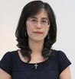
All the best,

Hsuan-lien Chu,
Chair, 2016 Asia-Pacific Management Accounting Association

On behalf of the chair of the doctoral colloquium, and the organizing committees, I want to express my welcome and thanks to all participants.
This year, we had 7 doctoral proposals, which we separated into two parts and presented in different conference rooms at the NTPU downtown campus. I would like to extend my gratitude to the help of Prof. Ni Putu Sri Harta Mimba, and Prof. Masumi Nakashima. They were excellent moderators and arranged the sections successfully. In addition, I would like to thank all discussants for sharing their suggestions and knowledge with the doctoral students. Lastly, I would like to thanks all doctoral students and all participants for their contribution.
Thank you again. Without all of you, the success of the APMAA 2016 Conference wouldn’t have been possible.
All the best,

Hsiao-Lun Lin
Doctoral Colloquium Chair, 2016 Asia-Pacific Management Accounting Association
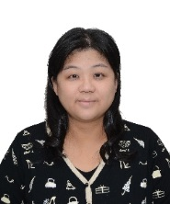
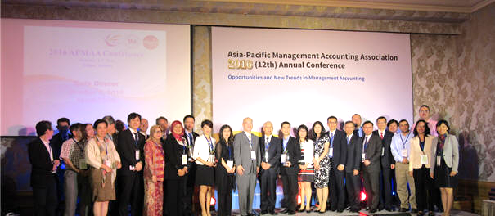  At Gala Dinner, The Sherwood Taipei, on Nov. 5 | 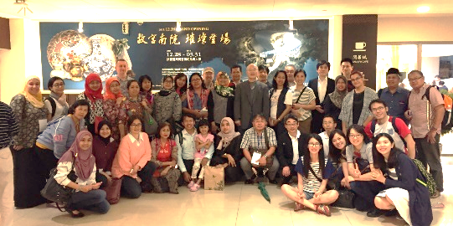  At National Palace Museum in Taipei on Nov. 7

4. 2017 APMAA Steering Committee Members
2017 Steering Committee Members as of January 1, 2017
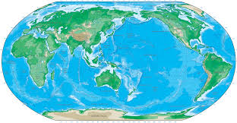
We welcome new volunteers on the APMAA steering committee. The responsibility of the committee is to facilitate the growth and development of APMAA. Please contact Dr. Susumu Ueno, APMAA Board Chair, if you are interested in serving in the position.
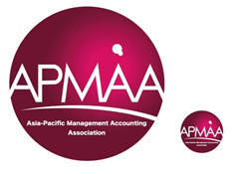

Australia | Boon, Foo Yee (foo.yee.boon@monashh.edu), Monash University  Perera, Sujatha (sperera@efs.mq.edu.au), Macquarie University  Robertson, Susan (sue.robertson@rmit.edu.au), RMIT (Royal Melbourne Institute of Technology)  Taylor, Dennis (dennis.taylor@rmit.edu.au),RMIT (Royal Melbourne Institute ofTechnology)  Terzioglu, Bulend (Bulend.Terzioglu@acu.edu.au), Australian, Catholic University  Willett, Roger(Roger.Willett@utas.edu.au), University of Tasmania  Chan, Elsie (Elsie.Chan@acu.edu.au), Australian Catholic University
Brazil | Aquino, André Carlos Busanellide (aaquino@usp.br), University of Sao Paulo
Canada | Scarbrough, Paul(pscarbrough@brocku.ca), Brock University  Sheng-Hua, Shih (mshih@uwindsor.ca ), University of Windsor
APMAA China | Chen, Chao (chen_chao@fudan.edu.cn), Fudan University  Chen, Xiao (chenx@sem.tsinghua.edu.cn), Tsinghua University  Changjiang, LYU (cjlu@fudan.edu.cn), Fudan University  Dai, De(deming_dai@263.net), Renmin University  Fang, Hong Xing (hxfang@dufe.edu.cn), Dongbei University of Finance and Economics, Dalian  Fu, Renhui ( renhuifu@sjtu.edu.cn ), Shanghai Jiao Tong University  Fu, YuanLue(ylfu@xmu.edu.cn), Xiamen University  Hao, Shenquan (sqhao@sjtu.edu.cn), Shanghai Jiao Tong University  Hu, Yiming(huym@sjtu.edu.cn), Shanghai Jiao Tong University  Mu, Linjuan(mulinjuan@yahoo.com), Beijing Technology and Business University  Jianqiao, Hong (jqhong@fudan.edu.cn), Fudan University  Qu, Xiaohui(xhqu@xmu.edu.cn), Xiamen University  Shi, Guifeng (shigfeng@sjtu.edu.cn), Shanghai Jiao Tong University  Shi, Wenyun (wenyun_shi@sjtu.edu.cn), Shanghai Jiao Tong University  Tang, GuLiang(tangguliang@263.net), University of International Business and Economics, Beijing.  Xia, Lijun ( ljxia@sjtu.edu.cn ), Shanghai Jiao Tong University  Xu, Xiaodong ( xuxd@sjtu.edu.cn), Shanghai Jiao Tong University  Yu, Zengbiao (yuzb@sem.tsinghua.edu.cn), Tsinghua University  Wang, Liyan (lywang@gsm.pku.edu.cn), Peking University  Zhihua, Xie(zhihui09@sohu.com), Beijing Technology and Business University
Egypt | Omran, Mohammed Fawzy (mfomran2013@gmail.com), Nile University
Finland. | Järvenpää, Marko(marko.järvenpää@econ.jyu.fi), University of Jyväskylä  Kurunsaari, Hannu (kurunsaari@hotmail.com), Osaka City University (Visiting Scholar from Finland)
India | Jaiswall, Manju(manju@iimcal.ac.in), Indian Institute of Management Caclcutta, India  Jhunjhunwala, Shital(jhunjhunwalas@ipeindia.org), Institute of Public Enterprise, India
APMAA  Indonesia | Agustia, Dian (agustia.dian@yahoo.com.), Airlangga University  Assih, Prihat (wr-2@unmer-malang.ac.id & prihat2001@yahoo.com),University of Merdeka Malang  Augustine, Yvonne (yvonneags@gmail.com), Trisakti University  Chandrarin, Grahita(grahitac@unmer.ac.id & grahitac@gmail.com), University of Merdeka Malang  Gani, Lindawati (lgani@ui.ac.id), University of Indonesia  Gunawan, Juniati (yuni_gnw@hotmail.com),Trisakti University  Mayangsari, Sekar(sekar@hotmail.com),Trisakti University  Mimba, Ni Putu Sri Harta (cip.unud@gmail.com), Udayana University  Murtanto (murayo2003@yahoo.com), Trisakti University  Nahartyo, Ertambang(ertambang@gmail.com), Gadjah Mada University  Pagalung, Gagaring (gpagalung@yahoo.com), Hasanuddin University - Makassar  Putra, AAGP Widana (agungwidana@yahoo.co.id), Udayana University – Bali,  Sanjaya, GustiNgurah (sanjaya1965@yahoo.com), Universitas Warmadewa - Bali  Soedaryono, Bambang(bambang@fe.trisakti.ac.id), Trisakti University – Jakarta  Tjahjadi, Bambang (bambang.tjahjadi@gmail.com), University of Airlangga, Surabaya  Triyuwono, Iwan(itriyuwono@gmail.com), University of Brawijaya  Utami, Wiwik(wiwikutami@gmail.com), Mercu Buana University - Jakarta  Widanaputra, A. A. G. P. (widanaputra@gmail.com), Udayana University Jakarta  Yoi, Yuliansyah (yulyy001@mymail.unisa.edu.au), University of Lampung  Zuhroh, Diana (dzuhroh@gmail.com), University of Merdeka Malang
Hong Kong | Wong, Raymond K. H. (raykhwong@baf.cuhk.edu.hk), The Chinese University of Hong Kong
APMAA  Japan | Aoki, Masaaki(maoki@econ.tohoku.ac.jp), Tohoku University  Fujii, Hideki (hujii@econ.kyoto-u.ac.jp), Kyoto University.  Hamada, Kazuki (bft88135@kwansei.ac.jp), kwansei University  Harada,Noboru(n-harada1116@nifty.com), Mejiro University.  Hiki,Fumiko (F.Hiki@r.hit-u.ac.jp), Hitotsubashi University  Hosomi,Shoichiro(hosomi@tmu.ac.jp), Tokyo Metropolitan University  Ito, Kazunori (itoh@isc.senshu-u.ac.jp), Senshu University  Kajiwara, Takehisa (kajiwara@people.kobe-u.ac.jp), Kobe University  Kaneda, Naoyuki(naoyuki.kaneda@gakushuin.ac.jp), Gakushuin University  Kawashima, Kazuhiro(kz03691@e.t-komazawa.ac.jp), Tomakomai Komazawa University  Kim, Jae Wook(jaewookk@hiroshima-u.ac.jp), Hiroshima University  Kimura, Shogo(kimura@soec.nagoya-u.ac.jp), Nagoya University  Kishita, Tetsuhiro(kishita@biz.ryukoku.ac.jp), Ryukoku University  Kobayashi, Yoshitaka(ykobay@waseda.jp), Waseda University  Koga, Kentaro(kkoga@ics.hit-u.ac.jp), Hitotsubashi University  Kosuga, Masanobu (masa-kos@kwansei.ac.jp), Kwansei Gakuin University  Kubota, Yu-ichi(kubota@eco.osakafu-u.ac.jp), Osaka Prefecture University  Mizoguchi,Shuji(shujim@ynu.ac.jp), Yokohama National University  Matsuo,Takami(mats@kobe-u.ac.jp), Kobe University  Mizuno,Ichiro(icmizuno@ipcku.kansai-u.ac.jp), Kansai University  Monden, Yasuhiro (yasuhirom@mail2.accsnet.ne.jp), Professor Emeritus at University of Tsukuba  Mori, Yuji (yujimori@u-shizuoka-ken.ac.jp), University of Shizuoka  Morofuji, Yumi (morofuji@rikkyo.ac.jp), Rikkyo University  Nagasaka, Yoshiyuki(nagasaka@konan-u.ac.jp), Konan University  Nakashima, Masumi (masumink@cuc.ac.jp),Chiba University of Commerce  Nishimura, Akira (akiran@nm.beppu-u.ac.jp), Professor Emeritus at Kyushu University  Obata, Hiroshi (hiroshi@obata.misc.hit-u.ac.jp), Hitotsubashi University  Otagiri, Junko (junko@biwako.shiga-u.ac.jp), Shiga University  Ogata, Isamu(isamu.ogata@kwansei.ac.jp)Kwansei Gakuin University  Ogura, Noboru(ny-ogura@mvi.biglobe.ne.jp), Aoyama Gakuin University  Oshika, Tomoki (oshikat@waseda.jp),Waseda University  Oshima, Masakatsu(oshima@asia-u.ac.jp), Asia University  Oshita, Johei(oshita@econ.kyushu-u.ac.jp), Kyushu University  Saito, Koichi (koichi@nanzan-u.ac.jp), Nanzan University  Sasaki, Ikuko( ikuko@mail.tohoku-gakuin.ac.jp), Tohoku Gakuin University  Shiiba, Atsushi(shiiba@econ.osaka-u.ac.jp), Osaka University  Shima, Yoshinobu(shima@bus.kindai.ac.jp), Kinki University  Suzuki, Kenichi(KGH00111@nifty.com), Meiji University  Takeda, Fumiko (takeda@tmi.t.u-tokyo.ac.jp), University of Tokyo  Tokuga, Yoshiro (tokuga@econ.kyoto-u.ac.jp), Kyoto University  Tomo, Makoto(seijo@xtomo.com), Seijo University  Tsuji, Masao(mtsuji@nucba.ac.jp), Nagoya University of Commerce & Business  Ueno, Susumu(s-ueno@dab.hi-ho.ne.jp), Konan University  Yasukata, Kenji(Kyasukata@bus.kindai.ac.jp), Kinki University  Yazawa, Nobuo(czq00554@nifty.com), Beppu University  Yokota,Eri (yokota@fbc.keio.ac.jp), Keio University  Yoshioka,Masamichi (yoshioka@ms.kuki.tus.ac.jp), Tokyo University of Science
Korea | Ahn, Taesik(ahnts@snu.ac.kr) , Seoul National University  Chi, Sung-Kwon (chisk@pusan.ac.kr), Pusan University  Choi, Ung-Yong (uychoi@chonnam.ac.kr), Chonnam University  Chung, H. Rock (jhrjhr@khu.ac.kr), Kyunghee University  Hong,Chul-Kyu(ckhong04@cau.ac.kr), Chungang University  Hwang, Iny(hiny72@snu.ac.kr), Seoul National University  Kim, Jinbae(jinbae@korea.ac.kr), Korea University  Ko, Wan-Seok(wsko7@naver.com), Hankuk University of Foreign Affairs  Lee, Kyung Tae (kyungtae@yonsei.ac.kr), Yonsei University  Lee, Sangchul(sclee68@dongguk.edu), Dongguk University  Lee, Sang-Soo(sslee@inha.ac.kr) , Inha University  Park, Joonho(bizintel@hanyang.ac.kr), Hanyang University  Paik, Tae-Young (typaik@skku.edu), Sungkyunkwan University  Shin, JaeYong (jshin@snu.ac.kr),Seoul National University
Macau | Lin, Zhijun(linzj@hkbu.edu.hk), Macau University of Science and Technology
Malaysia | Aziz, RozainunAbd(rozainun@salam.uitm.edu.my), Universiti Teknology MARA  Hui,Wee Shu (wee.shu.hui@gmail.com), Universiti Teknologi MARA, Malaysia  Isa, CheRuhana(cruhana@um.edu.my),University of Malaya  Omar, Norliza(norli795@salam.uitm.edu.my), Universiti Teknologi MARA  Omar, Normah(normah645@salam.uitm.edu.my), Universiti Teknologi MARA  Rahman, Ibrahim Kamal Abdul (ibrahimkamal@unikl.edu.my) , Universiti Kuala Lumpur  MdShahbudin, Amirul Shah (amirulshah@usm.my), Universiti Sains Malaysia (USM)  Sulaiman, Maliah(maliah@iium.edu.my), International Islamic University  Sulaiman, Suzana(s-suzana@lycos.com), Universiti Teknologi MARA  Thirumanickam, Nagarethnam(nagar279@salam.uitm.edu.my),University Teknologi MARA  Zaleha, AbdulRasid Siti (szaleha@ibs.utm.my), Universiti Teknologi Malaysia
New Zealand | Adler, Ralph(ralph.adler@otago.ac.nz), University of Otago  Kumarasinghe, Sriyalatha (sriya.kumarasinghe@otago.ac.nz), University of Otago  Seng, Dyna(dyna.seng@otago.ac.nz), University of Otago  Sharma, Umesh(ups@waikato.ac.nz), University of Waikato  Yahanpath, Noel (NYahanpath@eit.ac.nz), Eastern Institute of Technology
Poland | Tomasz, Wnuk-Pel(tomwnuk@uni.lodz.pl), Lodz University
Qatar | Anam, Ousama(ousama.anam@qu.edu.qa), Qatar University  Aouni, Belaid (belaid.aouni@qu.edu.qa), Qatar University  Awadallah, Emad(emad.awadallah@qu.edu.qa), Qatar University  Elgammal, Mohammed (m.elgammal@qu.edu.qa), Qatar University  Said Mohamed Mokhtar Mohamed Elbanna (selbanna@qu.edu.qa), Qatar University
Singapore | Cheng, Nam Sang (nscheng@smu.edu.sg), Singapore Management University  Kai, Chan Yoke (ykchan@unisim.edu.sg), SIM University(UniSIM)
Sweden | Alpenberg, Jan Kurt (jan.alpenberg@lnu.se), Linnaeus University  Samuelsson, Emilia Florin (Emilia.Florin.Samuelsson@handels.gu.se), Gothenburg University.
APMAA  Taiwan | Chang, Rachel M.L. (mingle@saturn.yzu.edu.tw), Yuan Ze University  Chen, Jiin-Feng (jfchen@g2.usc.edu.tw), Shih Chien University  Chen, Kuo-Tay (ktchen@management.ntu.edu.tw), National Taiwan University  Chou, Chi-Chun (ccchou0412@gmail.com), National Taipei College of Business  Chu, Hsuan-Lien (lien@gm.ntpu.edu.tw), National Taipei University  Duh, Rong-Ruey(rrduh@management.ntu.edu.tw), National Taiwan University  Ko, Chiung Feng(joanko@scu.edu.tw), Soochow University  Lee, Chao-Hsiung(chlee@nchu.edu.tw), National Chung Hsing University  Lee, Chialing(actcll@ccu.edu.tw), National Chung Cheng University  Li, Shu-Hsing(shli@management.ntu.edu.tw), National Taiwan University  Lin, Fengyi(fengyi@mail.ntut.edu.tw), National Taipei University of Technology  Lin, Suming(lichu@ntu.edu.tw), National Taiwan University  Liu, Shuen-Zen (sliu@management.ntu.edu.tw), National Taiwan University  Shiue, Fujiing N.(fjshiue@mail.ntpu.edu.tw) , National Taipei University  Shiue, Min-Jeng(smj@mail.ntpu.edu.tw) , National Taipei University  Tsai, Bi-Huei(bhtsai@faculty.nctu.edu.tw), National Chiao Tung University  Tsai, Wen-Hsien(whtsai@mgt.ncu.edu.tw), National Central University  Tsay, Yang-Tzong(yttsay@ntu.edu.tw), National Taiwan University  Tseng, Chih-Yang (chihyangtseng@ntu.edu.tw), National Taiwan University  Yang, Ching-Hsi(yangch@mail.ntpu.edu.tw), National Taipei University  Young, Chaur-Shiuh (actycs@mail.ncku.edu.tw), National Cheng Kung University  Wu, Anne (anwu@nccu.edu.tw), National Chengchi University
Thailand | Chatraphorn, Pongprot (pongprot@cbs.chula.ac.th), Chulalongkorn University  Keerasuntonpong, Prae (prae@cbs.chula.ac.th), Chulalongkorn University  Kiattikulwattana, Prapaporn(prapaporn@acc.chula.ac.th), Chulalongkorn University  Kuntonbutr, Chanongkorn(ck959@yahoo.com), Rajamangala University of Technology Thanyaburi  Lim-u-sanno, Kulwadee(Kulwadee_lim@hotmail.com), Prince of Songkla University  Nitirojntanad, Kanibhatti(kanibhatti@cbs.chula.ac.th), Chulalongkorn University  Prasertsri, Wanchai(chai_won12@hotmail.com ), Rajamakala University of Technology Thanyaburi  Supphatada, Somchai (sochsupp@tu.ac.th), Thammasat University  Tanlamai, Uthai (uthai@cbs.chula.ac.th) , Chulalongkorn University  Terdpaopong, Kanitsorn(kanitsorn@rsu.ac.th),Rungsit University.  Visedsun,Nimnual(n_naul@hotmail.com), Rungsit University.  Wongkaew, Wila-sini (wilasini@acc.chula.ac.th), Chulalongkorn University
UAE | Ahrens,Thomas(tahrens@uaeu.ac.ae), United Arab Emirates University  Abdel-Maksoud, Ahmed Bahgat (aabdelmaksoud@uaeu.ac.ae),United Arab Emirates University
U.K. | Burns, John(j.e.burns@exeter.ac.uk), University of Exeter  Chapman, Christopher(christopher.chapman@imperial.ac.uk), Imperial college of London  Greenwood, Robert P (rpgreenwood@yahoo.com) , University of Gloucestershire  Maunders, Keith(k.t.maunders@hull.ac.uk), Professor Emeritus at University of Hull  Mitchell, Falconer (Falconer.Mitchell@ed.ac.uk),University of Edinburgh  Xiao, Jason Zezhong(Xiao@cardiff.ac.uk), Cardiff University  Uddin, Shahzad N.(snuddin@essex.ac.uk), University of Essex
U.S.A. | Chen, Kung H (kchen@unl.edu), University of Nebraska  Gordon, Lawrence A. (lgordon@rhsmith.umd.edu), University of Maryland  Ho, Joanna(jlho@uci.edu), University of California, Irvine  Lin, Thomas W. (wtlin@marshall.usc.edu), University of Southern California,  Needles, Jr. Belvert E. (bneedles@needles-powers.com), Depaul University  Wu, Fredrick H. (FrederickWu@my.unt.edu), Professor Emeritus at University of North Texas

Editorial Team for APMAA News January 1, 2017 Issue(Vol.24):
Ueno, Susumu (s-ueno@dab.hi-ho.ne.jp) Chair, APMAA Board of Directors
Hu, Yiming (huym@sjtu.edu.cn), 2017 APMAA President
Scarbrough, Paul (pscarbrough@brocku.ca), APMAA 2017 Senior Director
Submission Deadlines of APMAA News Articles and Essays:
For May 1, 2017 edition (Vol.25): April 1, 2017
For September 15, 2017 edition (Vol.26): August 15, 2017
For January 1, 2018 edition (Vol.27): December 1, 2017

